M.Sc. IT Sem II MODERN NETWORKING.

|  |  |  |  |
| --- | --- | --- | --- |
| **Sr. No** | **PRACTICAL** | **DATE** | **SIGN** |
| 1 | Configure IP SLA Tracking and Path Control Topology. |  |  |
| 2 | Using the AS_PATH Attribute. |  |  |
| 3 | Configuring IBGP and EBGP Sessions, Local  Preference, and MED. |  |  |
| 4 | Secure the Management Plane. |  |  |
| 5 | Configure and Verify Path Control Using PBR. |  |  |
| 6 | IP Service Level Agreements and Remote SPAN in a  Campus Environment. |  |  |
| 7 | Inter-VLAN Routing. |  |  |
| 8 | Simulating an MPLS environment and Simulating VRF. |  |  |
| 9 | Simulating SDN with Open Daylight SDN Controller with the  Mininet Network Emulator.  OF Net SDN network emulator. |  |  |
| 10 | Simulating OpenFlow Using MININET. |  |  |

# Practical 1

**Aim:** - Configure IP SLA Tracking and Path Control Topology.

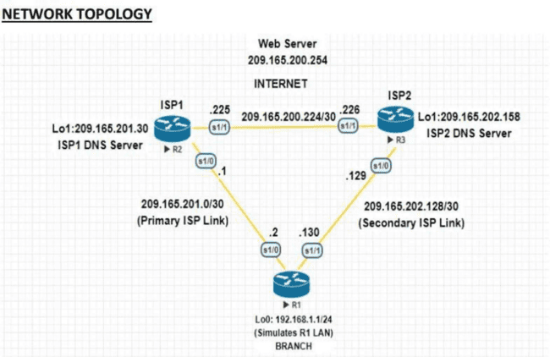

## R1

Router>enable Router# conf t R

outer(config)#hostname R1 R1(config)#interface Loopback 0

R1(config-if)#ip address 192.168.1.1 255.255.255.0 R1(config-if)#exit

R1(config)#interface s1/0

R1(config-if)#ip address 209.165.201.2 255.255.255.252 R1(config-if)#no shutdown

R1(config-if)#exit R1(config)#interface s1/1

R1(config-if)#ip address 209.165.202.130 255.255.255.252 R1(config-if)#no shutdown

R1(config-if)#exit

R1(config)#ip route 0.0.0.0 0.0.0.0 209.165.201.1

R1(config)#ip sla 12

R1(config-ip-sla)#icmp-echo 209.165.201.30

R1(config-ip-sla-echo)#frequency 11 R1(config-ip-sla-echo)#exit

R1(config)#ip sla schedule 12 life forever start-time now R

->1#sh ip sla configuration 12

IP SLAs Infrastructure Engine-III Entry number: 12

Owner:



Tag:

Operation timeout (milliseconds): 5000 Type of operation to perform: icmp-echo

Target address/Source address: 209.165.201.30/0.0.0.0 Type Of Service parameter: 0x0

Request size (ARR data portion): 28 Verify data: No

Vrf Name:

Schedule:

Operation frequency (seconds): 11 (not considered if randomly scheduled)

Next Scheduled Start Tim e: Start Time already passed

Group Scheduled : FALSE Randomly Scheduled : FALSE Life (seconds): Forever

Entry Ageout (seconds): never Recurring (Starting Everyday): FALSE

Status of entry (SNMP RowStatus): Active Threshold (milliseconds): 5000 Distribution Statistics:

Number of statistic hours kept: 2

Number of statistic distribution buckets kept: 1 Statistic distribution interval (milliseconds): 20 Enhanced History:

History Statistics:

Number of history Lives kept: 0 Number of history Buckets kept: 15

History Filter Type: None R1#sh ip sla statistics IPSLAs Latest Operation Statistics

IPSLA operation id: 12 Latest RTT: 11 milliseconds

Latest operation start time: 18:21:25 EET Thu Apr 9 2020 Latest operation return code: OK

Number of successes: 22 Number of failures: 0 Operation time to live: Forever R1(config)#ip sla 24

R1(config-ip-sla)#icmp-echo 209.165.202.158

R1(config-ip-sla-echo)#frequency 10 R1(config-ip-sla-echo)#exit

R1(config)#ip sla schedule 24 life forever start-time now R1#sh ip sla configuration 24

IP SLAs Infrastructure Engine-III Entry number: 24

Owner:

Tag:

Operation timeout (milliseconds): 5000 Type of operation to perform: icmp-echo

Target address/Source address: 209.165.202.158/0.0.0.0 Type Of Service parameter: 0x0



Request size (A

RR data portion): 28 Verify data: No Vrf Name:

Schedule:

Operation frequency (seconds): 10 (not considered if randomly scheduled) Next Scheduled Start Time: Start Time already passed

Group Scheduled : FALSE Randomly Scheduled : FALSE Life (seconds): Forever

Entry Ageout (seconds): never Recurring (Starting Everyday): FALSE

Status of entry (SNMP RowStatus): Active Threshold (milliseconds): 5000 Distribution Statistics:

Number of statistic hours kept: 2

Number of statistic distribution buckets kept: 1 Statistic distribution interval (milliseconds): 20 Enhanced History:

History Statistics:

Number of history Lives kept: 0 Number of history Buckets kept: 15 History Filter Type: None

R1#sh ip sla statistics 24

IPSLAs Latest Operation Statistics

IPSLA operation id: 24 Latest RTT: 20 milliseconds Latest operation start time: 18:33:25 EET Thu Apr 9 2020 Latest operation return code: OK

Number of successes: 16 Number of failures: 0 Operation time to live: Forever

R1(config)#no ip route 0.0.0.0 0.0.0.0 209.165.201.1

R1(config)#ip route 0.0.0.0 0.0.0.0 209.165.201.1 5

R1#sh ip route

Codes: L - local, C - connected, S - static, R - RIP, M - mobile, B - BGP D - EIGRP, EX - EIGRP external, O - OSPF, IA - OSPF inter area N1 - OSPF NSSA external type 1, N2 - OSPF NSSA external type 2 E1 - OSPF external type 1, E2 - OSPF external type 2 i - IS-IS, su - IS-IS summary, L1 - IS-IS level-1, L2 - IS-IS level-2 ia - IS-IS inter area, * - candidate default, U - per-user static route o - ODR, P - periodic downloaded static route, H - NHRP, l - LISP a - application route + - replicated route, % - next hop override

Gateway of last resort is 209.165.201.1 to network 0.0.0.0

S* 0.0.0.0/0 [5/0] via 209.165.201.1 192.168.1.0/24 is variably subnetted, 2 subnets, 2 masks C 192.168.1.0/24 is directly connected, Loopback0

L 192.168.1.1/32 is directly connected, Loopback0 209.165.201.0/24 is variably subnetted, 2 subnets, 2 masks

C 209.165.201.0/30 is directly connected, Serial1/0

L 209.165.201.2/32 is directly connected, Serial1/0 209.165.202.0/24 is variably subnetted, 2 subnets, 2 masks

C 209.165.202.128/30 is directly connected, Serial1/1 L 209.165.202.130/32 is directly connected, Serial1/1



R1(config)#track 1 ip sla 12 reachability

R1(config-track)#delay down 10 up 1 R1(config-track)#exit

R1(config)#ip route 0.0.0.0 0.0.0.0 209.165.201.1 2 track 1

R1(config)#track 2 ip sla 12 reachability

R1(config-track)#delay down 10 up 1 R1(config-track)#exit

R1(config)#ip route 0.0.0.0 0.0.0.0 209.165.201.1 3 track 2 R1#sh ip route

Codes: L - local, C - connected, S - static, R - RIP, M - mobile, B - BGP D - EIGRP, EX - EIGRP external, O - OSPF, IA - OSPF inter area N1 - OSPF NSSA external type 1, N2 - OSPF NSSA external type 2 E1 - OSPF external type 1, E2 - OSPF external type 2 i - IS-IS, su - IS-IS summary, L1 - IS-IS level-1, L2 - IS-IS level-2 ia - IS-IS inter area, * - candidate default, U - per-user static route o - ODR, P - periodic downloaded static route, H - NHRP, l - LISP a - application route + - replicated route, % - next hop override

Gateway of last resort is 209.165.201.1 to network 0.0.0.0

S* 0.0.0.0/0 [3/0] via 209.165.201.1 192.168.1.0/24 is variably subnetted, 2 subnets, 2 masks C 192.168.1.0/24 is directly connected, Loopback0

L 192.168.1.1/32 is directly connected, Loopback0 209.165.201.0/24 is variably subnetted, 2 subnets, 2 masks

C 209.165.201.0/30 is directly connected, Serial1/0

L 209.165.201.2/32 is directly connected, Serial1/0 209.165.202.0/24 is variably subnetted, 2 subnets, 2 masks

C 209.165.202.128/30 is directly connected, Serial1/1 L 209.165.202.130/32 is directly connected, Serial1/1 R1#sh ip route

Codes: L - local, C - connected, S - static, R - RIP, M - mobile, B - BGP D - EIGRP, EX - EIGRP external, O - OSPF, IA - OSPF inter area N1 - OSPF NSSA external type 1, N2 - OSPF NSSA external type 2 E1 - OSPF external type 1, E2 - OSPF external type 2 i - IS-IS, su - IS-IS summary, L1 - IS-IS level-1, L2 - IS-IS level-2 ia - IS-IS inter area, * - candidate default, U - per-user static route o - ODR, P - periodic downloaded static route, H - NHRP, l - LISP a - application route + - replicated route, % - next hop override

Gateway of last resort is 209.165.201.1 to network 0.0.0.0

S* 0.0.0.0/0 [5/0] via 209.165.201.1 192.168.1.0/24 is variably subnetted, 2 subnets, 2 masks C 192.168.1.0/24 is directly connected, Loopback0

L 192.168.1.1/32 is directly connected, Loopback0 209.165.201.0/24 is variably subnetted, 2 subnets, 2 masks

C 209.165.201.0/30 is directly connected, Serial1/0

L 209.165.201.2/32 is directly connected, Serial1/0 209.165.202.0/24 is variably subnetted, 2 subnets, 2 masks

C 209.165.202.128/30 is directly connected, Serial1/1 L 209.165.202.130/32 is directly connected, Serial1/1 R1#sh ip sla statistics

IPSLAs Latest Operation Statistics IPSLA operation id: 12

Latest RTT: NoConnection/Busy/Timeout

Latest operation start time: 19:02:29 EET Thu Apr 9 2020 Latest operation return code: Timeout

Number of successes: 227



Number of failures: 19 Operation time to live: Forever IPSLA operation id: 24

Latest RTT: 20 milliseconds

Latest operation start time: 19:02:35 EET Thu Apr 9 2020 Latest operation return code: OK

Number of successes: 190 Number of failures: 1 Operation time to live: Forever

R1#trace 209.165.200.254 source 192.168.1.1

Type escape sequence to abort. Tracing the route to 209.165.200.254

VRF info: (vrf in name/id, vrf out name/id) 1 209.165.201.1 10 msec 14 msec * R1#sh ip sla statistics

IPSLAs Latest Operation Statistics IPSLA operation id: 12

Latest RTT: 10 milliseconds

Latest operation start time: 19:07:04 EET Thu Apr 9 2020 Latest operation return code: OK

Number of successes: 236 Number of failures: 35 Operation time to live: Forever

IPSLA operation id: 24 Latest RTT: 21 milliseconds Latest operation start time: 19:07:05 EET Thu Apr 9 2020 Latest operation return code: OK

Number of successes: 217 Number of failures: 1 Operation time to live: Forever R1#sh ip route

Codes: L - local, C - connected, S - static, R - RIP, M - mobile, B - BGP D - EIGRP, EX - EIGRP external, O - OSPF, IA - OSPF inter area N1 - OSPF NSSA external type 1, N2 - OSPF NSSA external type 2 E1 - OSPF external type 1, E2 - OSPF external type 2 i - IS-IS, su - IS-IS summary, L1 - IS-IS level-1, L2 - IS-IS level-2 ia - IS-IS inter area, * - candidate default, U - per-user static route o - ODR, P - periodic downloaded static route, H - NHRP, l - LISP a - application route + - replicated route, % - next hop override

Gateway of last resort is 209.165.201.1 to network 0.0.0.0

S* 0.0.0.0/0 [3/0] via 209.165.201.1 192.168.1.0/24 is variably subnetted, 2 subnets, 2 masks C 192.168.1.0/24 is directly connected, Loopback0

L 192.168.1.1/32 is directly connected, Loopback0 209.165.201.0/24 is variably subnetted, 2 subnets, 2 masks

C 209.165.201.0/30 is directly connected, Serial1/0

L 209.165.201.2/32 is directly connected, Serial1/0 209.165.202.0/24 is variably subnetted, 2 subnets, 2 masks

C 209.165.202.128/30 is directly connected, Serial1/1 L 209.165.202.130/32 is directly connected, Serial1/1

###### ISP1 (R2)

Router>enable



Router#conf t Router(config)#hostname ISP1 ISP1(config)#interface Loopback0

ISP1(config-if)#description Simulated Internet Web Server ISP1(config-if)#ip address 209.165.200.254 255.255.255.255 ISP1(config-if)#exit

ISP1(config)#interface Loopback1

ISP1(config-if)#ip address 209.165.201.30 255.255.255.255 ISP1(config-if)#exit

ISP1(config)#interface s1/0

ISP1(config-if)#ip address 209.165.201.1 255.255.255.252 ISP1(config-if)#no shutdown

ISP1(config-if)#exit ISP1(config)#interface s1/1

ISP1(config-if)#ip address 209.165.200.225 255.255.255.252 ISP1(config-if)#no shutdown

ISP1(config-if)#exit ISP1(config)#router eigrp 200

ISP1(config-router)#network 209.165.200.224

ISP1(config-router)#network 209.165.201.0 ISP1(config-router)#no auto-summary ISP1(config-router)#exit

ISP1(config)#ip route 192.168.1.0 255.255.255.0 209.165.201.2

ISP1(config)#interface loopback 1 ISP1(config-if)#shut ISP1(config)#interface loopback 1 ISP1(config-if)#no shutdown

**ISP2 (R3)**

Router>enable Router#conf t

Router(config)#hostname ISP2 ISP2(config)#interface Loopback0

ISP2(config-if)#description Simulated Internet Web Server ISP2(config-if)#ip address 209.165.200.254 255.255.255.255 ISP2(config-if)#exit

ISP2(config)#interface Loopback1

ISP2(config-if)#ip address 209.165.202.158 255.255.255.255 ISP2(config-if)#exit

ISP2(config)#interface s1/1

ISP2(config-if)#ip address 209.165.200.226 255.255.255.252 ISP2(config-if)#no shutdown

ISP2(config-if)#exit ISP2(config)#interface s1/0 ISP2(config-if)#ip address 20

9.165.202.129 255.255.255.252

ISP2(config-if)#no shutdown



# Practical 2

**Aim:** - Using the AS_PATH Attribute.

**Code:** -

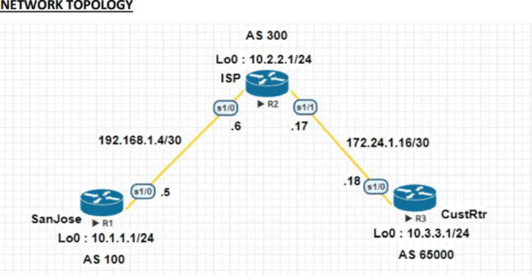

## SanJose

Router>enable Router#conf t

Router(config)#hostname SanJose SanJose(config)#interface Loopback0

SanJose(config-if)#ip address 10.1.1.1 255.255.255.0 SanJose(config-if)#exit

SanJose(config)#interface Serial1/0

SanJose(config-if)#ip address 192.168.1.5 255.255.255.252 SanJose(config-if)#no shutdown

SanJose(config-if)#end SanJose(config)#router bgp 100

SanJose(config-router)#network 10.1.1.0 mask 255.255.255.0

SanJose(config-router)#neighbor 192.168.1.6 remote-as 300 SanJose(config-router)#exit

SanJose#sh ip route

Codes: L - local, C - connected, S - static, R - RIP, M - mobile, B - BGP D - EIGRP, EX - EIGRP external, O - OSPF, IA - OSPF inter area N1 - OSPF NSSA external type 1, N2 - OSPF NSSA external type 2 E1 - OSPF external type 1, E2 - OSPF external type 2 i - IS-IS, su - IS-IS summary, L1 - IS-IS level-1, L2 - IS-IS level-2 ia - IS-IS inter area, * - candidate default, U - per-user static route o - ODR, P - periodic downloaded static route, H - NHRP, l - LISP a - application route + - replicated route, % - next hop override

Gateway of last resort is not set

10.0.0.0/8 is variably subnetted, 4 subnets, 2 masks C 10.1.1.0/24 is directly connected, Loopback0



L 10.1.1.1/32 is directly connected, Loopback0 B 10.2.2.0/24 [20/0] via 192.168.1.6, 00:05:47

B 10.3.3.0/24 [20/0] via 192.168.1.6, 00:02:13 192.168.1.0/24 is variably subnetted, 2 subnets, 2 masks

C 192.168.1.4/30 is directly connected, Serial1/0 L 192.168.1.5/32 is directly connected, Serial1/0 SanJose#sh ip bgp

BGP table version is 4, local router ID is 10.1.1.1

Status codes: s suppressed, d damped, h history, * valid, > best, i - internal, r RIB-failure, S Stale, m multipath, b backup-path, f RT-Filter, x best-external, a additional-path, c RIB- compressed, Origin codes: i - IGP, e - EGP, ? - incomplete RPKI validation codes: V valid, I invalid, N Not found

Network Next Hop Metric LocPrf Weight Path

*> 10.1.1.0/24 0.0.0.0 0 32768 i

*> 10.2.2.0/24 192.168.1.6 0 0 300 i

*> 10.3.3.0/24 192.168.1.6 0 300 65000 i

SanJose#sh ip bgp

BGP table version is 5, local router ID is 10.1.1.1

Status codes: s suppressed, d damped, h history, * valid, > best, i - internal, r RIB-failure, S Stale, m multipath, b backup-path, f RT-Filter, x best-external, a additional-path, c RIB- compressed, Origin codes: i - IGP, e - EGP, ? - incomplete RPKI validation codes: V valid, I invalid, N Not found

|  |  |  |  |
| --- | --- | --- | --- |
| Network Weight Path | Next Hop | Metric | LocPrf |
| *> 10.1.1.0/24 | 0.0.0.0 | 0 | 32768 i |
| *> 10.2.2.0/24 | 192.168.1.6 | 0 | 0 300 i |
| *> 10.3.3.0/24 | 192.168.1.6 |  | 0 300 i |

## ISP Router>enable

Router#conf t Router(config)#hostname ISP ISP(config)#interface Loopback0

ISP(config-if)#ip address 10.2.2.1 255.255.255.0 ISP(config-if)#exit ISP(config)#interface Serial1/0 ISP(config-if)#ip address 192.168.1.6 255.255.255.252 I SP(config-if)#no shutdown

ISP(config-if)#exit ISP(config)#interface Serial1/1

ISP(config-if)#ip address 172.24.1.17 255.255.255.252 ISP(config-if)#no shutdown

ISP(config-if)#end ISP(config)#router bgp 300

ISP(config-router)#network 10.2.2.0 mask 255.255.255.0

ISP(config-router)#neighbor 192.168.1.5 remote-as 100

ISP(config-router)#neighbor 172.24.1.18 remote-as 65000

ISP(config)#router bgp 300

ISP(config-router)#neighbor 192.168.1.5 remove-private-as ISP(config-router)#end



ISP#clear ip bgp * soft

ISP(config)#ip as-path access-list 1 deny ^100$ ISP(config)#ip as-path access-list 1 permit .* ISP(config)#router bgp 300

ISP(config-router)#neighbor 172.24.1.18 filter-list 1 out ISP(config-router)#end

ISP#sh ip route

Codes: L - local, C - connected, S - static, R - RIP, M - mobile, B - BGP D - EIGRP, EX - EIGRP external, O - OSPF, IA - OSPF inter area N1 - OSPF NSSA external type 1, N2 - OSPF NSSA external type 2 E1 - OSPF external type 1, E2 - OSPF external type 2 i - IS-IS, su - IS-IS summary, L1 - IS-IS level-1, L2 - IS-IS level-2 ia - IS-IS inter area, * - candidate default, U - per-user static route o - ODR, P - periodic downloaded static route, H - NHRP, l - LISP a - application route + - replicated route, % - next hop override

Gateway of last resort is not set

10.0.0.0/8 is variably subnetted, 4 subnets, 2 masks

B 10.1.1.0/24 [20/0] via 192.168.1.5, 00:46:41

C 10.2.2.0/24 is directly connected, Loopback0 L 10.2.2.1/32 is directly connected, Loopback0

B 10.3.3.0/24 [20/0] via 172.24.1.18, 00:43:07 172.24.0.0/16 is variably subnetted, 2 subnets, 2 masks

C 172.24.1.16/30 is directly connected, Serial1/1

L 172.24.1.17/32 is directly connected, Serial1/1 192.168.1.0/24 is variably subnetted, 2 subnets, 2 masks

C 192.168.1.4/30 is directly connected, Serial1/0 L 192.168.1.6/32 is directly connected, Serial1/0 ISP#show ip bgp regexp ^100$

BGP table version is 4, local router ID is 10.2.2.1

Status codes: s suppressed, d damped, h history, * valid, > best, i - internal, r RIB-failure, S Stale, m multipath, b backup-path, f RT-Filter, x best-external, a additional-path, c RIB- compressed,

Origin codes: i - IGP, e - EGP, ? - incomplete

RPKI validation codes: V valid, I invalid, N Not found

Network Pat

Next Hop Metric LocPrf Weight

h *> 10.1.1.0/24 192.168.1.5 0 0 100 i

**CustRtr** Router>enable Router#conf t

Router(config)#hostname CustRtr CustRtr(config)#interface Loopback0 CustRtr(config-if)#ip address 10.3.3.1 255.255.255.0 CustRtr(config-if)#exit

CustRtr(config)#interface Serial1/0

CustRtr(config-if)#ip address 172.24.1.18 255.255.255.252 CustRtr(config-if)#no shutdown

CustRtr(config-if)#end CustRtr(config)#router bgp 65000

CustRtr(config-router)#network 10.3.3.0 mask 255.255.255.0

CustRtr(config-router)#neighbor 172.24.1.17 remote-as 30



0 CustRtr(config-router)#end CustRtr#sh ip route

Codes: L - local, C - connected, S - static, R - RIP, M - mobile, B - BGP D - EIGRP, EX - EIGRP external, O - OSPF, IA - OSPF inter area N1 - OSPF NSSA external type 1, N2 - OSPF NSSA external type 2 E1 - OSPF external type 1, E2 - OSPF external type 2 i - IS-IS, su - IS-IS summary, L1 - IS-IS level-1, L2 - IS-IS level-2 ia - IS-IS inter area, * - candidate default, U - per-user static route o - ODR, P - periodic downloaded static route, H - NHRP, l - LISP a - application route + - replicated route, % - next hop override

Gateway of last resort is not set

10.0.0.0/8 is variably subnetted, 3 subnets, 2 masks

B 10.2.2.0/24 [20/0] via 172.24.1.17, 00:45:59

C 10.3.3.0/24 is directly connected, Loopback0

L 10.3.3.1/32 is directly connected, Loopback0 172.24.0.0/16 is variably subnetted, 2 subnets, 2 mask

s C 172.24.1.16/30 is directly connected, Serial1/0 L 172.24.1.18/32 is directly connected, Serial1/0



# Practical 3

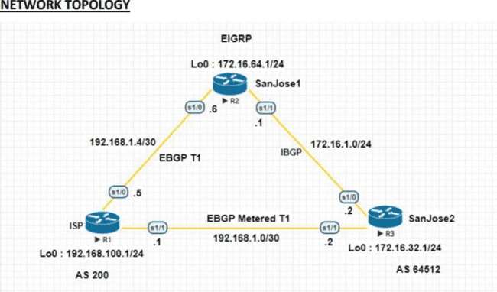**Aim:** - Configuring IBGP and EBGP Sessions, Local Preference, and MED**. Code: -**

**R1(ISP)**

Router>enable Router#conf t

Router(config)#hostname ISP ISP(config)#interface Loopback0

ISP(config-if)#ip address 192.168.100.1 255.255.255.0 ISP(config-if)#exit

ISP(config)#interface Serial1/0

ISP(config-if)#ip address 192.168.1.5 255.255.255.252 ISP(config-if)#no shutdown

ISP(config-if)#exit ISP(config)#interface Serial1/1

ISP(config-if)#ip address 192.168.1.1 255.255.255.252 ISP(config-if)#no shutdown

ISP(config-if)#exit ISP(config)#router bgp 200

ISP(config-router)#network 192.168.100.0

ISP(config-router)#neighbor 192.168.1.6 remote-as 64512

ISP(config-router)#neighbor 192.168.1.2 remote-as 64512 ISP(config-router)#exit

ISP#sh ip bgp

BGP table version is 3, local router ID is 192.168.100.1

Status codes: s suppressed, d damped, h history, * valid, > best, i - internal, r RIB-failure, S Stale, m multipath, b backup-path, f RT-Filter, x best-external, a additional-path, c RIB- compressed,

Origin codes: i - IGP, e - EGP, ?  incomplete



RPKI validation codes: V valid, I invalid, N Not found

Network Next Hop Metric LocPrf Weight Path

* 172.16.0.0 192.168.1.2 0 0 64512

i

*> 192.168.1.6 0 0 64512

i

*> 192.168.100.0 0.0.0.0 0 32768 i

ISP#ping 172.16.1.1 source 192.168.100.1

Type escape sequence to abort.

Sending 5, 100-byte ICMP Echos to 172.16.1.1, timeout is 2 seconds: Packet sent with a source address of 192.168.100.1 !!!!!

Success rate is 100 percent (5/5), round-trip min/avg/max = 10/10/11 ms ISP#ping 172.16.32.1 source 192.168.100.1

Type escape sequence to abort.

Sending 5, 100-byte ICMP Echos to 172.16.32.1, timeout is 2 seconds: Packet sent with a source address of 192.168.100.1 !!!!!

Success rate is 100 percent (5/5), round-trip min/avg/max = 15/15/16 ms ISP#ping 172.16.1.2 source 192.

168.100.1

Type escape sequence to abort.

Sending 5, 100-byte ICMP Echos to 172.16.1.2, timeout is 2 seconds: Packet sent with a source address of 192.168.100.1 !!!!!

Success rate is 100 percent (5/5), round-trip min/avg/max = 15/17/25 ms ISP(config)#router bgp 200

ISP(config-router)#network 192.168.1.0 mask 255.255.255.252

ISP(config-router)#network 192.168.1.4 mask 255.255.255.252 ISP(config-router)#exit

ISP#sh ip bgp

BGP table version is 5, local router ID is 192.168.100.1

Status codes: s suppressed, d damped, h history, * valid, > best, i - internal, r RIB-failure, S Stale, m multipath, b backup-path, f RT-Filter, x best-external, a additional-path, c RIB- compressed,

Origin codes: i - IGP, e - EGP, ?  incomplete

RPKI validation codes: V valid, I invalid, N Not found

|  |  |  |  |  |
| --- | --- | --- | --- | --- |
| Network | Next Hop | Metric |  | LocPrf |
| Weight Path * 172.16.0.0 | 192.168.1.6 |  | 0 |  |
| 0 64512 i |  |  |  |  |
| *> 192.168.1.2 | 0 | 0 |  |  |
| 64512 |  |  |  |  |
| i *> 192.168.1.0/30 | 0.0.0.0 | 0 |  |  |
| 32768 i |  |  |  |  |
| *> 192.168.1.4/30 | 0.0.0.0 | 0 |  |  |
| 32768 i |  |  |  |  |
| *> 192.168.100.0 | 0.0.0.0 | 0 |  |  |
| 32768 i  ISP#sh ip bgp |  |  |  |  |

BGP table version is 6, local router ID is 192.168.100.1



Status codes: s suppressed, d damped, h history, * valid, > best, i - internal, r RIB-failure, S Stale, m multipath, b backup-path, f RT-Filter, x best-external, a additional-path, c RIB- compressed,

Origin codes: i - IGP, e - EGP, ? - incomplete

RPKI validation codes: V valid, I invalid, N Not found

|  |  |  |  |  |
| --- | --- | --- | --- | --- |
| Network | Next Hop | Metric |  | LocPrf |
| Weight Path *> 172.16.0.0 | 192.168.1.6 |  | 50 |  |
| 0 64512 i |  |  |  |  |
| * 192.168.1.2 | 75 | 0 |  |  |
| 64512 i |  |  |  |  |
| *> 192.168.1.0/30 | 0.0.0.0 | 0 |  |  |
| 32768 i |  |  |  |  |
| *> 192.168.1.4/30 | 0.0.0.0 | 0 |  |  |
| 32768 i |  |  |  |  |
| *> 192.168.100.0 | 0.0.0.0 | 0 |  |  |
| 32768 i |  |  |  |  |
| ISP#ping 172.16.1.1 |  |  |  |  |

Type escape sequence to abort.

Sending 5, 100-byte ICMP Echos to 172.16.1.1, timeout is 2 seconds: !!!!! Success rate is 100 percent (5/5), round-trip min/avg/max = 9/10/11 ms ISP#ping 172.16.1.2

Type escape sequence to abort.

Sending 5, 100-byte ICMP Echos to 172.16.1.2, timeout is 2 seconds: !!!!! Success rate is 100 percent (5/5), round-trip min/avg/max = 20/21/25 ms ISP#traceroute 172.16.1.1

Type escape sequence to abort. Tracing the route to 172.16.1.1

VRF info: (vrf in name/id, vrf out name/id) 1 192.168.1.6 10 msec 10 msec *

ISP#traceroute 172.16.1.2 Type escape sequence to abort. Tracing the route to 172.16.1.2

VRF info: (vrf in name/id, vrf out name/id)

1 192.168.1.6 10 msec 10 msec 13 msec

2 172.16.1.2 [AS 64512] 20 msec 19 msec

**\* R2 (SanJose1)**

Router>enable Router#conf t Router(config)#hostname SanJose1 SanJose1(config)#interface Loopback0

SanJose1(config-if)#ip address 172.16.64.1 255.255.255.0

SanJose1(config-if)#ip address 172.16.64.1 255.255.255.0 SanJose1(config-if)#exit

SanJose1(config)#interface Serial1/0

SanJose1(config-if)#ip address 192.168.1.6 255.255.255.252 SanJose1(config-if)#no shutdown

SanJose1(config-if)#exit SanJose1(config)#interface Serial1/1

SanJose1(config-if)#ip address 172.16.1.1 255.255.255.0



SanJose1(config-if)#no shutdown SanJose1(config-if)#exit SanJose1(config)#router eigrp 64512

SanJose1(config-router)#network 172.16.0.0 SanJose1(config-router)#no auto-summary SanJose1(config-router)#exit SanJose1(config)#router bgp 64512

SanJose1(config-router)#neighbor 172.16.32.1 remote-as 64512 SanJose1(config-router)#neighbor 172.16.32.1 update-source loopback0 SanJose1(config-router)#exit

SanJose1(config)#ip route 172.16.0.0 255.255.0.0 null 0

SanJose1(config)#router bgp 64512

SanJose1(config-router)#network 172.16.0.0

SanJose1(config-router)#neighbor 192.168.1.5 remote-as 200 S anJose1(config-router)#exit

SanJose1(config)#router bgp 64512 SanJose1(config-router)#neig

hbor 172.16.32.1 next-hop-self SanJose1(config-router)#exit SanJose1#sh ip bgp

BGP table version is 5, local router ID is 172.16.64.1

Status codes: s suppressed, d damped, h history, * valid, > best, i - internal, r RIB-failure, S Stale, m multipath, b backup-path, f RT-Filter, x best-external, a additional-path, c RIB- compressed, Origin codes: i - IGP, e - EGP, ? - incomplete

RPKI validation codes: V valid, I invalid, N Not found

LocPrf

|  |  |  |  |
| --- | --- | --- | --- |
| Network | Next Hop |  | Metric |
| Weight Path * i 172.16.0.0 |  | 172.16.32.1 | 0 |
| 100 0 i |  |  |  |
| *> 0.0.0.0 | 0 |  | 32768 i |

|  |  |  |  |  |  |
| --- | --- | --- | --- | --- | --- |
| * i 192.168.1.0/30 172.16.32.1 0 100  *> 192.168.1.5 0 0 200 i r i 192.168 1.4/30 172.16.32.1 0 100 | | | | 0 | 0 200 i  200 i |
| r> 192.168.1.5 0 0 200 i | | | |  |  |
| * i 192.168.100.0 172.16.32.1  i |  | 0 | 100 | 0 200 | |
| *> 192.168.1.5 | 0 |  | 0 | 200 | |
| i |  |  |  |  | |

SanJose1(config)#route-map PRIMARY_T1_IN permit 10 SanJose1(config-route-map)#set local-preference 160 SanJose1(config-route-map)#exit

SanJose1(config)#router bgp 64512

SanJose1(config-router)#neighbor 192.168.1.5 route-map PRIMARY_T1_IN in SanJose1(config-router)#exit

SanJose1#clear ip bgp * soft SanJose1#sh ip bgp



BGP table version is 8, local router ID is 172.16.64.1

Status codes: s suppressed, d damped, h history, * valid, > best, i - internal, r RIB-failure, S Stale, m multipath, b backup-path, f RT-Filter, x best-external, a additional-path, c RIB- compressed, Origin codes: i - IGP, e - EGP, ? - incomplete

RPKI validation codes: V valid, I invalid, N Not found

|  |  |  |  |  |  |
| --- | --- | --- | --- | --- | --- |
| Network | Next Hop |  | Metric |  | LocPrf |
| Weight Path * i 172.16.0.0 |  | 172.16.32.1 |  | 0 |  |
| 100 0 i |  |  |  |  |  |
| *> 0.0.0.0 | 0 |  |  |  |  |
| 32768 |  |  |  |  |  |
| i *> 192.168.1.0/30 | 192.168.1.5 |  | 0 |  | 160 0 |
| 200 i |  |  |  |  |  |
| r> 192.168.1.4/30 192.168.1.5  200 i | 0 |  | 160 |  | 0 |

*> 192.168.100.0 192.168.1.5 0

160 0 200 i

SanJose1(config)#route-map PRIMARY_T1_MED_OUT permit 10 SanJose1(config-route-map)#set Metric 50

SanJose1(config-route-map)#exit SanJose1(config)#router bgp 64512

SanJose1(config-router)#neighbor 192.168.1.5 route-map PRIMARY_T1_MED_OUT out SanJose1(config-router)#exit

SanJose1(config)#exit SanJose1#clear ip bgp * soft SanJose1#sh ip bgp

BGP table version is 8, local router ID is 172.16.64.1

Status codes: s suppressed, d damped, h history, * valid, > best, i - internal, r RIB-failure, S Stale, m multipath, b backup-path, f RT-Filter, x best-external, a additional-path, c RIB- compressed, Origin codes: i - IGP, e - EGP, ?  incomplete

RPKI validation codes: V valid, I invalid, N Not found

LocPrf

|  |  |  |  |  |
| --- | --- | --- | --- | --- |
| Network | Next Hop |  | Metric | |
| Weight Path * i 172.16.0.0 |  | 172.16.32.1 | 0 | |
| 100 0 i |  |  |  | |
| *> 0.0.0.0  32768 i | 0 |  |  | |
| *> 192.168.1.0/30 | 192.168.1.5 | |  | 0 |
| 160 0 200 i  r> 192.168.1.4/30 | 192.168.1.5 | | 0 |  |
| 160 0 200 i  *> 192.168.100.0 | 192.168.1.5 | | 0 |  |
| 160 0 200 i |  | |  |  |



SanJose1#sh ip route

Codes: L - local, C - connected, S - static, R - RIP, M - mobile, B - BGP D - EIGRP, EX - EIGRP external, O - OSPF, IA - OSPF inter area N1 - OSPF NSSA external type 1, N2 - OSPF NSSA external type 2 E1 - OSPF external type 1, E2 - OSPF external type 2 i - IS-IS, su - IS-IS summary, L1 - IS-IS level-1, L2 - IS-IS level-2 ia - IS-IS inter area, * - candidate default, U - per-user static route o - ODR, P - periodic downloaded static route, H - NHRP, l - LISP a - application route + - replicated route, % - next hop override

Gateway of last resort is not set

172.16.0.0/16 is variably subnetted, 6 subnets, 3 masks S 172.16.0.0/16 is directly connected, Null0

C 172.16.1.0/24 is directly connected, Serial1/1 L 172.16.1.1/32 is directly connected, Serial1/1

D 172.16.32.0/24 [90/2297856] via 172.16.1.2, 01:28:25, Serial1/1

C 172.16.64.0/24 is directly connected, Loopback0

L 172.16.64.1/32 is directly connected, Loopback0 192.168.1.0/24 is variably subnetted, 3 subnets, 2 masks

B 192.168.1.0/30 [20/0] via 192.168.1.5, 00:45:28

C 192.168.1.4/30 is directly connected, Serial1/0 L 192.168.1.6/32 is directly connected, Serial1/0

B 192.168.100.0/24 [20/0] via 192.168.1.5, 00:45:28

After issuing ip default-network SanJose1(config)#ip default-network 192.168.100.0 SanJose1(config)#end SanJose1#sh ip route

Codes: L - local, C - connected, S - static, R - RIP, M - mobile, B - BGP D - EIGRP, EX - EIGRP external, O - OSPF, IA - OSPF inter area N1 - OSPF NSSA external type 1, N2 - OSPF NSSA external type 2 E1 - OSPF external type 1, E2 - OSPF external type 2 i - IS-IS, su - IS-IS summary, L1 - IS-IS level-1, L2 - IS-IS level-2 ia - IS-IS inter area, * - candidate default, U - per-user static route o - ODR, P - periodic downloaded static route, H - NHRP, l - LISP a - application route + - replicated route, % - next hop override

Gateway of last resort is 192.168.1.5 to network 192.168.100.0

S* 0.0.0.0/0 [20/0] via 192.168.1.5 172.16.0.0/16 is variably subnetted, 6 subnets, 3 masks S 172.16.0.0/16 is directly connected, Null0

C 172.16.1.0/24 is directly connected, Serial1/1 L 172.16.1.1/32 is directly connected, Serial1/1

D 172.16.32.0/24 [90/2297856] via 172.16.1.2, 01:33:38, Serial1/1

C 172.16.64.0/24 is directly connected, Loopback0

L 172.16.64.1/32 is directly connected, Loopback0 192.168.1.0/24 is variably subnetted, 3 subnets, 2 masks

B 192.168.1.0/30 [20/0] via 192.168.1.5, 00:50:41

C 192.168.1.4/30 is directly connected, Serial1/0 L 192.168.1.6/32 is directly connected, Serial1/0

B* 192.168.100.0/24 [20/0] via 192.168.1.5, 00:50:41

SanJose1#ping 192.168.1.2



Type escape sequence to abort.

Sending 5, 100-byte ICMP Echos to 192.168.1.2, timeout is 2 seconds: !!!!! Success rate is 100 percent (5/5), round-trip min/avg/max = 14/15/16 ms SanJose1#traceroute 192.168.1.2

Type escape sequence to abort. Tracing the route to 192.168.1.2

VRF info: (vrf in name/id, vrf out name/id) 1 192.168.1.5 [AS 200] 10 msec 10 msec 10 msec 2

192.168.1.2 [AS 200] 15 msec 15 msec *

SanJose1#ping 192.168.1.1 Type escape sequence to abort.

Sending 5, 100-byte ICMP Echos to 192.168.1.1, timeout is 2 seconds: !!!!! Success rate is 100 percent (5/5), round-trip min/avg/max = 9/9/11 ms SanJose1#traceroute 192.168.1.1

Type escape sequence to abort. Tracing the route to 192.168.1.1

VRF info: (vrf in name/id, vrf out name/id 1 192.168.1.5 [AS 200] 10 msec 11 msec *

R3 (SanJose2) Router>en Router#conf t

Router(config)#hostname SanJose2 SanJose2(config)#interface Loopback0

SanJose2(config-if)#ip address 172.16.32.1 255.255.255.0 SanJose2(config-if)#exit

SanJose2(config)#interface Serial1/1

SanJose2(config-if)#ip address 192.168.1.2 255.255.255.252 SanJose2(config-if)#no shutdown

SanJose2(config-if)#exit SanJose2(config)#interface Serial1/0

SanJose2(config-if)#ip address 172.16.1.2 255.255.255.0 SanJose2(config-if)#no shutdown

SanJose2(config-if)#exit SanJose2(config)#router eigrp 64512

SanJose2(config-router)#network 172.16.0.0 SanJose2(config-router)#no auto-summary SanJose2(config-router)#exit SanJose2(config)#router bgp 64512

SanJose2(config-router)#neighbor 172.16.64.1 remote-as 64512 SanJose2(config-router)#neighbor 172.16.64.1 update-source loopback0 SanJose2(config-router)#exit

SanJose2(config)#ip route 172.16.0.0 255.255.0.0 null 0

SanJose2(config)#router bgp 64512

SanJose2(config-router)#network 172.16.0.0

SanJose2(config-router)#neighbor 192.168.1.1 remote-as 200 SanJose2(config-router)#exit

SanJose2#sh ip bgp summary

BGP router identifier 172.16.32.1, local AS number 64512 BGP table version is 4, main routing table version 4

2 network entries using 280 bytes of memory



4 path entries using 320 bytes of memory 4/2 BGP path/bestpath attribute entries using 576 bytes of memory

1 BGP AS-PATH entries using 24 bytes of memory

0 BGP route-map cache entries using 0 bytes of memory 0 BGP filter-list cache entries using 0 bytes of memory BGP using 1200 total bytes of memory

BGP activity 2/0 prefixes, 4/0 paths, scan interval 60 secs Neighbor V AS MsgRcvd MsgSent TblVer InQ OutQ Up/Down State/PfxRcd 172.16.64.1 4 64512 31 32 4 0 0 00:24:41 2

192.168.1.1 4 200 8 6 4 0 0 00:01:22 1

SanJose2#sh ip route

Codes: L - local, C - connected, S - static, R - RIP, M - mobile, B - BGP D - EIGRP, EX - EIGRP external, O - OSPF, IA - OSPF inter area N1 - OSPF NSSA external type 1, N2 - OSPF NSSA external type 2 E1 - OSPF external type 1, E2 - OSPF external type 2 i - IS-IS, su - IS-IS summary, L1 - IS-IS level-1, L2 - IS-IS level-2 ia - IS-IS inter area, * - candidate default, U - per-user static route o - ODR, P - periodic downloaded static route, H - NHRP, l - LISP a - application route + - replicated route, % - next hop override

Gateway of last resort is not set

172.16.0.0/16 is variably subnetted, 6 subnets, 3 masks S 172.16.0.0/16 is directly connected, Null0

C 172.16.1.0/24 is directly connected, Serial1/0 L 172.16.1.2/32 is directly connected, Serial1/0 C 172.16.32.0/24 is directly connected, Loopback0

L 172.16.32.1/32 is directly connected, Loopback0

D 172.16.64.0/24 [90/2297856] via 172.16.1.1, 00:08:46, Serial1/0 192.168.1.0/24 is variably

subnetted, 3 subnets, 2 mask

s C 192.168.1.0/30 is directly connected, Serial1/1 L 192.168.1.2/32 is directly connected, Serial1/1 B 192.168.1.4/30 [20/0] via 192.168.1.1, 00:02:19

B 192.168.100.0/24 [20/0] via 192.168.1.1, 00:07:40

SanJose2#sh ip bgp

BGP table version is 5, local router ID is 172.16.32.1

Status codes: s suppressed, d damped, h history, * valid, > best, i - internal, r RIB-failure, S Stale, m multipath, b backup-path, f RT-Filter, x best-external, a additional-path, c RIB- compressed, Origin codes: i - IGP, e - EGP, ? - incomplete

RPKI validation codes: V valid, I invalid, N Not found

Network Next Hop Metric LocPrf Weight Path * i 172.16.0.0 172.16.64.1 0

100 0 i

*> 0.0.0.0 0 32768 i r i 192.168.1.0/30 192.168.1.5 0 100

0 200 i

r> 192.168.1.1 0 0 200 i

* i 192.168.1.4/30 192.168.1.5 0 100

0 200 i



|  |  |  |  |
| --- | --- | --- | --- |
| *> 192.168.1.1 | 0 |  | 0 |
| 200 i |  |  |  |
| * i 192.168.100.0 192.168.1.5 | 0 |  | 100 |
| 0 200 i |  |  |  |
| *> 192.168.1.1 |  | 0 | 0 |
| 200 i SanJose2(config)#router bgp 64512 |  |  |  |

SanJose2(config-router)#neighbor 172.16.64.1 next-hop-self SanJose2(config-router)#exi

t SanJose2#sh ip bgp

BGP table version is 5, local router ID is 172.16.32.1

Status codes: s suppressed, d damped, h history, * valid, > best, i - internal, r RIB-failure, S Stale, m multipath, b backup-path, f RT-Filter, x best-external, a additional-path, c RIB- compressed, Origin codes: i - IGP, e - EGP, ? - incomplete

RPKI validation codes: V valid, I invalid, N Not found Network Next Hop Metric LocPrf Weight Path * i 172.16.0.0 172.16.64.1 0 100 0 i *> 0.0.0.0 0 32768 i r i 192.168.1.0/30

172.16.64.1 0 100 0 200 i r> 192.168.1.1 0 0 200 i * i 192.168.1.4/30 172.16.64.1 0 100 0 200 i

*> 192.168.1.1 0 0 200 i * i 192.168.100.0 172.16.64.1 0 100 0 200 i *> 192.168.1.1 0 0 200 i

SanJose2(config)#route-map SECONDARY_T1_IN permit 10 SanJose2(config-route-map)#set local-preference 125 SanJose2(config-route-map)#exi

t SanJose2(config)#router bgp 64512

SanJose2(config-router)#neighbor 192.168.1.1 route-map SECONDARY_T1_IN in SanJose2(config-router)#exit

SanJose2#clear ip bgp * soft SanJose2#sh ip bgp

BGP table version is 8, local router ID is 172.16.32.1 Status codes: s suppressed, d damped, h history, * valid, > best, i - internal, r RIB-failure, S Stale, m multipath, b backup-path, f RT- Filter, x best-external, a additional-path, c RIB-compressed, Origin codes: i - IGP, e - EGP, ?  incomplete

RPKI validation codes: V valid, I invalid, N Not found Network Next Hop Metric LocPrf Weight Path * i 172.16.0.0 172.16.64.1 0 100 0 i *> 0.0.0.0 0 32768 i r>i 192.168.1.0/30

172.16.64.1 0 160 0 200 i r 192.168.1.1 0 125 0 200 i *>i 192.168.1.4/30 172.16.64.1 0 160 0

200 i * 192.168.1.1 0 125 0 200 i *>i 192.168.100.0 172.16.64.1 0 160 0 200 i * 192.168.1.1 0

125 0 200 i

SanJose2(config)#route-map SECONDARY_T1_MED_OUT permit 10 SanJose2(config-route-map)#set Metric 75

SanJose2(config-route-map)#exit SanJose2(config)#router bgp 64512

SanJose2(config-router)#$2.168.1.1 route-map SECONDARY_T1_MED_OUT out



SanJose2(config-router)#end SanJose2#clear ip bgp * soft SanJose2#sh ip bgp

BGP table version is 8, local router ID is 172.16.32.1 Status codes: s suppressed, d damped, h history, * valid, > best, i - internal, r RIB-failure, S Stale, m multipath, b backup-path, f RT- Filter, x best-external, a additional-path, c RIB-compressed, Origin codes: i - IGP, e - EGP, ?  incomplete

RPKI validation codes: V valid, I invalid, N Not found

|  |  |  |  |  |  |
| --- | --- | --- | --- | --- | --- |
| Network | Next Hop | Metric | |  | LocPrf |
| Weight Path * i 172.16.0.0 | 172.16.64.1 |  | | 0 |  |
| 100 0 i |  |  | |  |  |
| *> 0.0.0.0 | 0 |  | |  |  |
| 32768 i  r>i 192.168.1.0/30 | 172.16.64.1 | 0 | |  | 160 |
| 0 200 i  r 192.168.1.1 0 | 125 0 | | | | |
| 200 i  *>i 192.168.1.4/30 | 172.16.64.1 0 160 0 | | | | |
| 200 i |  | | | | |
| * 192.168.1.1 0  200 i | 125 | | 0 | | |
| *>i 192.168.100.0 172.16.64.1 | 0 160 | |  | | |
| 0 200 i |  | |  | | |



### Code:

-

# Practical 4

**Aim:** Secure the Management Plane.

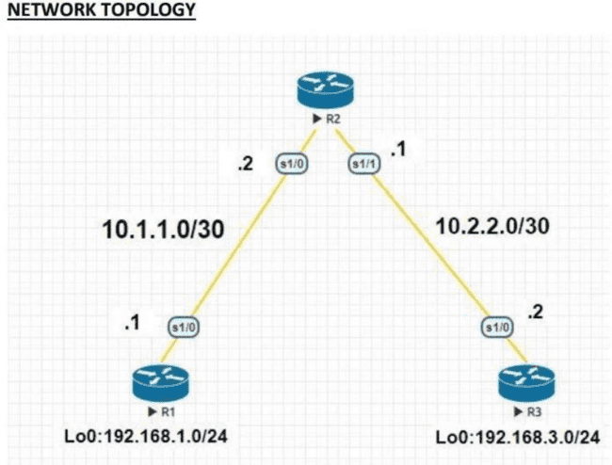

###### R1 Router>en

Router#conf t

Enter configuration commands, one per line. End with CNTL/Z. Router(config)#hostname R1

R1(config)#interface Loopback 0

*Dec 19 07:53:42.473: %LINEPROTO-5-UPDOWN: Line protocol on Interface Loopback0, changed state to up

R1(config-if)#ip address 192.168.1.1 255.255.255.0 R1(config-if)#exit

R1(config)#interface s1/0

R1(config-if)#ip address 10.1.1.1 255.255.255.252 R1(config-if)#no shutdown

*Dec 19 07:57:21.998: %LINK-3-UPDOWN: Interface Serial1/0, changed state to up

*Dec 19 07:57:22.999: %LINEPROTO-5-UPDOWN: Line protocol on Interface Serial1/0, changed state to up

R1(config-if)#exit

R1(config)#exit Configure static routes a.

On R1, configure a default static route to ISP. R1(config)# ip route 0.0.0.0 0.0.0.0 10.1.1.2 R1#show ip route

Codes: L - local, C - connected, S - static, R - RIP, M - mobile, B  BGP D - EIGRP, EX - EIGRP external, O - OSPF, IA - OSPF inter area N1 - OSPF NSSA external type 1, N2 - OSPF



NSSA external type 2 E1 - OSPF external type 1, E2 - OSPF external type 2 i - IS-IS, su - IS-IS summary, L1 - IS-IS level-1, L2 - IS-IS level-2 ia - IS-IS inter area, * - candidate default,U - per-user static route o - ODR, P - periodic downloaded static route,H - NHRP,l - LISP a - application route + - replicated route, % - next hop override

Gateway of last resort is 10.1.1.2 to network 0.0.0.0

S* 0.0.0.0/0 [1/0] via 10.1.1.2 10.0.0.0/8 is variably subnetted, 2 subnets, 2 masks C 10.1.1.0/30 is directly connected, Serial1/0

L 10.1.1.1/32 is directly connected, Serial1/0 192.168.1.0/24 is variably subnetted, 2 subnets, 2 masks

C 192.168.1.0/24 is directly connected, Loopback0

L 192.168.1.1/32 is directly connected, Loopback0 Secure management access R1(config)#security passwords min-length 10

R1(config)#enable secret class12345 R1(config)#line console 0

R1(config-line)#password ciscoconpass R1(config-line)#exec-timeout 5 0 R1(config-line)#login

R1(config-line)#logging synchronous R1(config-line)#exit

R1(config)#line vty 0 4

R1(config-line)#password ciscovtypass R1(config-line)#exec-timeout 5 0 R1(config-line)#login

R1(config-line)#exit R1(config)#line aux 0 R1(config-line)#no exec

R1(config-line)#end

R1(config)#service password-encryption

R1(config)#banner motd $Unauthorized access strictly prohibited!$ R1(config)#exit Configure enhanced username password security R1(config)#username JR-ADMIN secret class12345 R1(config)#username ADMIN secret class54321

R1(config)#line console 0 R1(config-line)#login local R1(config-line)#end R1(config)#line vty 0 4

R1(config-line)#login local

R1(config-line)#end Enabling AAA RADIUS Authentication with Local User for Backup R1(config)# aaa new-model

R1(config)# radius server RADIUS-1

R1(config-radius-server)# address ipv4 192.168.1.101 R1(config-radius-server)# key RADIUS-1-pa55w0rd R1(config-radius-server)# exit

R1(config)# radius server RADIUS-2

R1(config-radius-server)# address ipv4 192.168.1.102 R1(config-radius-server)# key RADIUS-2-pa55w0rd R1(config-radius-server)# exit



R1(config)# aaa group server radius RADIUS-GROUP R1(config-sg-radius)# server name RADIUS-1 R1(config-sg-radius)# server name RADIUS-2 R1(config-sg-radius)# exit

R1(config)# aaa authentication login default group RADIUS-GROUP local

R1(config)# aaa authentication login TELNET-LOGIN group RADIUS-GROUP localcase R1(config)# line vty 0 4

R1(config-line)# login authentication TELNET-LOGIN R1(config-line)# exit

R2 Router>enable

Router#conf t Enter configuration commands, one per line. End with CNTL/Z. Router(config)#hostname R2

R2(config)#interface s1/0

R2(config-if)#ip address 10.1.1.2 255.255.255.252 R2(config-if)#no shutdown

*Dec 19 08:01:10.279: %LINK-3-UPDOWN: Interface Serial1/0, changed state to up *Dec 19 08:01:11.279: %LINEPROTO-5-UPDOWN: Line protocol on Interface Serial1/0, changed state to up R2(config-if)#exit

R2(config)#interface s1/1

R2(config-if)#ip address 10.2.2.1 255.255.255.252 R2(config-if)#no shutdown

*Dec 19 08:02:33.002: %LINK-3-UPDOWN: Interface Serial1/1, changed state to up

*Dec 19 08:02:34.009: %LINEPROTO-5-UPDOWN: Line protocol on Interface Serial1/1, changed state to up

R2(config-if)#exit

R2(config)#exit Configure static routes a. On R2, configure two static routes. R2(config)# ip route 192.168.1.0 255.255.255.0 10.1.1.1

R2(config)# ip route 192.168.3.0 255.255.255.0 10.2.2.2

R2#show ip route Codes: L - local, C - connected, S - static, R - RIP, M - mobile, B  BGP D - EIGRP, EX - EIGRP external, O - OSPF, IA - OSPF inter area N1 - OSPF NSSA external type 1, N2 - OSPF NSSA external type 2 E1 - OSPF external type 1, E2 - OSPF external type 2 i - IS-IS, su - IS-IS summary, L1 - IS-IS level-1, L2 - IS-IS level-2 ia - IS-IS inter area, * - candidate default, U - per-user static route o - ODR, P - periodic downloaded static route, H - NHRP, l - LISP a - application route + - replicated route, % - next hop override

Gateway of last resort is not set 10.0.0.0/8 is variably subnetted, 4 subnets, 2 mask

s C 10.1.1.0/30 is directly connected, Serial1/0 L 10.1.1.2/32 is directly connected, Serial1/0 C 10.2.2.0/30 is directly connected, Serial1/1

L 10.2.2.1/32 is directly connected, Serial1/1 S 192.168.1.0/24 [1/0] via 10.1.1.1

S 192.168.3.0/24 [1/0] via 10.2.2.2 Secure management access R2(config)#security passwords min-length 10 R2(config)#enable secret class12345

R2(config)#line console 0 R2(config-line)#password ciscoconpass R2(config-line)#exec-timeout 5 0



R2(config-line)#login

R2(config-line)#logging synchronous R2(config-line)#exit

R2(config)#line vty 0 4

R2(config-line)#password ciscovtypass R2(config-line)#exec-timeout 5 0 R2(config-line)#login

R2(config-line)#exit R2(config)#line aux 0 R2(config-line)#no exec R2(config-line)#end

R2(config)#service password-encryption

R2(config)#banner motd $Unauthorized access strictly prohibited!$ R2(config)#exit Configure enhanced username password security R2(config)#username JR-ADMIN secret class12345 R2(config)#username ADMIN secret class54321

R2(config)#line console 0 R2(config-line)#login local R2(config-line)#end

R2(config)#line vty 0 4 R2(config-line)#login local

R2(config-line)#end Enabling AAA RADIUS Authentication with Local User for Backup R2(config)# aaa new-model

R2(config)# radius server RADIUS-1

R2(config-radius-server)# address ipv4 192.168.1.101 R2(config-radius-server)# key RADIUS-1-pa55w0rd R2(config-radius-server)# exit

R2(config)# radius server RADIUS-2

R2(config-radius-server)# address ipv4 192.168.1.102 R2(config-radius-server)# key RADIUS-2-pa55w0rd

R2(config-radius-server)# exit R2(config)# aaa group server radius RADIUS-GROUP R2(config-sg-radius)# server name RADIUS-1

R2(config-sg-radius)# server name RADIUS-2 R2(config-sg-radius)# exit

R2(config)# aaa authentication login default group RADIUS-GROUP local

R2(config)# aaa authentication login TELNET-LOGIN group RADIUS-GROUP localcase R2(config)# line vty 0 4

R2(config-line)# login authentication TELNET-LOGIN R2(config-line)# exit

R3 Router>enable

Router#conf t Enter configuration commands, one per line. End with CNTL/Z. Router(config)#hostname R3

R3(config)#interface loopback 0

*Dec 19 08:07:50.079: %LINEPROTO-5-UPDOWN: Line protocol on Interface Loopback0, changed state to up

R3(config-if)#ip address 192.168.3.1 255.255.255.0



R3(config-if)#exit R3(config)#interface s1/0

R3(config-if)#ip address 10.2.2.2 255.255.255.252 R3(config-if)#no shutdown

R3(config-if)#exit

*Dec 19 08:09:26.986: %LINK-3-UPDOWN: Interface Serial1/0, changed state to up

*Dec 19 08:09:27.996: %LINEPROTO-5-UPDOWN: Line protocol on Interface Serial1/0, changed state to up

R3(config)#end Configure static routes a. On R3, configure a default static route to ISP. R3(config)# ip route 0.0.0.0 0.0.0.0 10.2.2.1

R3#show ip route Codes: L - local, C - connected, S - static, R - RIP, M - mobile, B  BGP D - EIGRP, EX - EIGRP external, O - OSPF, IA - OSPF inter area N1 - OSPF NSSA external type 1, N2 - OSPF NSSA external type 2 E1 - OSPF external type 1, E2 - OSPF external type 2 i - IS-IS, su - IS-IS summary, L1 - IS-IS level-1, L2 - IS-IS level-2 ia - IS-IS inter area, * - candidate default, U - per-user static route o - ODR, P - periodic downloaded static route, H - NHRP, l - LISP a - application route + - replicated route, % - next hop override

Gateway of last resort is 10.2.2.1 to network 0.0.0.0

S* 0.0.0.0/0 [1/0] via 10.2.2.1 10.0.0.0/8 is variably subnetted, 2 subnets, 2 masks C 10.2.2.0/30 is directly connected, Serial1/0

L 10.2.2.2/32 is directly connected, Serial1/0 192.168.3.0/24 is variably subnetted, 2 subnets, 2 masks

C 192.168.3.0/24 is directly connected, Loopback0

L 192.168.3.1/32 is directly connected, Loopback0 Secure management access R3(config)#security passwords min-length 10

R3(config)#enable secret class12345 R3(config)#line console 0

R3(config-line)#password ciscoconpass R3(config-line)#exec-timeout 5 0 R3(config-line)#login

R3(config-line)#logging synchronous R3(config-line)#exit

R3(config)#line vty 0 4

R3(config-line)#password ciscovtypass R3(config-line)#exec-timeout 5 0 R3(config-line)#login R3(config-line)#exit R3(config)#line aux 0

R3(config-line)#no exec R3(config-line)#end

R3(config)#service password-encryption

R3(config)#banner motd $Unauthorized access strictly prohibited!$ Configure enhanced username password security

R3(config)#username JR-ADMIN secret class12345 R3(config)#username ADMIN secret class54321 R3(config)#line console 0



R3(config-line)#login local R3(config-line)#exit R3(config)#line vty 0 4 R3(config-line)#login local R3(config-line)#exit

Enabling AAA RADIUS Authentication with Local User for Backup R3(config)# aaa new-model

R3(config)# radius server RADIUS-1

R3(config-radius-server)# address ipv4 192.168.1.101 R3(config-radius-server)# key RADIUS-1-pa55w0rd R3(config-radius-server)# exit

R3(config)# radius server RADIUS-2

R3(config-radius-server)# address ipv4 192.168.1.102 R3(config-radius-server)# key RADIUS-2-pa55w0rd R3(config-radius-server)# exit

R3(config)# aaa group server radius RADIUS-GROUP R3(config-sg-radius)# server name RADIUS-1

R3(config-sg-radius)# server name RADIUS-2 R3(config-sg-radius)# exit R3(config)# aaa authentication login default group RADIUS-GROUP loca

l R3(config)# aaa authentication login TELNET-LOGIN group RADIUS-GROUP localcase R3(config)# line vty 0 4

R3(config-line)# login authentication TELNET-LOGIN R3(config-line)# exit



# Practical 5

**Aim:** Configure and Verify Path Control Using PBR.

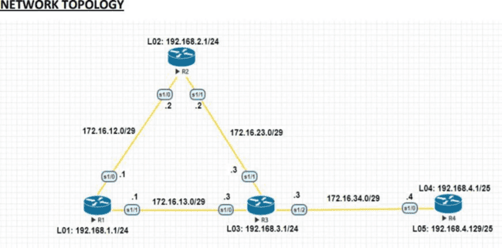

###### R1 Router>enable

Router#conf t Enter configuration commands, one per line. End with CNTL/Z. Router(config)#hostname R1

R1(config)#interface Lo1

R1(config-if)#ip address 192.168.1.1 255.255.255.0 R1(config-if)#exit

R1(config)#interface s1/0

R1(config-if)#ip address 172.16.12.1 255.255.255.248 R1(config-if)#no shutdown

R1(config-if)#exit R1(config)#interface s1/1

R1(config-if)#ip address 172.16.13.1 255.255.255.248 R1(config-if)#no shutdown R1(config-if)#exit

R1(config)#router eigrp 100

R1(config-router)#network 192.168.1.0

R1(config-router)#network 172.16.12.0

R1(config-router)#network 172.16.13.0 R1(config-router)#no auto-summary R1(config-router)#exit

R1#sh ip eigrp neighbors

EIGRP-IPv4 Neighbors for AS(100) H Address Interface Hold Uptime SRTT RTO Q Seq (sec) (ms) Cnt Num 1 172.16.13.3 Se1/1 14 00:04:43 11 100 0 10 0 172.16.12.2 Se1/0 12 00:07:05 19

114 0 8

R1#sh ip route

Codes: L - local, C - connected, S - static, R - RIP, M - mobile, B - BGP D - EIGRP, EX - EIGRP external, O - OSPF, IA - OSPF inter area N1 - OSPF NSSA external type 1, N2 - OSPF



NSSA external type 2 E1 - OSPF external type 1, E2 - OSPF external type 2 i - IS-IS, su - IS-IS summary, L1 - IS-IS level-1, L2 - IS-IS level-2 ia - IS-IS inter area, * - candidate default, U - per-user static route o - ODR, P - periodic downloaded static route, H - NHRP, l - LISP a - application route + - replicated route, % - next hop override

Gateway of last resort is not set

172.16.0.0/16 is variably subnetted, 6 subnets, 2 masks C 172.16.12.0/29 is directly connected, Serial1/0

L 172.16.12.1/32 is directly connected, Serial1/0 C 172.16.13.0/29 is directly connected, Serial1/1 L 172.16.13.1/32 is directly connected, Serial1/1

D 172.16.23.0/29 [90/2681856] via 172.16.13.3, 00:08:31, Serial1/1 [90/2681856] via 172.16.12.2, 00:08:31, Serial1/0

D 172.16.34.0/29 [90/2681856] via 172.16.13.3, 00:08:31, Serial1/1 192.168.1.0/24 is variably

subnetted, 2 subnets, 2 masks

C 192.168.1.0/24 is directly connected, Loopback1 L 192.168.1.1/32 is directly connected, Loopback1

D 192.168.2.0/24 [90/2297856] via 172.16.12.2, 00:08:31, Serial1/0

D 192.168.3.0/24 [90/2297856] via 172.16.13.3, 00:08:31, Serial1/1 192.168.4.0/25 is

subnetted, 2 subnets

D 192.168.4.0 [90/2809856] via 172.16.13.3, 00:05:15, Serial1/1

D 192.168.4.128 [90/2809856] via 172.16.13.3, 00:05:15, Serial1/1

**R2 Router>enable** Router#conf t Router(config)#hostname R2 R2(config)#interface Lo2

R2(config-if)#ip address 192.168.2.1 255.255.255.0 R2(config-if)#exit

R2(config)#interface s1/0

R2(config-if)#ip address 172.16.12.2 255.255.255.248 R2(config-if)#no shutdown

R2(config-if)#exit R2(config)#interface s1/1

R2(config-if)#ip address 172.16.23.2 255.255.255.248 R2(config-if)#no shutdown R2(config-if)#exit R2(config)#router eigrp 100

R2(config-router)#network 192.168.2.0

R2(config-router)#network 172.16.12.0

R2(config-router)#network 172.16.23.0 R2(config-router)#no auto-summary R2#sh ip eigrp neighbors EIGRP-IPv4

Neighbors for AS(100) H Address Interface Hold Uptime SRTT RTO Q Seq (sec) (ms) Cnt Num 1 172.16.23.3 Se1/1 12 00:05:23 12 100 0 11 0 172.16.12.1 Se1/0 12 00:07:45 22 132 0 8

R3 **Router>enable** Router#conf t Router(config)#hostname R3 R3(config)#interface Lo3

R3(config-if)#ip address 192.168.3.1 255.255.255.0 R3(config-if)#exit

R3(config)#interface s1/0



R3(config-if)#ip address 172.16.13.3 255.255.255.248 R3(config-if)#no shutdown

R3(config-if)#exit R3(config)#interface s1/1

R3(config-if)#ip address 172.16.23.3 255.255.255.248 R3(config-if)#no shutdown

R3(config-if)#exit R3(config)#interface s1/2

R3(config-if)#ip address 172.16.34.3 255.255.255.248 R3(config-if)#no shutdown

R3(config-if)#exit R3(config)#router eigrp 100

R3(config-router)#network 192.168.3.0

R3(config-router)#network 172.16.13.0

R3(config-router)#network 172.16.23.0

R3(config-router)#network 172.16.34.0 R3(config-router)#no auto-summary

R3#sh ip eigrp neighbors EIGRP-IPv4 Neighbors for AS(100) H Address Interface Hold Uptime SRTT RTO Q Seq (sec) (ms) Cnt Num 2 172.16.34.4 Se1/2 14 00:03:09 15 100 0 3 1

172.16.13.1 Se1/0 14 00:06:25 21 126 0 9 0 172.16.23.2 Se1/1 13 00:06:25 20 120 0 9

R3#sh ip route

Codes: L - local, C - connected, S - static, R - RIP, M - mobile, B - BGP D - EIGRP, EX - EIGRP external, O - OSPF, IA - OSPF inter area N1 - OSPF NSSA external type 1, N2 - OSPF NSSA external type 2 E1 - OSPF external type 1, E2 - OSPF external type 2 i - IS-IS, su - IS-IS summary, L1 - IS-IS level-1, L2 - IS-IS level-2 ia - IS-IS inter area, * - candidate default, U - per-user static route o - ODR, P - periodic downloaded static route, H - NHRP, l - LISP a - application route + - replicated route, % - next hop override

Gateway of last resort is not set

172.16.0.0/16 is variably subnetted, 7 subnets, 2 masks

D 172.16.12.0/29 [90/2681856] via 172.16.23.2, 00:16:48, Serial1/1 [90/2681856] via 172.16.13.1, 00:16:48, Serial1/0

C 172.16.13.0/29 is directly connected, Serial1/0 L 172.16.13.3/32 is directly connected, Serial1/0 C 172.16.23.0/29 is directly connected, Serial1/1 L 172.16.23.3/32 is directly connected, Serial1/1 C 172.16.34.0/29 is directly connected, Serial1/2 L 172.16.34.3/32 is directly connected, Serial1/2

D 192.168.1.0/24 [90/2297856] via 172.16.13.1, 00:16:48, Serial1/0

D 192.168.2.0/24 [90/2297856] via 172.16.23.2, 00:16:48, Serial1/1 192.168.3.0/24 is variably

subnetted, 2 subnets, 2 masks

C 192.168.3.0/24 is directly connected, Loopback3

L 192.168.3.1/32 is directly connected, Loopback3 192.168.4.0/25 is subnetted, 2 subnets D 192.168.4.0 [90/2297856] via 172.16.34.4, 00:13:32, Serial1/2

D 192.168.4.128 [90/2297856] via 172.16.34.4, 00:13:32, Serial1/2

R3(config)#ip access-list standard PBR-ACL R3(config-std-nacl)#remark ACL matches R4 LAN B traffic

R3(config-std-nacl)#permit 192.168.4.128 0.0.0.127 R3(config-std-nacl)#exit



R3(config)#route-map R3-to-R1 permit

R3(config-route-map)#match ip address PBR-ACL R3(config-route-map)#set ip next-hop 172.16.13.1 R3(config-route-map)#end

R3(config)#int s1/2

R3(config-if)#ip policy route-map R3-to-R1 R3(config-if)#exit

R3#sh route-map route-map R3-to-R1, permit, sequence 10 Match clauses: ip address (access- lists): PBR-ACL Set clauses: ip next-hop 172.16.13.1 Policy routing matches: 0 packets, 0 bytes R3(config)#access-list 1 permit 192.168.4.0 0.0.0.255

###### R4

Router>enable Router#conf t

Router(config)#hostname R4 R4(config)#interface lo4

R4(config-if)#ip address 192.168.4.1 255.255.255.128 R4(config-if)#exit

R4(config)#interface lo5

R4(config-if)#ip address 192.168.4.129 255.255.255.128 R4(config-if)#exit

R4(config)#interface s1/0

R4(config-if)#ip address 172.16.34.4 255.255.255.248 R4(config-if)#no shutdown

R4(config-if)#exit R4(config)#router eigrp 100

R4(config-router)#network 192.168.4.0

R4(config-router)#network 172.16.34.0 R4(config-router)#no auto-summary

R4#sh ip eigrp neighbors EIGRP-IPv4 Neighbors for AS(100) H Address Interface Hold Uptime SRTT RTO Q Seq (sec) (ms) Cnt Num 0 172.16.34.3 Se1/0 14 00:04:07 25 150 0 9

Before Route Maps R4#traceroute 192.168.1.1 source 192.168.4.1 Type escape sequence to abort.

Tracing the route to 192.168.1.1

VRF info: (vrf in name/id, vrf out name/id) 1 172.16.34.3 13 msec 11 msec 10 msec 2

172.16.13.1 20 msec 17 msec *

R4#traceroute 192.168.1.1 source 192.168.4.129 Type escape sequence to abort.

Tracing the route to 192.168.1.1

VRF info: (vrf in name/id, vrf out name/id) 1 172.16.34.3 15 msec 10 msec 10 msec 2

172.16.13.1 19 msec 24 msec *

After Route Maps R4#traceroute 192.168.1.1 source 192.168.4.1 Type escape sequence to abort. Tracing the route to 192.168.1.1

VRF info: (vrf in name/id, vrf out name/id) 1 172.16.34.3 11 msec 10 msec 10 msec 2

172.16.13.1 21 msec 22 msec *

R4#traceroute 192.168.1.1 source 192.168.4.129 Type escape sequence to abort.

Tracing the route to 192.168.1.1



# Practical 6

**Aim:** IP Service Level Agreements and Remote SPAN in a Campus Environment.

### Code: -

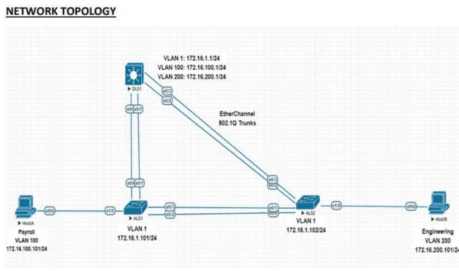

**DLS1 Switch>en** Switch#conf t Switch(config)#hostname DLS1 DLS1(config)#interface vlan 1

DLS1(config-if)#ip address 172.16.1.1 255.255.255.0 DLS1(config-if)#no shutdown

DLS1(config-if)#exit Configure the trunks and EtherChannel from DLS1 to ALS1. DLS1(config)#interface range e0/0-1

DLS1(config-if-range)#switchport trunk encapsulation dot1q DLS1(config-if-range)#switchport mode trunk

DLS1(config-if-range)#channel-group 1 mode desirable Creating a port-channel interface Port-

channel 1

DLS1(config-if-range)#exit Configure the trunks and EtherChannel from DLS1 to ALS2. DLS1(config)#interface range e0/2-3

DLS1(config-if-range)#switchport trunk encapsulation dot1q DLS1(config-if-range)#switchport mode trunk

DLS1(config-if-range)#channel-group 2 mode desirable Creating a port-channel interface Port-



channel 2

DLS1(config-if-range)#exit Configure VTP on DLS1 and create VLANs 100 and 200 for the domain DLS1(config)#vtp domain SWPOD Changing VTP domain name from NULL to SWPOD DLS1(config)#vtp version 2

DLS1(config)#vlan 100 DLS1(config-vlan)#name Payroll DLS1(config-vlan)#exit DLS1(config)#vlan 200

DLS1(config-vlan)#name Engineering

DLS1(config-vlan)#exit On DLS1, create the SVIs for VLANs 100 and 200.

Note that the corresponding Layer 2 VLANs must be configured for the Layer 3 SVIs to activate DLS1(config)#interface vlan 100

DLS1(config-if)#ip address 172.16.100.1 255.255.255.0 DLS1(config-if)#no shutdown

DLS1(config-if)#exit DLS1(config)#interface vlan 200

DLS1(config-if)#ip address 172.16.200.1 255.255.255.0 DLS1(config-if)#no shutdown

DLS1(config-if)#exit The ip routing command is also needed to allow the

DLS1 switch to act as a Layer 3 device to route between these VLANs. Because the VLANs are all considered directly connected, a routing protocol is not needed at this time. The default configuration on 3560 switches is no ip routing.

DLS1(config)#ip routing

DLS1#sh ip route Codes: L - local, C - connected, S - static, R - RIP, M - mobile, B - BGP D - EIGRP, EX - EIGRP external, O - OSPF, IA - OSPF inter area N1 - OSPF NSSA external type 1, N2 - OSPF NSSA external type 2 E1 - OSPF external type 1, E2 - OSPF external type 2 i - IS-IS, su - IS-IS summary, L1 - IS-IS level-1, L2 - IS-IS level-2 ia - IS-IS inter area, * - candidate default, U - per-user static route o - ODR, P - periodic downloaded static route, H - NHRP, l - LISP a - application route + - replicated route, % - next hop override

Gateway of last resort is not set

172.16.0.0/16 is variably subnetted, 6 subnets, 2 masks C 172.16.1.0/24 is directly connected, Vlan1

L 172.16.1.1/32 is directly connected, Vlan1

C 172.16.100.0/24 is directly connected, Vlan100 L 172.16.100.1/32 is directly connected, Vlan100 C 172.16.200.0/24 is directly connected, Vlan200 L 172.16.200.1/32 is directly connected, Vlan200

Configure the Cisco IOS IP SLA source to measure network performance DLS1(config)#ip sla 1

DLS1(config-ip-sla)#icmp-echo 172.16.100.101 DLS1(config-ip-sla-echo)#exit

DLS1(config)#ip sla 2

DLS1(config-ip-sla)#icmp-echo 172.16.200.101 DLS1(config-ip-sla-echo)#exit

DLS1(config)#ip sla 3

DLS1(config-ip-sla)#udp-jitter 172.16.1.101 5000 DLS1(config-ip-sla-jitter)#exi

t DLS1(config)#ip sla 4

DLS1(config-ip-sla)#udp-jitter 172.16.1.102 5000



DLS1(config-ip-sla-jitter)#exit

DLS1(config)#ip sla schedule 1 life forever start-time now DLS1(config)#ip sla schedule 2 life forever start-time now DLS1(config)#ip sla schedule 3 life forever start-time now

DLS1(config)#ip sla schedule 4 life forever start-time now Monitor IP SLAs operations DLS1#show ip sla configuration 1

IP SLAs Infrastructure Engine-III Entry number: 1 Owner: Tag: Operation timeout (milliseconds): 5000 Type of operation to perform: icmp-echo Target address/Source address: 172.16.100.101/0.0.0.0 Type Of Service parameter: 0x0 Request size (ARR data portion): 28 Data pattern: 0xABCDABCD Verify data: No Vrf Name: Schedule: Operation frequency (seconds): 60 (not considered if randomly scheduled)

Next Scheduled Start Time: Start Time already passed Group Scheduled : FALSE Randomly Scheduled : FALSE Life (seconds): Forever Entry Ageout (seconds): never

Recurring (Starting Everyday): FALSE Status of entry (SNMP RowStatus): Active Threshold (milliseconds): 5000

Distribution Statistics:

Number of statistic hours kept: 2

Number of statistic distribution buckets kept: 1 Statistic distribution interval (milliseconds): 20 E nhanced History: History Statistics:

Number of history Lives kept: 0 Number of history Buckets kept: 15 History Filter Type: None

DLS1#show ip sla configuration 3 IP SLAs Infrastructure Engine-III Entry number: 3

Owner: Tag: Operation timeout (milliseconds): 5000 Type of operation to perform: udp-jitter

Target address/Source address: 172.16.1.101/0.0.0.0 Target port/Source port: 5000/0 Type Of Service parameter: 0x0

Request size (ARR data portion): 32

Packet Interval (milliseconds)/Number of packets: 20/10 Verify data: No Vrf Name: Control Packets: enabled Schedule:

Operation frequency (seconds): 60 (not considered if randomly scheduled)

Next Scheduled Start Time: Start Time already passed Group Scheduled : FALSE Randomly Scheduled : FALSE Life (seconds): Forever Entry Ageout (seconds): never

Recurring (Starting Everyday): FALSE Status of entry (SNMP RowStatus): Active Threshold (milliseconds): 5000 Distribution Statistics:

Number of statistic hours kept: 2

Number of statistic distribution buckets kept: 1 Statistic distribution interval (milliseconds): 20 Enhanced History: Percentile:

DLS1#show ip sla application IP Service Level Agreements Version: Round Trip Time MIB 2.2.0, Infrastructure Engine-III

Supported Operation Types: icmpEcho, path-echo, path-jitter, udpEcho, tcpConnect, http dns, udpJitter, dhcp, ftp, lsp Group, lspPing, lspTrace pseudowirePing, udpApp, wspApp, mcast,



generic Supported Features: IPSLAs Event Publisher IP SLAs low memory water mark: 225778552 Estimated system max number of entries: 165365

Estimated number of configurable operations: 165241 Number of Entries configured : 4 Number of active Entries : 4

Number of pending Entries : 0

Number of inactive Entries : 0 Time of last change in whole IP SLAs: *14:08:46.139 EET Sat Apr 11 2020 DLS1#show ip sla statistics 1 IPSLAs

Latest Operation Statistics IPSLA operation id: 1 Latest RTT: 1 milliseconds Latest operation start time: 14:34:23 EET Sat Apr 11 2020

Latest operation return code: OK Number of successes: 26

Number of failures: 1 Operation time to live: Forever

DLS1#show ip sla statistics 3 IPSLAs Latest Operation Statistics IPSLA operation id: 3 Type of operation: udp-jitter Latest RTT: 1 milliseconds Latest operation start time: 14:34:36 EET Sat Apr 11 2020 Latest operation return code: OK RTT Values: Number Of RTT: 10 RTT Min/Avg/Max: 1/1/2 milliseconds Latency one-way time

: Number of Latency one-way Samples: 6

Source to Destination Latency one way Min/Avg/Max: 0/0/1 milliseconds Destination to Source Latency one way Min/Avg/Max: 0/0/1 milliseconds Jitter Time:

Number of SD Jitter Samples: 9 Number of DS Jitter Samples: 9

Source to Destination Jitter Min/Avg/Max: 0/1/1 milliseconds

Destination to Source Jitter Min/Avg/Max: 0/1/1 milliseconds Over Threshold: Number Of RTT Over Threshold: 0 (0%) Packet Loss Values: Loss Source to Destination: 0

Source to Destination Loss Periods Number: 0 Source to Destination Loss Period Length Min/Max: 0/0 Source to Destination Inter Loss Period Length Min/Max: 0/0 Loss Destination to Source: 0 Destination to Source Loss Periods Number: 0

Destination to Source Loss Period Length Min/Max: 0/0

Destination to Source Inter Loss Period Length Min/Max: 0/0 Out Of Sequence: 0 Tail Drop: 0 Packet Late Arrival: 0 Packet Skipped: 0 Voice Score Values: Calculated Planning Impairment Factor (ICPIF): 0 Mean Opinion Score (MOS): 0 Number of successes: 27 Number of failures: 0 Operation time to live: Forever Configure Remote Span

DLS1(config)#vlan 100 DLS1(config-vlan)#remote-span DLS1(config-vlan)#exi

t DLS1(config)#monitor session 1 source interface e0/0 both DLS1(config)# monitor session 1 destination remote vlan 100 ALS1 Switch>en Switch#conf t

Switch(config)#hostname ALS1 ALS1(config)#interface vlan 1

ALS1(config-if)#ip address 172.16.1.101 255.255.255.0 ALS1(config-if)#no shutdown

ALS1(config-if)#exit

ALS1(config)#ip default-gateway 172.16.1.1

Configure the trunks and EtherChannel between ALS1 and DLS1



ALS1(config)#interface range e0/0-1

ALS1(config-if-range)# switchport trunk encapsulation dot1q ALS1(config-if-range)#switchport mode trunk

ALS1(config-if-range)#channel-group 1 mode desirable Creating a port-channel interface Port- channel 1

ALS1(config-if-range)#exit

Configure the trunks and EtherChannel between ALS1 and ALS2 ALS1(config)#interface range e0/2-3

ALS1(config-if-range)#switchport trunk encapsulation dot1q ALS1(config-if-range)#switchport mode trunk

ALS1(config-if-range)#channel-group 2 mode desirable Creating a port-channel interface Port- channel 2 Configure VTP on ALS1

ALS1(config)#vtp mode client Setting device to VTP Client mode for VLANS. ALS1(config)#int e1/0

ALS1(config-if)#switchport mode access ALS1(config-if)#switchport access vlan 100

ALS1(config-if)#exit Configure Cisco IOS IP SLA responders. ALS1(config)#ip sla responder

ALS1(config)#ip sla responder udp-echo ipaddress 172.16.1.1 port 5000 ALS1#show ip sla responder General IP SLA Responder on Control port 1967

General IP SLA Responder on Control V2 port 1167 General IP SLA Responder is: Enabled Number of control message received: 16

Number of errors: 0 Recent sources: 172.16.1.1 [14:23:36.259 EET Sat Apr 11 2020] 172.16.1.1

[14:22:36.257 EET Sat Apr 11 2020] 172.16.1.1 [14:21:36.255 EET Sat Apr 11 2020]

172.16.1.1 [14:20:36.256 EET Sat Apr 11 2020] 172.16.1.1 [14:19:36.258 EET Sat Apr 11

2020] Recent error sources:

Number of control v2 message received: 0 Number of errors: 0

Recent sources: Recent error sources:

Permanent Port IP SLA Responder Permanent Port IP SLA Responder is: Enabled udpEcho Responder: IP Address Port 172.16.1.1 5000

ALS2 Switch>en Switch#conf t Enter configuration commands, one per line. End with CNTL/Z. Switch(config)#hostname ALS2

ALS2(config)#interface vlan 1

ALS2(config-if)#ip address 172.16.1.102 255.255.255.0 ALS2(config-if)#no shutdown

ALS2(config-if)#exit

ALS2(config)#ip default-gateway 172.16.1.1 Configure the trunks and EtherChannel between ALS2 and ALS1

ALS2(config)#interface range e0/0-1

ALS2(config-if-range)#switchport trunk encapsulation dot1q ALS2(config-if-range)#switchport mode trunk

ALS2(config-if-range)#channel-group 2 mode desirable Creating a port-channel interface Port- channel 2



ALS2(config-if-range)#exit Configure the trunks and EtherChannel between ALS2 and DLS1 ALS2(config)#interface range e0/2-3

ALS2(config-if-range)#switchport trunk encapsulation dot1q ALS2(config-if-range)#switchport mode trunk

ALS2(config-if-range)#channel-group 1 mode desirable Creating a port-channel interface Port- channel 1

ALS2(config-if-range)#exit Configure VTP on ALS2 ALS2(config)#vtp mode

client Setting device to VTP Client mode for VLANS ALS2(config)#int e1/0 ALS2(config-if)#switchport mode access ALS2(config-if)#switchport access vlan 200

ALS2(config-if)#exit Configure Cisco IOS IP SLA responders. ALS2(config)#ip sla responder

ALS2(config)#ip sla responder udp-echo ipaddress 172.16.1.1 port 5000



# Practical 7

**Aim:** Inter-VLAN Routing.

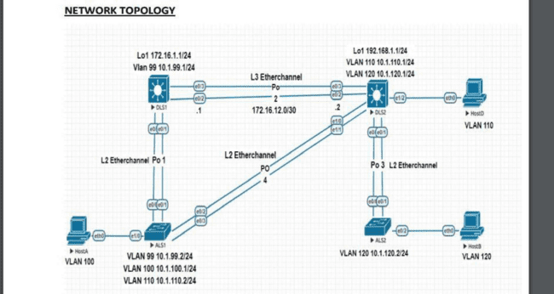

**DLS1 Switch>enable** Switch#conf t Switch(config)#hostname DLS1

DLS1(config)#interface loopback 1

DLS1(config-if)#ip address 172.16.1.1 255.255.255.0 DLS1(config-if)#exit

DLS1(config)#interface vlan 99

DLS1(config-if)#ip address 10.1.99.1 255.255.255.0 DLS1(config-if)#no shutdown

Implement a Layer 3 EtherChannel DLS1(config)#int range e0/2-3 DLS1(config-if-range)#no switchport DLS1(config-if-range)#no ip address

DLS1(config-if-range)#channel-group 2 mode on Creating a port-channel interface Port-channel 2 DLS1(config-if-range)#exit

DLS1(config)#interface port-channel 2

DLS1(config-if)#ip address 172.16.12.1 255.255.255.252 DLS1(config-if)#end

DLS1(config)#int range e0/0-1

DLS1(config-if-range)#switchport trunk encapsulation dot1q DLS1(config-if-range)#switchport mode trunk

DLS1(config-if-range)#channel-group 1 mode desirable Creating a port-channel interface Port- channel 1

DLS1(config-if-range)#end

DLS1#sh interfaces trunk Port Mode Encapsulation Status Native vlan Po1 on 802.1q trunking 1 Port Vlans allowed on trunk Po1 1-4094 Port Vlans allowed and active in management



domain Po1 1,99 Port Vlans in spanning tree forwarding state and not pruned Po1 1,99 Implement Static Routing DLS1(config)#ip routing

DLS1(config)#ip route 192.168.1.0 255.255.255.252 172.16.12.2

DLS1(config)# ip route 192.168.1.0 255.255.255.0 10.1.120.1

DLS1(config)# ip route 192.168.1.0 255.255.255.0 10.1.110.1

DLS1#sh ip route Codes: L - local, C - connected, S - static, R - RIP, M - mobile, B - BGP D - EIGRP, EX - EIGRP external, O - OSPF, IA - OSPF inter area N1 - OSPF NSSA external type 1, N2 - OSPF NSSA external type 2 E1 - OSPF external type 1, E2 - OSPF external type 2 i - IS-IS, su - IS-IS summary, L1 - IS-IS level-1, L2 - IS-IS level-2 ia - IS-IS inter area, * - candidate default, U - per-user static route o - ODR, P - periodic downloaded static route, H - NHRP, l - LISP a - application route + - replicated route, % - next hop override

Gateway of last resort is not set 10.0.0.0/8 is variably subnetted, 2 subnets, 2 masks C 10.1.99.0/24 is directly connected, Vlan99

L 10.1.99.1/32 is directly connected, Vlan99 172.16.0.0/16 is variably subnetted, 4 subnets, 3 masks C 172.16.1.0/24 is directly connected, Loopback1

L 172.16.1.1/32 is directly connected, Loopback1

C 172.16.12.0/30 is directly connected, Port-channel2

L 172.16.12.1/32 is directly connected, Port-channel2 192.168.1.0/30 is subnetted, 1 subnets S 192.168.1.0 [1/0] via 172.16.12.2

DLS2 Switch>en Switch#conf t Switch(config)#hostname DLS2 DLS2(config)#interface loopback 1

DLS2(config-if)#ip address 192.168.1.1 255.255.255.0 DLS2(config-if)#exit

DLS2(config)#interface vlan 110

DLS2(config-if)#ip address 10.1.110.1 255.255.255.0 DLS2(config-if)#no shutdown

DLS2(config-if)#exi

t DLS2(config)#interface vlan 120

DLS2(config-if)#ip address 10.1.120.1 255.255.255.0 DLS2(config-if)#no shutdown

DLS2(config-if)#exit Implement a Layer 3 EtherChannel DLS2(config)#interface range e0/2-3

DLS2(config-if-range)#no switchport DLS2(config-if-range)#no ip DLS2(config-if-range)#no ip address

DLS2(config-if-range)#channel-group 2 mode on Creating a port-channel interface Port-channel 2 DLS2(config-if-range)#exit

DLS2(config)#interface port-channel 2

DLS2(config-if)#ip address 172.16.12.2 255.255.255.252 DLS2(config-if)#end DLS2(config)#interface range e0/0-1 DLS2(config-if-range)#switchport trunk encapsulation dot1q DLS2(config-if-range)#switchport mode trunk

DLS2(config-if-range)#channel-group 3 mode desirable Creating a port-channel interface Port- channel 3

DLS2(config-if-range)#exit DLS2(config)#interface range e1/0-1

DLS2(config-if-range)#switchport trunk encapsulation dot1q DLS2(config-if-range)#switchport mode trunk



DLS2(config-if-range)#channel-group 4 mode desirable Creating a port-channel interface Port- channel 4

DLS2(config-if-range)#end

DLS2#sh interfaces trunk Port Mode Encapsulation Status Native vlan Po3 on 802.1q trunking 1 Po4 on 802.1q trunking 1 Port Vlans allowed on trunk Po3 1-4094 Po4 1-4094 Port Vlans allowed and active in management domain Po3 1,110,120 Po4 1,110,120 Port Vlans in spanning tree forwarding state and not pruned Po3 1,110,120 Po4 1,110,120 Implement Static Routing DLS2(config)#ip routing DLS2(config)#ip route 172.16.1.0 255.255.255.252 172.16.12.1 DLS2(config)# ip route 172.16.1.0 255.255.255.0 10.1.99.1 Configure the host ports for the appropriate VLANs according to the diagram

DLS2(config)#interface e1/2 DLS2(config-if)#switchport mode access

DLS2(config-if)#switchport access vlan 110 DLS2#sh ip route

Codes: L - local, C - connected, S - static, R - RIP, M - mobile, B - BGP D - EIGRP, EX - EIGRP external, O - OSPF, IA - OSPF inter area N1 - OSPF NSSA external type 1, N2 - OSPF NSSA external type 2 E1 - OSPF external type 1, E2 - OSPF external type 2 i - IS-IS, su - IS-IS summary, L1 - IS-IS level-1, L2 - IS-IS level-2 ia - IS-IS inter area, * - candidate default, U - per-user static route o - ODR, P - periodic downloaded static route, H - NHRP, l - LISP a - application route + - replicated route, % - next hop override

Gateway of last resort is not set 10.0.0.0/8 is variably subnetted, 4 subnets, 2 masks C 10.1.110.0/24 is directly connected, Vlan110

L 10.1.110.1/32 is directly connected, Vlan110 C 10.1.120.0/24 is directly connected, Vlan120

L 10.1.120.1/32 is directly connected, Vlan120 172.16.0.0/16 is variably subnetted, 3 subnets, 2 masks S 172.16.1.0/30 [1/0] via 172.16.12.1

C 172.16.12.0/30 is directly connected, Port-channel2

L 172.16.12.2/32 is directly connected, Port-channel2 192.168.1.0/24 is variably subnetted, 2 subnets, 2 masks

C 192.168.1.0/24 is directly connected, Loopback1

L 192.168.1.1/32 is directly connected, Loopback1 ALS1 Switch>en Switch#conf t S

witch(config)#hostname ALS1 ALS1(config)#ip default-gateway 10.1.99.1

ALS1(config)#ip default-gateway 10.1.110.1

ALS1(config)#ip default-gateway 10.1.100.2 Implement a Layer 3 EtherChannel ALS1(config)#int range e0/0-1

ALS1(config-if-range)#switchport trunk encapsulation dot1q ALS1(config-if-range)#switchport mode trunk

ALS1(config-if-range)#channel-group 1 mode desirable Creating a port-channel interface Port- channel 1

ALS1(config-if-range)#exit ALS1(config)#int range e0/2-3

ALS1(config-if-range)#switchport trunk encapsulation dot1q ALS1(config-if-range)#switchport mode trunk

ALS1(config-if-range)#channel-group 4 mode desirable Creating a port-channel interface Port- channel 4

ALS1(config-if-range)#end ALS1#sh etherchannel summary



Flags: D - down P - bundled in port-channel I - stand-alone s - suspended H - Hot-standby (LACP only) R - Layer3 S - Layer2 U - in use N - not in use, no aggregation f - failed to allocate aggregator M - not in use, minimum links not met m - not in use, port not aggregated due to minimum links not met u - unsuitable for bundling w - waiting to be aggregated d - default port A - formed by Auto LAG Number of channel-groups in use: 2

Number of aggregators: 2

Group Port-channel Protocol Ports + + +

- 1 Po1(SU) PAgP Et0/0(P) Et0/1(P) 4 Po4(SU) PAgP Et0/2(P) Et0/3(P)

Configure the host ports for the appropriate VLANs according to the diagram ALS1(config)#interface e1/0

ALS1(config-if)#switchport mode access ALS1(config-if)#switchport access vlan 100 ALS2 Switch>en Switch#conf t Switch(config)#hostname ALS2

ALS2(config)#ip default-gateway 10.1.120.1 Implement a Layer 3 EtherChannel ALS2(config)#int range e0/0-1

ALS2(config-if-range)#switchport trunk encapsulation dot1q ALS2(config-if-range)#switchport mode trunk

ALS2(config-if-range)#channel-group 3 mode desirable Creating a port-channel interface Port- channel 3

ALS2(config-if-range)#end ALS2#sh etherchannel summary

Flags: D - down P - bundled in port-channel I - stand-alone s - suspended H - Hot-standby (LACP only) R - Layer3 S - Layer2 U - in use N - not in use, no aggregation f - failed to allocate aggregator M - not in use, minimum links not met m - not in use, port not aggregated due to minimum links not met u - unsuitable for bundling w - waiting to be aggregated d - default port A - formed by Auto LAG Number of channel-groups in use: 1

Number of aggregators: 1

Group Port-channel Protocol Ports + + +

- 3 Po3(SU) PAgP Et0/0(P) Et0/1(P) Configure the host ports for the appropriate VLANs

according to the diagram ALS2(config)#interface e0/2 ALS2(config-if)#switchport mode access

ALS2(config-if)#switchport access vlan 120 HOST A VPCS> ip 10.1.100.1 255.255.255.0

10.1.100.2 HOST B

VPCS> ip 10.1.120.2 255.255.255.0 10.1.120.1 HOST D

VPCS> ip 10.1.110.2 255.255.255.0 10.1.110.1



### Code:

-

# Practical 8

**Aim:** Simulating an MPLS environment and Simulating VRF.

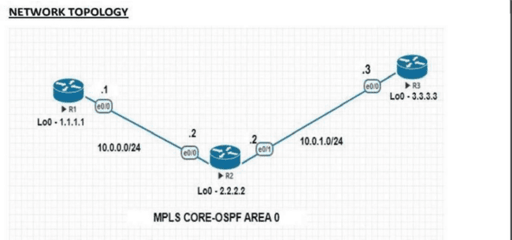

**R1 Router>enable** Router#conf t Router(config)#hostname R1

R1(config)# interface loopback 0

R1(config-if)#ip address 1.1.1.1 255.255.255.255 R1(config-if)#exit R1(config)#int e0/0 R1(config-if)#ip address 10.0.0.1 255.255.255.0 R1(config-if)#no shut

R1(config)#router ospf 1

R1(config-router)#network 1.1.1.0 0.0.0.255 area 0

R1(config-router)#network 10.0.0.0 0.0.0.255 area 0 R1(config-router)#exit R

1#show ip route ospf

Codes: L - local, C - connected, S - static, R - RIP, M - mobile, B - BGP D - EIGRP, EX - EIGRP external, O - OSPF, IA - OSPF inter area N1 - OSPF NSSA external type 1, N2 - OSPF NSSA external type 2 E1 - OSPF external type 1, E2 - OSPF external type 2 i - IS-IS, su - IS-IS summary, L1 - IS-IS level-1, L2 - IS-IS level-2 ia - IS-IS inter area, * - candidate default, U - per-user static route o - ODR, P - periodic downloaded static route, H - NHRP, l - LISP a - application route + - replicated route, % - next hop override

Gateway of last resort is not set

2.0.0.0/32 is subnetted, 1 subnets O 2.2.2.2 [110/11] via 10.0.0.2, 00:15:40, Ethernet0/0 3.0.0.0/32 is subnetted, 1 subnets

O 3.3.3.3 [110/21] via 10.0.0.2, 00:04:01, Ethernet0/0 10.0.0.0/8 is variably subnetted, 3

subnets, 2 masks

O 10.0.1.0/24 [110/20] via 10.0.0.2, 00:09:25, Ethernet0/0

R1#sh ip cef Prefix Next Hop Interface 0.0.0.0/0 no route 0.0.0.0/8 drop 0.0.0.0/32 receive 1.1.1.1/32 receive Loopback0 2.2.2.2/32 10.0.0.2



Ethernet0/0 3.3.3.3/32 10.0.0.2 Ethernet0/0 10.0.0.0/24 attached Ethernet0/0 10.0.0.0/32 receive Ethernet0/0 10.0.0.1/32 receive Ethernet0/0 10.0.0.2/32 attached Ethernet0/0 10.0.0.255/32 receive Ethernet0/0 10.0.1.0/24 10.0.0.2

Ethernet0/0 127.0.0.0/8 drop 224.0.0.0/4 drop 224.0.0.0/24 receive 240.0.0.0/4 drop 255.255.255.255/32 receive

R1#sh ip route 2.2.2.2

Routing entry for 2.2.2.2/32 Known via "ospf 1", distance 110, metric 11, type intra area Last update from 10.0.0.2 on Ethernet0/0, 00:30:34 ago Routing Descriptor Blocks: * 10.0.0.2, from 2.2.2.2, 00:30:34 ago, via Ethernet0/0 Route metric is 11, traffic share count is 1 R1#sh ip route

3.3.3.3 Routing entry for 3.3.3.3/32 Known via "ospf 1", distance 110, metric 21, type intra area Last update from 10.0.0.2 on Ethernet0/0, 00:11:43 ago Routing Descriptor Blocks: * 10.0.0.2, from 3.3.3.3, 00:11:43 ago, via Ethernet0/0 Route metric is 21, traffic share count is 1 R1#sh ip cef 2.2.2.2 2.2.2.2/32 nexthop 10.0.0.2 Ethernet0/0

R1#sh ip cef 3.3.3.3 3.3.3.3/32 nexthop 10.0.0.2 Ethernet0/0 R1(config)#mpls label range 100 199

R1(config)#mpls label protocol ldp R1(config)#mpls ldp router-id loopback 0 R1(config)#int e0/0

R1(config-if)#mpls ip

R1#sh mpls interfaces Interface IP Tunnel BGP Static Operational Ethernet0/0 Yes (ldp) No No No Yes

R1#sh mpls ldp neighbor Peer LDP Ident: 2.2.2.2:0; Local LDP Ident 1.1.1.1:0 TCP connection: 2.2.2.2.27963 - 1.1.1.1.646 State: Oper; Msgs sent/rcvd: 13/14; Downstream Up time: 00:05:21 LDP discovery sources: Ethernet0/0, Src IP addr: 10.0.0.2 Addresses bound to peer LDP Ident:

10.0.0.2 10.0.1.2 2.2.2.2

R1#sh ip cef 3.3.3.3 3.3.3.3/32 nexthop 10.0.0.2 Ethernet0/0 label 201 R1#sh ip cef 2.2.2.2 2.2.2.2/32 nexthop 10.0.0.2 Ethernet0/0

R1#sh mpls forwarding-table

Local Outgoing Prefix Bytes Label Outgoing Next Hop Label Label or Tunnel Id Switched interface 100 Pop Label 2.2.2.2/32 0 Et0/0 10.0.0.2 101 201 3.3.3.3/32 0 Et0/0 10.0.0.2 102 Pop

Label 10.0.1.0/24 0 Et0/0 10.0.0.2

R1#sh mpls ldp bindings lib entry: 1.1.1.1/32, rev 2 local binding: label: imp-null

remote binding: lsr: 2.2.2.2:0, label: 200

lib entry: 2.2.2.2/32, rev 4 local binding: label: 100 remote binding: lsr: 2.2.2.2:0, label: imp- null

lib entry: 3.3.3.3/32, rev 6 local binding: label: 101 remote binding: lsr: 2.2.2.2:0, label: 201 lib entry: 10.0.0.0/24, rev 8 local binding: label: imp-null remote binding: lsr: 2.2.2.2:0, label: imp-null lib entry: 10.0.1.0/24, rev 10 local binding: label: 102 remote binding: lsr: 2.2.2.2:0, label: imp-null

R1#ping 3.3.3.3 source 10.0.0.1

Type escape sequence to abort. Sending 5, 100-byte ICMP Echos to 3.3.3.3, timeout is 2 seconds:

Packet sent with a source address of 10.0.0.1 !!!!! Success rate is 100 percent (5/5), round-trip min/avg/max = 1/1/2 ms

R1#traceroute 3.3.3.3 source 10.0.0.1 Type escape sequence to abort.

Tracing the route to 3.3.3.3 VRF info: (vrf in name/id, vrf out name/id) 1 10.0.0.2 [MPLS: Label 201 Exp 0] 1 msec 1 msec 0 msec 2 10.0.1.3 1 msec 2 msec



* R1#ping 2.2.2.2 source 10.0.0.1 Type escape sequence to abort. Sending 5, 100-byte ICMP Echos to 2.2.2.2, timeout is 2 seconds:

Packet sent with a source address of 10.0.0.1 !!!!!

Success rate is 100 percent (5/5), round-trip min/avg/max = 5/5/6 ms R1#traceroute 2.2.2.2 source 10.0.0.1 Type escape sequence to abort.

Tracing the route to 2.2.2.2 VRF info: (vrf in name/id, vrf out name/id) 1 10.0.0.2 2 msec 1 msec

**\* R2** Router>enable Router#conf t

Router(config)#hostname R2 R2(config)# interface loopback 0

R2(config-if)#ip address 2.2.2.2 255.255.255.255 R2(config-if)# exit

R2(config)#int e0/0

R2(config-if)#ip address 10.0.0.2 255.255.255.0 R2(config-if)#no shut R2(config)#int e0/1

R2(config-if)#ip address 10.0.1.2 255.255.255.0 R2(config-if)#no shut

R2(config)#router ospf 1

R2(config-router)#network 2.2.2.0 0.0.0.255 area 0

R2(config-router)#network 10.0.0.0 0.0.0.255 area 0 R2(config-router)#network 10.0.1.0

0.0.0.255 area 0

R2(config-router)#exit R2#show ip route

ospf Codes: L - local, C - connected, S - static, R - RIP, M - mobile, B - BGP D - EIGRP, EX - EIGRP external, O - OSPF, IA - OSPF inter area N1 - OSPF NSSA external type 1, N2 - OSPF NSSA external type 2 E1 - OSPF external type 1, E2 - OSPF external type 2 i - IS-IS, su - IS-IS summary, L1 - IS-IS level-1, L2 - IS-IS level-2 ia - IS-IS inter area, * - candidate default, U - per-user static route o - ODR, P - periodic downloaded static route, H - NHRP, l - LISP a - application route + - replicated route, % - next hop override

Gateway of last resort is not set

1.0.0.0/32 is subnetted, 1 subnets O 1.1.1.1 [110/11] via 10.0.0.1, 00:15:32, Ethernet0/0

3.0.0.0/32 is subnetted, 1 subnets O 3.3.3.3 [110/11] via 10.0.1.3, 00:03:58, Ethernet0/1 R2#sh ip cef Prefix Next Hop Interface 0.0.0.0/0 no route 0.0.0.0/8 drop 0.0.0.0/32 receive 1.1.1.1/32 10.0.0.1 Ethernet0/0 2.2.2.2/32

receive Loopback0 3.3.3.3/32 10.0.1.3 Ethernet0/1 10.0.0.0/24 attached Ethernet0/0 10.0.0.0/32 receive Ethernet0/0 10.0.0.1/32 attached Ethernet0/0 10.0.0.2/32

receive Ethernet0/0 10.0.0.255/32

receive Ethernet0/0 10.0.1.0/24 attached Ethernet0/1 10.0.1.0/32 receive Ethernet0/1 10.0.1.2/32

receive Ethernet0/1 10.0.1.3/32 attached Ethernet0/1 10.0.1.255/32 r eceive Ethernet0/1 127.0.0.0/8 drop 224.0.0.0/4 drop 224.0.0.0/24 receive 240.0.0.0/4 drop 255.255.255.255/32 receive

R2#sh ip route 1.1.1.1

Routing entry for 1.1.1.1/32 Known via "ospf 1", distance 110, metric 11, type intra area Last update from 10.0.0.1 on Ethernet0/0, 00:33:11 ago

Routing Descriptor Blocks: * 10.0.0.1, from 1.1.1.1, 00:33:11 ago, via Ethernet0/0 Route metric is 11, traffic share count is 1



R2#sh ip route 3.3.3.3

Routing entry for 3.3.3.3/32 Known via "ospf 1", distance 110, metric 11, type intra area Last update from 10.0.1.3 on Ethernet0/1, 00:21:49 ago R

outing Descriptor Blocks: * 10.0.1.3, from 3.3.3.3, 00:21:49 ago, via Ethernet0/1 Route metric is 11, traffic share count is 1

R2#sh ip cef 1.1.1.1 1.1.1.1/32 nexthop 10.0.0.1 Ethernet0/0 R2#sh ip cef 3.3.3.3 3.3.3.3/32 nexthop 10.0.1.3 Ethernet0/1

R2(config)#mpls label range 200 299 R2(config)#mpls label protocol ldp R2(config)#mpls ldp router-id loopback 0 R2(config)#int e0/0

R2(config-if)#mpls ip R2(config-if)#int e0/1 R2(config-if)#mpls ip R2#sh mpls interfaces

Interface IP Tunnel BGP Static Operational Ethernet0/0 Yes (ldp) No No No Yes Ethernet0/1 Yes (ldp) No No No Yes

R2#sh mpls forwarding-table

Local Outgoing Prefix Bytes Label Outgoing Next Hop Label Label or Tunnel Id Switched interface 200 Pop Label 1.1.1.1/32 0 Et0/0 10.0.0.1 201 Pop Label 3.3.3.3/32 1266 Et0/1

10.0.1.3

R2#sh mpls ldp neighbor

Peer LDP Ident: 1.1.1.1:0; Local LDP Ident 2.2.2.2:0 TCP connection: 1.1.1.1.646 - 2.2.2.2.27963 State: Oper; Msgs sent/rcvd: 41/42; Downstream Up time: 00:29:24 LDP discovery sources: Ethernet0/0, Src IP addr: 10.0.0.1 Addresses bound to peer LDP Ident:

10.0.0.1 1.1.1.1 Peer LDP Ident: 3.3.3.3:0; Local LDP Ident 2.2.2.2:0 TCP connection: 3.3.3.3.44196 - 2.2.2.2.646 State: Oper; Msgs sent/rcvd: 38/38; Downstream Up time: 00:27:24 LDP discovery sources: Ethernet0/1, Src IP addr: 10.0.1.3 Addresses bound to peer LDP Ident:

10.0.1.3 3.3.3.3

R2#sh mpls ldp bindings

lib entry: 1.1.1.1/32, rev 2 local binding: label: 200 remote binding: lsr: 1.1.1.1:0, label: imp- null remote binding: lsr: 3.3.3.3:0, label: 300

lib entry: 2.2.2.2/32, rev 4 local binding: label: imp-null remote binding: lsr: 1.1.1.1:0, label: 100 remote binding: lsr: 3.3.3.3:0, label: 301

lib entry: 3.3.3.3/32, rev 6 local binding: label: 201 remote binding: lsr: 1.1.1.1:0, label: 101 remote binding: lsr: 3.3.3.3:0, label: imp-null

lib entry: 10.0.0.0/24, rev 8 local binding: label: imp-null remote binding: lsr: 1.1.1.1:0, label: imp-null remote binding: lsr: 3.3.3.3:0, label: 302

lib entry: 10.0.1.0/24, rev 10 local binding: label: imp-null remote binding: lsr: 1.1.1.1:0, label: 102 remote binding: lsr: 3.3.3.3:0, label: imp-null

R2#ping 1.1.1.1 source 10.0.0.2

Type escape sequence to abort. Sending 5, 100-byte ICMP Echos to 1.1.1.1, timeout is 2 seconds:

Packet sent with a source address of 10.0.0.2 !!!!!

Success rate is 100 percent (5/5), round-trip min/avg/max = 1/1/1 ms

R2#traceroute 1.1.1.1 source 10.0.0.2 Type escape sequence to abort. Tracing the route to 1.1.1.1

VRF info: (vrf in name/id, vrf out name/id) 1 10.0.0.1 2 msec 1 msec *



R2#ping 3.3.3.3 source 10.0.1.2 Type escape sequence to abort. Sending 5, 100-byte ICMP Echos to 3.3.3.3, timeout is 2 seconds:

Packet sent with a source address of 10.0.1.2 !!!!! Success rate is 100 percent (5/5), round-trip min/avg/max = 1/1/1 ms

R2#traceroute 3.3.3.3 source 10.0.1.2 Type escape sequence to abort. Tracing the route to

3.3.3.3 VRF info: (vrf in name/id, vrf out name/id) 1 10.0.1.3 0 msec 1 msec * R3

Router>enable Router#conf t Router(config)#hostname R

3 R3(config)#interface loopback 0

R3(config-if)#ip address 3.3.3.3 255.255.255.255 R3(config-if)#exit

R3(config)#int e0/0

R3(config-if)#ip address 10.0.1.3 255.255.255.0 R3(config-if)#no shu

t R3(config-if)#exit R3(config)#router ospf 1

R3(config-router)#network 3.3.3.0 0.0.0.255 area 0

R3(config-router)#network 10.0.1.0 0.0.0.255 area 0 R3(config-router)#exit

R3#sh ip route osp

f Codes: L - local, C - connected, S - static, R - RIP, M - mobile, B - BGP D - EIGRP, EX - EIGRP external, O - OSPF, IA - OSPF inter area N1 - OSPF NSSA external type 1, N2 - OSPF NSSA external type 2 E1 - OSPF external type 1, E2 - OSPF external type 2 i - IS-IS, su - IS-IS summary,

L1 - IS-IS level-1, L2 - IS-IS level-2 ia - IS-IS inter area, * - candidate default, U - per-user static route o - ODR, P - periodic downloaded static route, H - NHRP, l - LISP a - application route + - replicated route, % - next hop override

Gateway of last resort is not set

1.0.0.0/32 is subnetted, 1 subnets O 1.1.1.1 [110/21] via 10.0.1.2, 00:03:45,

Ethernet0/0 2.0.0.0/32 is subnetted, 1 subnets O 2.2.2.2 [110/11] via 10.0.1.2, 00:03:45, Ethernet0/0 10.0.0.0/8 is variably subnetted, 3 subnets, 2 masks O 10.0.0.0/24 [110/20] via 10.0.1.2, 00:03:45,

Ethernet0/0

R3#sh ip cef Prefix

Next Hop Interface 0.0.0.0/0 no route 0.0.0.0/8 drop 0.0.0.0/32 receive 1.1.1.1/32 10.0.1.2 Ethernet0/0 2.2.2.2/32 10.0.1.2 Ethernet0/0 3.3.3.3/32 receive Loopback0 10.0.0.0/24 10.0.1.2 Ethernet0/0 10.0.1.0/24 attached

Ethernet0/0 10.0.1.0/32 receive Ethernet0/0 10.0.1.2/32 attached Ethernet0/0 10.0.1.3/32 receive Ethernet0/0 10.0.1.255/32 receive

Ethernet0/0 127.0.0.0/8 drop 224.0.0.0/4 drop 224.0.0.0/24 receive 240.0.0.0/4 drop 255.255.255.255/32 receive

R3#sh ip route 1.1.1.1

Routing entry for 1.1.1.1/32 Known via "ospf 1", distance 110, metric 21, type intra area Last update from 10.0.1.2 on Ethernet0/0, 00:23:51 ago Routing Descriptor Blocks: * 10.0.1.2, from 1.1.1.1, 00:23:51 ago, via Ethernet0/0 Route metric is 21, traffic share count is 1

R3#sh ip route 2.2.2.2 Routing entry for 2.2.2.2/32 Known via "ospf 1", distance 110, metric 11, type intra area Last update from 10.0.1.2 on Ethernet0/0, 00:23:58 ago Routing Descriptor



Blocks: * 10.0.1.2, from 2.2.2.2, 00:23:58 ago, via Ethernet0/0 Route metric is 11, traffic share count is 1

R3#sh ip cef 1.1.1.1 1.1.1.1/32 nexthop 10.0.1.2 Ethernet0/0 R3#sh ip cef 2.2.2.2 2.2.2.2/32 nexthop 10.0.1.2 Ethernet0/0 R3(config)#mpls label range 300 399

R3(config)#mpls lab el protocol ldp

R3(config)#mpls ldp router-id loopback 0 R3(config)#int e0/0

R3(config-if)#mpls ip R3#sh mpls interfaces Interface IP Tunnel BGP Static Operational Ethernet0/0 Yes (ldp) No No No Yes R3#sh mpls ldp binding

lib entry: 1.1.1.1/32, rev 2 local binding: label: 300 remote binding: lsr: 2.2.2.2:0, label: 200 lib entry: 2.2.2.2/32, rev 4 local

binding: label: 301 remote binding: lsr: 2.2.2.2:0, label: imp-null lib entry: 3.3.3.3/32, rev 6 local binding: label: imp-null remote binding: lsr: 2.2.2.2:0, label: 201 lib entry: 10.0.0.0/24,

rev 8 local binding: label: 302 remote binding: lsr: 2.2.2.2:0, label: imp-null lib entry: 10.0.1.0/24,

rev 10 local binding: label: imp-null remote binding: lsr: 2.2.2.2:0, label: imp-null R3#sh mpls ldp neighbor Peer LDP Ident: 2.2.2.2:0; Local LDP Ident 3.3.3.3:0 TCP connection: 2.2.2.2.646 - 3.3.3.3.44196 State: Oper; Msgs sent/rcvd: 51/51; Downstream Up time: 00:38:15

LDP discovery sources:

Ethernet0/0, Src IP addr: 10.0.1.2 Addresses bound to peer LDP Ident: 10.0.0.2 10.0.1.2 2.2.2.2 R3#sh mpls forwarding-table

Local Outgoing Prefix Bytes

Label Outgoing Next Hop Label Label or Tunnel Id Switched interface 300 200 1.1.1.1/32 0 Et0/0 10.0.1.2 301 Pop Label 2.2.2.2/32 0 Et0/0 10.0.1.2 302 Pop Label 10.0.0.0/24 0 Et0/0

10.0.1.2

R3#sh ip cef 1.1.1.1 1.1.1.1/32 nexthop 10.0.1.2 Ethernet0/0 label 200 R3#sh ip cef 2.2.2.2 2.2.2.2/32 nexthop 10.0.1.2 Ethernet0/0

R3#ping 1.1.1.1 source 10.0.1.3 Type escape sequence to abort.

Sending 5, 100-byte ICMP Echos to 1.1.1.1, timeout is 2 seconds: Packet sent with a source address of 10.0.1.3 !!!!!

Success rate is 100 percent (5/5), round-trip min/avg/max = 1/1/3 ms R3#traceroute 1.1.1.1 source 10.0.1.3

Type escape sequence to abort. Tracing the route to 1.1.1.1 VRF info:

(vrf in name/id, vrf out name/id) 1 10.0.1.2 [MPLS: Label 200 Exp 0] 1 msec 2 msec 1 msec 2

10.0.0.1 2 msec 2 msec *

R3#ping 2.2.2.2 source 10.0.1.3 Type escape sequence to abort. Sending 5, 100-byte ICMP Echos to 2.2.2.2, timeout is 2 seconds: Packet sent with a source address of 10.0.1.3 !!!!!

Success rate is 100 percent (5/5), round-trip min/avg/max = 1/1/1 ms R3#traceroute 2.2.2.2

source 10.0.1.3

Type escape sequence to abort. Tracing the route to 2.2.2.2



# Practical 9

**Aim:** - Simulating SDN with

 Open Daylight SDN Controller with the Mininet Network Emulator  OF Net SDN network emulator

### Code:

**-**

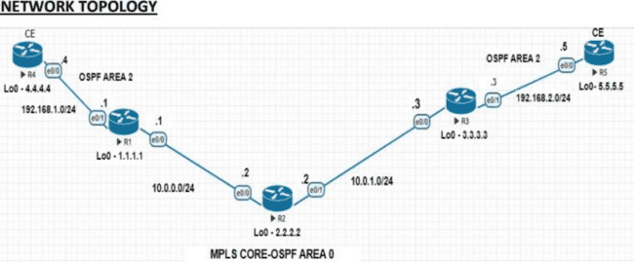

R1

Router>enable Router#conf t

Router(config)#hostname R1 R1(config)# interface loopback 0

R1(config-if)#ip address 1.1.1.1 255.255.255.255 R1(config-if)#exit

R1(config)#int e0/0

R1(config-if)#ip address 10.0.0.1 255.255.255.0 R1(config-if)#no shut

R1(config)#int e0/1

R1(config-if)#ip address 192.168.1.1 255.255.255.0 R1(config-if)#no shut

R1(config)#router ospf 1

R1(config-router)#network 1.1.1.0 0.0.0.255 area 0

R1(config-router)#network 10.0.0.0 0.0.0.255 area 0 R1(config-router)#exit

R1(config)#mpls label range 100 199 R1(config)#mpls label protocol ldp R1(config)#mpls ldp router-id loopback 0 R1(config)#int e0/0

R1(config-if)#mpls ip R1(config)#ip vrf A-1 R1(config-vrf)#rd 500:1

R1(config-vrf)#route-target import 500:1

R1(config-vrf)#route-target export 500:1 R1(config-vrf)#exit

R1(config)#exit

R1#sh ip vrf Name Default RD Interfaces A-1 500:1 R1#sh ip vrf detail VRF A-1 (VRF Id = 1);



default RD 500:1;

default VPNID Old CLI format, supports IPv4 only Flags: 0xC No interfaces Address family ipv4 unicast (Table ID = 0x1): Flags: 0x0 Export VPN route-target communities RT:500:1 Import VPN route-target communities RT:500:1 No import route-map No global export route- map No export route-map VRF label distribution protocol: not configured VRF label allocation mode: per-prefix

R1(config)#int e0/1

R1(config-if)#ip vrf forwarding A-1 % Interface Ethernet0/1 IPv4 disabled and address(es) removed due to enabling VRF A-1 R1(config-if)#ip address 192.168.1.1 255.255.255.0 R1(config-if)#end

R1#sh ip route vrf A-1

Routing Table: A-1 Codes: L - local, C - connected, S - static, R - RIP, M - mobile, B - BGP D - EIGRP, EX - EIGRP external, O - OSPF, IA - OSPF inter area N1 - OSPF NSSA external type 1, N2 - OSPF NSSA external type 2 E1 - OSPF external type 1, E2 - OSPF external type 2 i -

IS-IS, su - IS-IS

summary,

L1 - IS-IS level-1, L2 - IS-IS level-2 ia - IS-IS inter area, * - candidate default, U - per-user static route o - ODR, P - periodic downloaded static route, H - NHRP, l - LISP a - application route + - replicated route, % - next hop override

Gateway of last resort is not set

192.168.1.0/24 is variably subnetted, 2 subnets, 2 masks C 192.168.1.0/24 is directly connected, Ethernet0/1

L 192.168.1.1/32 is directly connected, Ethernet0/1 R1#sh ip vrf Name Default RD Interfaces A-1 500:1 Et0/1 R1(config)#router ospf 10 vrf A-1

R1(config-router)#network 192.168.1.0 0.0.0.255 area 10 R1(config-router)#end

R1#sh ip ospf neighbor Neighbor ID Pri State Dead Time Address In

terface 2.2.2.2 1 FULL/DR 00:00:39 10.0.0.2 Ethernet0/0 4.4.4.4 1 FULL/DR 00:00:38

192.168.1.4 Ethernet0/1 R1#sh ip ospf 10 neighbor Neighbor ID Pri State Dead Time Address Interface 4.4.4.4 1 FULL/DR 00:00:38 192.168.1.4 Ethernet0/1

R1#sh ip route vrf A-1 ospf

Routing Table: A-1 Codes: L - local, C - connected, S - static, R - RIP, M - mobile, B - BGP D - EIGRP, EX - EIGRP external, O - OSPF, IA - OSPF inter area N1 - OSPF NSSA external type 1, N2 - OSPF NSSA external type 2 E1 - OSPF external type 1, E2 - OSPF external type 2 i -

IS-IS, su - IS-IS

summary,

L1 - IS-IS level-1,

L2 - IS-IS level-2 ia - IS-IS inter area,

* - candidate default,

U - per-user static route o  ODR

, P - periodic downloaded static route, H - NHRP, l - LISP a - application route + - replicated route,

% - next hop override Gateway of last resort is not set 4.0.0.0/32 is subnetted, 1 subnets O

4.4.4.4 [110/11] via 192.168.1.4, 00:03:58, Ethernet0/1 R1(config)#router bgp 500 R1(config-router)#no bgp default ipv4-unicast

R1(config-router)#neighbor 3.3.3.3 remote-as 500

R1(config-router)#neighbor 3.3.3.3 update-source loopback 0 R1(config-router)#address-family vpnv4 unicast



R1(config-router-af)#neighbor 3.3.3.3 activate R1(config-router-af)#neighbor 3.3.3.3 send- community extended R1(config-router-af)#neighbor 3.3.3.3 next-hop-self R1(config-router- af)#end

R1#sh ip bgp vpnv4 all summary

BGP router identifier 1.1.1.1, local AS number 500 BGP table version is 1, main routing table version 1 Neighbor V AS MsgRcvd MsgSent TblVer InQ OutQ Up/Down State/PfxRcd 3.3.3.3 4 500 6 7 1 0 0 00:03:19 0

R1(config)#router bgp 500

R1(config-router)#address-family ipv4 vrf A-1

R1(config-router-af)#redistribute ospf 10 vrf A-1 match internal external 1 external 2 R1(config-router-af)#exit R1(config-router)#exit

R1(config)#router ospf 10 vrf A-1

R1(config-router)#redistribute bgp 500 subnets

R1(config-router)#end R1#sh ip bgp vpnv4 all BGP table version is 7, local router ID is 1.1.1.1 Status codes: s suppressed, d damped, h history, * valid, > best, i - internal, r RIB-failure, S Stale, m multipath, b backup-path, f RT-Filter, x best-external, a additional-path, c RIB- compressed, Origin codes: i - IGP, e - EGP, ? - incomplete RPKI validation codes: V valid, I invalid, N Not found

Network Next Hop Metric LocPrf Weight Path Route Distinguisher: 500:1 (default for vrf A-1)

*> 4.4.4.4/32 192.168.1.4 11 32768 ?

*>i 5.5.5.5/32 3.3.3.3 11 100 0 ?

*> 192.168.1. 0 0.0.0.0 0 32768 ?

*>i 192.168.2.0 3.3.3.3

R1#sh ip route vrf A-1

0 100 0 ?

Routing Table: A-1 Codes: L - local, C - connected, S - static, R - RIP, M - mobile, B - BGP D - EIGRP, EX - EIGRP external, O - OSPF, IA - OSPF inter area N1 - OSPF NSSA external type 1, N2 - OSPF NSSA external type 2 E1 - OSPF external type 1, E2 - OSPF external type 2 i -

IS-IS, su - IS-IS

summary,

L1 - IS-IS level-1, L2 - IS-IS level-2 ia - IS-IS inter area, * - candidate default, U - per-user static route o - ODR, P - periodic downloaded static route, H - NHRP, l - LISP a - application route + - replicated route, % - next hop override

Gateway of last resort is not set

4.0.0.0/32 is subnetted, 1 subnets O 4.4.4.4 [110/11] via 192.168.1.4, 07:36:09, Ethernet0/1

5.0.0.0/32 is subnetted, 1 subnets B 5.5.5.5 [200/11] via 3.3.3.3, 00:06:15 192.168.1.0/24 is

variably subnetted, 2 subnets, 2 masks

C 192.168.1.0/24 is directly connected, Ethernet0/1 L 192.168.1.1/32 is directly connected, Ethernet0/1 B 192.168.2.0/24 [200/0] via 3.3.3.3, 00:06:15

R1#sh ip route vrf A-1 bgp

Routing Table: A-1 Codes: L - local, C - connected, S - static, R - RIP, M - mobile, B - BGP D

- EIGRP, EX - EIGRP external, O - OSPF, IA - OSPF inter area N1 - OSPF NSSA external type 1, N2 - OSPF NSSA external type 2 E1 - OSPF external type 1, E2 - OSPF external type 2 i -

IS-IS, su - IS-IS summary, L1 - IS-IS level-1, L2 - IS-IS level-2 ia - IS-IS inter area, * - candidate default, U - per-user static route o - ODR, P - periodic downloaded static route, H - NHRP, l - LISP a - application route + - replicated route, % - next hop override

Gateway of last resort is not set 5.0.0.0/32 is subnetted, 1 subnets B 5.5.5.5 [200/11] via 3.3.3.3, 00:07:31 B 192.168.2.0/24 [200/0] via 3.3.3.3, 00:07:31

R1#ping vrf A-1 4.4.4.4



Type escape sequence to abort.

Sending 5, 100-byte ICMP Echos to 4.4.4.4, timeout is 2 seconds: !!!!! Success rate is 100 percent (5/5), round-trip min/avg/max = 1/2/6 ms R2

Router>enable Router#conf t

Router(config)#hostname R2 R2(config)# interface loopback 0

R2(config-if)#ip address 2.2.2.2 255.255.255.255 R2(config-if)# exit

R2(config)#int e0/0

R2(config-if)#ip address 10.0.0.2 255.255.255.0 R2(config-if)#no shut

R2(config)#int e0/1

R2(config-if)#ip address 10.0.1.2 255.255.255.0 R2(config-if)#no shut

R2(config)#router ospf 1

R2(config-router)#network 2.2.2.0 0.0.0.255 area 0

R2(config-router)#network 10.0.0.0 0.0.0.255 area 0

R2(config-router)#network 10.0.1.0 0.0.0.255 area 0 R2(config-router)#exit

R2(config)#mpls label range 200 299 R2(config)#mpls label protocol ldp R2(config)#mpls ldp router-id loopback 0

R2(config)#int e0/0 R2(config-if)#mpls ip R2(config-if)#int e0/1

R2(config-if)#mpls ip R3

Router>enable Router#conf t Router(config)#hostname

R3

R3(config)#interface loopback 0

R3(config-if)#ip address 3.3.3.3 255.255.255.255 R3(config-if)#exit

R3(config)#int e0/0

R3(config-if)#ip address 10.0.1.3 255.255.255.0 R3(config-if)#no shut

R3(config-if)#exit R3(config)#interface e0/1

R3(config-if)#ip address 192.168.2.3 255.255.255.0 R3(config-if)#no shut

R3(config-if)#exit R3(config)#router ospf 1

R3(config-router)#network 3.3.3.0 0.0.0.255 area 0

R3(config-router)#network 10.0.1.0 0.0.0.255 area 0



R3(config-router)#exit R3(config)#mpls label range 300 399 R3(config)#mpls label protocol ldp

R3(config)#mpls ldp router-id loopback 0 R3(config)#int e0/0

R3(config-if)#mpls ip R3(config)#ip vrf A-2 R3(config-vrf)#rd 500:1

R3(config-vrf)#route-target import 500:1

R3(config-vrf)#route-target export 500:1

R3#sh ip vrf Name Default RD Interfaces A-2 500:1 R3#sh ip vrf detail

VRF A-2 (VRF Id = 1);

default RD 500:1; default VPNID Old CLI format, supports IPv4 only Flags: 0xC No interfaces Address family ipv4 unicast (Table ID = 0x1): Flags: 0x0 Export VPN route-target communities RT:500:1 Import VPN route-target communities RT:500:1 No import route-map No global export route-map No export route-map VRF label distribution protocol: not configured VRF label allocation mode: per-prefix R3(config)#int e0/1 R3(config-if)#ip vrf forwarding A-2 % Interface Ethernet0/1 IPv4 disabled and address(es) removed due to enabling VRF A-2 R3(config-if)#ip address 192.168.2.3 255.255.255.0

R3(config-if)#end

R3#sh ip route vrf A-2 Routing Table: A-2

Codes: L - local, C - connected, S - static, R - RIP, M - mobile, B - BGP D - EIGRP, EX - EIGRP external, O - OSPF, IA - OSPF inter area N1 - OSPF NSSA external type 1, N2 - OSPF NSSA external type 2 E1 - OSPF external type 1, E2 - OSPF external type 2 i - IS-IS, su - IS-IS summary, L1 - IS-IS level-1, L2 - IS-IS level-2 ia - IS-IS inter area, * - candidate default, U - per-user static route o - ODR, P - periodic downloaded static route, H - NHRP, l - LISP a - application route + - replicated route, % - next hop override

Gateway of last resort is not set

192.168.2.0/24 is variably subnetted, 2 subnets, 2 masks C 192.168.2.0/24 is directly connected, Ethernet0/1 L 192.168.2.3/32 is directly connected,

Ethernet0/1

R3#sh ip vrf Name Default RD Interfaces A-2 500:1 Et0/1 R3(config)#router ospf 10 vrf A-2

R3(config-router)#network 192.168.2.0 0.0.0.255 area 0 R3(config-router)#end R3#sh ip ospf 10 neighbor Neighbor ID Pri State Dead Time Address Interface 5.5.5.5 1 FULL/DR 00:00:33 192.168.2.5 Ethernet0/1

R3#sh ip route vrf A-2 ospf Routing Table: A-2

Codes: L - local, C - connected, S - static, R - RIP, M - mobile, B - BGP D - EIGRP, EX - EIGRP external, O - OSPF, IA - OSPF inter area N1 - OSPF NSSA external type 1, N2 - OSPF NSSA external type 2 E1 - OSPF external type 1, E2 - OSPF external type 2 i - IS-IS, su - IS-IS



summary, L1 - IS-IS level-1, L2 - IS-IS level-2 ia - IS-IS inter area, * - candidate default, U - per-user static route o - ODR, P - periodic downloaded static route, H - NHRP, l - LISP a - application route + - replicated route, % - next hop override

Gateway of last resort is not set

5.0.0.0/32 is subnetted, 1 subnets O 5.5.5.5 [110/11] via 192.168.2.5, 00:06:37, Ethernet0/1

R3(config)#router bgp 500

R3(config-router)#no bgp default ipv4-unicast R3(config-router)#neighbor 1.1.1.1 remote-as 500

R3(config-router)#neighbor 1.1.1.1 update-source loopback 0 R3(config-router)#address-family vpnv4 unicast

R3(config-router-af)#neighbor 1.1.1.1 activate

R3(config-router-af)#neighbor 1.1.1.1 send-community extended R3(config-router-af)#neighbor 1.1.1.1 next-hop-self

R3#sh ip bgp vpnv4 all summary

BGP router identifier 3.3.3.3, local AS number 500 BGP table version is 1, main routing table version 1 Neighbor V AS MsgRcvd MsgSent TblVer InQ OutQ Up/Down State/PfxRcd 1.1.1.1 4 500 7 6 1 0 0 00:03:01

R3(config)#router bgp 500

R3(config-router)#address-family ipv4 vrf A-2

R3(config-router-af)#redistribute ospf 10 vrf A-2 match internal external 1 external 2 R3(config-router-af)#exit R

3(config-router)#exit R3(config)#router ospf 10 vrf A-2

R3(config-router)#redistribute bgp 500 subnets R3(config-router)#end

R3#sh ip bgp vpnv4 all

BGP table version is 7, local router ID is 3.3.3.3

Status codes: s suppressed, d damped, h history, * valid, > best, i - internal, r RIB-failure, S Stale, m multipath, b backup-path, f RT-Filter, x best-external, a additional-path, c RIB- compressed, Origin codes: i - IGP, e - EGP, ? - incomplete RPKI validation codes: V valid, I invalid, N Not found

Network Next Hop Metric LocPrf Weight Path Route Distinguisher: 500:1 (default for vrf A-2)

|  |  |  |
| --- | --- | --- |
| *>i 4.4.4.4/32 1.1.1.1 | 11 | 100 0 ? |
| *> 5.5.5.5/32 192.168.2.5 | 11 | 32768 ? |
| *>i 192.168.1.0 1.1.1.1 | 0 | 100 0 ? |
| *> 192.168.2.0 0.0.0.0 | 0 | 32768 ? |
| R3#sh ip route vrf A-2 Routing Table: A-2 |  |  |

Codes: L - local, C - connected, S - static, R - RIP, M - mobile, B - BGP D - EIGRP, EX - EIGRP external, O - OSPF, IA - OSPF inter area N1 - OSPF NSSA external type 1, N2 - OSPF



NSSA external type 2 E1 - OSPF external type 1, E2 - OSPF external type 2 i - IS-IS, su - IS-IS summary, L1 - IS-IS level-1, L2 - IS-IS level-2 ia - IS-IS inter area, * - candidate default, U - per-user static route o - ODR, P - periodic downloaded static route, H - NHRP, l - LISP a - application route + - replicated route, % - next hop override

Gateway of last resort is not set

4.0.0.0/32 is subnetted, 1 subnets B 4.4.4.4 [200/11] via 1.1.1.1, 00:55:23 5.0.0.0/32 is

subnetted, 1 subnets O 5.5.5.5 [110/11] via 192.168.2.5, 01:50:21,

Ethernet0/1 B 192.168.1.0/24 [200/0] via 1.1.1.1, 00:55:23 192.168.2.0/24 is variably subnetted, 2 subnets, 2 masks C 192.168.2.0/24 is directly connected,

Ethernet0/1 L 192.168.2.3/32 is directly connected, Ethernet0/1 R3#ping vrf A-2 5.5.5.5 T ype escape sequence to abort.

Sending 5, 100-byte ICMP Echos to 5.5.5.5, timeout is 2 seconds: !!!!! Success rate is 100 percent (5/5), round-trip min/avg/max = 1/1/1 ms R4 Router>enable

Router#conf t Router(config)#hostname R4 R4(config)#int loopback 0

R4(config-if)#ip address 4.4.4.4 255.255.255.255 R4(config-if)#exit

R4(config)#int e0/0

R4(config-if)#ip address 192.168.1.4 255.255.255.0 R4(config-if)#no shutdown

R4(config-if)#exit R4(config)#router ospf 1

R4(config-router)#network 4.4.4.0 0.0.0.255 area 10

R4(config-router)#network 192.168.1.0 0.0.0.255 area 10 R4(config-router)#exit

R4#sh ip route ospf

Codes: L - local, C - connected, S - static, R - RIP, M - mobile, B - BGP D - EIGRP, EX - EIGRP external, O - OSPF, IA - OSPF inter area N1 - OSPF NSSA external type 1, N2 - OSPF NSSA external type 2 E1 - OSPF external type 1, E2 - OSPF external type 2 i - IS-IS, su - IS-IS summary, L1 - IS-IS level-1, L2 - IS-IS level-2 ia - IS-IS inter area, * - candidate default, U - per-user static route o - ODR, P - periodic downloaded static route, H - NHRP, l - LISP a - application route + - replicated route, % - next hop override

Gateway of last resort is not set

5.0.0.0/32 is subnetted, 1 subnets O IA 5.5.5.5 [110/21] via 192.168.1.1, 00:23:41, Ethernet0/0 O IA 192.168.2.0/24 [110/11] via 192.168.1.1, 00:23:41,

Ethernet0/0 R4#ping 5.5.5.5 source lo 0 Type escape sequence to abort.

Sending 5, 100-byte ICMP Echos to 5.5.5.5, timeout is 2 seconds: Packet sent with a source address of 4.4.4.4 !!!!!

Success rate is 100 percent (5/5), round-trip min/avg/max = 1/1/2 ms R5 Router>enable

Router#conf t Router(config)#hostname R5 R5(config)#int loopback 0



R5(config-if)#ip address 5.5.5.5 255.255.255.255 R5(config-if)#exit

R5(config)#int e0/0

R5(config-if)#ip address 192.168.2.5 255.255.255. R5(config-if)#no shutdown

R5(config-if)#exit R5(config)#router ospf 1

R5(config-router)#network 5.5.5.0 0.0.0.255 area 0

R5(config-router)#network 192.168.2.0 0.0.0.255 area 0 R5(config-router)#exit

R5#sh ip route ospf Codes: L - local, C - connected, S - static, R - RIP, M - mobile, B - BGP D

- EIGRP, EX - EIGRP external, O - OSPF, IA - OSPF inter area N1 - OSPF NSSA external type 1, N2 - OSPF NSSA external type 2 E1 - OSPF external type 1, E2 - OSPF external type 2 i -

IS-IS, su - IS-IS

summary, L1 - IS-IS level-1, L2 - IS-IS level-2 ia - IS-IS inter area, * - candidate default, U - per-user static route o - ODR, P - periodic downloaded static route, H - NHRP, l - LISP a - application route + - replicated route, % - next hop override

Gateway of last resort is not set 4.0.0.0/32 is subnetted, 1 subnets O IA 4.4.4.4 [110/21] via 192.168.2.3, 00:23:51, Ethernet0/0 O IA 192.168.1.0/24 [110/11] via 192.168.2.3, 00:23:51,

Ethernet0/0

R5#ping 4.4.4.4 source lo 0

Type escape sequence to abort. Sending 5, 100-byte ICMP Echos to 4.4.4.4, timeout is 2 seconds: Packet sent with a source address of 5.5.5.5 !!!!!

Success rate is 100 percent (5/5), round-trip min/avg/max = 2/2/3 ms



### Code:

-

# Practical 10

**Aim:** Simulating OpenFlow Using MININET.

To simulate an OpenFlow-based SDN network using Mininet.

### Step-by-Step Procedure:

**Step 1: Update and Install Mininet Open Terminal and run:**

sudo apt update

sudo apt install mininet -y

### Alternatively, install from source:

git clone https://github.com/mininet/mininet.git cd mininet

sudo ./util/install.sh -a

### Step 2: Run a Basic OpenFlow Topology

**Start a simple topology with 1 switch and 2 hosts:**

sudo mn --topo=single,2 --controller=remote,ip=127.0.0.1 --switch ovsk  This creates:

 1 Open vSwitch (ovsk)

 2 Hosts

 Connected to a remote controller (yet to be started)

### Step 3: Verify Network Connectivity

Inside the Mininet CLI 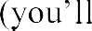 see mininet> prompt): mininet> pingall

 This will check connectivity between the hosts.

To show switch info: mininet> sh ovs-vsctl show



### Step 4: Install and Run the POX Controller

**Open a new terminal (do not close the Mininet window)**

git clone https://github.com/noxrepo/pox.git cd pox

./pox.py forwarding.l2_learning

 This will start a Layer 2 learning switch controller.

### Step 5: Run Mininet with POX Controller

In the original terminal (or a new one if needed), run this command:

sudo mn --topo=tree,depth=2 --controller=remote,ip=127.0.0.1,port=6633 --switch ovsk

 Creates a **tree topology** with depth 2.

 Connects to the POX controller on the default OpenFlow port 6633.

### Step 6: Monitor OpenFlow Communication Open a new terminal and run:

sudo tcpdump -i any port 6633

 This will show OpenFlow messages between the switch and controller.

### Step 7: View Flow Rules on Switch

In Mininet CLI, check the switch name with:

mininet> sh ovs-vsctl show

Then, dump flow table (replace br0 with switch name if different): sudo ovs-ofctl dump-flows br0



**M.Sc. IT Sem II Computer Vision Practical.**

|  |  |  |  |
| --- | --- | --- | --- |
| **Sr. No** | **PRACTICAL** | **DATE** | **SIGN** |
| 1 | Perform Geometric transformations |  |  |
| Perform Image Stitching |  |  |
| Perform Camera Calibration |  |  |
| 2 | Perform the following:   1. Face detection 2. Object detection 3. Pedestrian detection 4. Face recognition |  |  |
| Construct a 3D model from images I |
| Implement object detection and tracking from video |
| 3 | Perform Feature extraction using RANSAC |  |  |
| Perform Colorization |
| 4 | Perform text detection and recognition |  |  |
| Perform Image matting and composting |  |  |

**M.Sc.IT ** **Semester II**

#### Practical No. 1

**Part A:**

**Aim:** Perform Geometric Transformations

**Concept:**

Geometric transformations are mathematical operations that move or manipulate

objects in space. These transformations are fundamental concepts in fields like computer graphics, geometry, and physics. The primary aim is to alter the position, orientation, and scale of objects while preserving certain properties like angles, lengths, or areas.

**Translation:** Translation moves every point of an object in the same direction by the same distance. if T(x,y) represents the translation of a point P(x,y), the new coordinates after translation would be: T(x,y)=(x+tx,y+ty), where tx and ty are the translation distances along the x and y axes, respectively.

**Scaling:** Scaling changes the size of an object, either enlarging or shrinking it, while maintaining its shape. If S(sx,sy) represents the scaling of a point P(x,y),the new coordinates after scaling are: S(sx,sy)=(x sx, y sy)

where  and  are the scaling factors along the x and y axes, respectively. **Rotation:** Involves turning an object around a fixed point(called the center of rotation) by a specified angle. if () represents the rotation of a point P(x,y) by an angle , the new coordinates after rotation are:

  where  is the angle of rotation. **Reflection:** Reflection creates a mirror image of an object across a specific line, known as the line of reflection.

**Shearing:** Shearing involves shifting one part of an object while the other part stays fixed, resulting in a skewed appearance. A shear transformation along the x-axis is represented as:

Sh(x,y)=(x+shx y,y) where    is the shear factor in the x direction. A similar transformation can be applied along the y-axis. Sh(x,y)=(x,y +shy x)

**Packages Used :**

**numpy** is a powerful library in Python used for working with numbers and arrays (lists of numbers). It stands for Numerical Python and is widely used in data science, machine learning, and scientific computing. NumPy is essential for anyone working with large amounts of numerical data in Python.

**OpenCV (Open Source Computer Vision Library)**, often imported in Python as cv2, is a powerful library used for computer vision tasks. It provides tools to work with images and videos, such as analyzing, processing, and manipulating visual data.

##### M.Sc.IT Semester II

**def translate(image, x, y):**

**M = np.float32([[1, 0, x], [0, 1, y]])**

**translated_image = cv2.warpAffine(image, M, (image.shape[1], image.shape[0])) return translated_image**

Translates the image, i.e., shifts the image by x pixels along the horizontal axis and y pixels along the vertical axis.

 image : The input image that you want to translate (a NumPy array).

 M : The transformation matrix M defines the translation in terms of the affine transformation.

1 0 0



 = 0 1 0

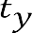1

x : The number of pixels to shift the image along the x-axis (horizontal direction). y : The number of pixels to shift the image along the y-axis (vertical direction).

The cv2.warpAffine() function applies this matrix to the image, which moves every pixel by x and y.

**def rotate(image, angle, center=None, scale=1.0):**

**(h, w) = image.shape[:2] if center is None:**

**center = (w // 2, h // 2)**

**M = cv2.getRotationMatrix2D(center, angle, scale) rotated_image = cv2.warpAffine(image, M, (w, h)) return rotated_image**

Rotates the image by a specified angle around a center point. You can also scale the image during rotation.  image : The input image to rotate (NumPy array).

 angle : The angle (in degrees) by which to rotate the image. A positive value rotates counterclockwise, and a negative value rotates clockwise.

 center : The point around which to rotate. It defaults to the center of the image (None means the center will be used).

 scale : A scaling factor. 1.0 means no scaling (same size), values greater than 1 scale the image up, and values between 0 and 1 scale it down.

 M : The transformation matrix M defines the rotation in terms of the affine transformation.

 =

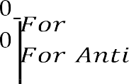

,    (  )

,    ()



##### M.Sc.IT Semester II

 cv2.getRotationMatrix2D() generates the transformation matrix for rotation. It takes the center, angle, and scale as inputs.

 The cv2.warpAffine() function then applies this transformation to the image, resulting in a rotated version.

**def scale(image, scale_x, scale_y):**

**scaled_image = cv2.resize(image, None, fx=scale_x, fy=scale_y) return scaled_image**

Scales the image by different factors along the x and y axes. image : The input image (NumPy array).

scale_x : The scaling factor along the x-axis (horizontal). scale_y : The scaling factor along the y-axis (vertical).

M : The transformation matrix M defines the scaling in terms of the affine transformation.

0 0

 = 0 0

0 0 1

 cv2.resize() changes the size of the image based on the given scaling factors fx and fy.

**def shear(image, shear_x, shear_y):**

**M = np.float32([[1, shear_x, 0], [shear_y, 1, 0]])**

**sheared_image = cv2.warpAffine(image, M, (image.shape[1], image.shape[0])) return sheared_image**

Shears the image along the x and y axes. Shearing is a transformation that slants the image along one direction.

 image : The input image to shear (NumPy array).

 shear_x : The shear factor along the x-axis. This value determines how much the image will shift horizontally based on the vertical position of each pixel.

 shear_y : The shear factor along the y-axis. This value determines how much the image will shift vertically based on the horizontal position of each pixel.

 M : The transformation matrix M defines the shearing in terms of the affine transformation.









() =







1 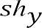 0

0 1 0

0 0 1

() =



##### M.Sc.IT Semester II

cv2.imread('img.jpg') : Reads the image from the file 'img.jpg' (make sure the image exists).

The image undergoes translation, rotation, scaling, and shearing using the functions defined earlier.

 cv2.imshow() : Displays the original and transformed images in separate windows.

 cv2.waitKey(0) : Waits indefinitely for a key press to close the image windows.

**reflected_x = cv2.flip(image, 0)**

The second argument (0) specifies that the image should be flipped along the X-axis. This results in a vertical flip, meaning the top and bottom parts of the image are swapped.

**reflected_y = cv2.flip(image, 1)**

The second argument (1) specifies that the image should be flipped along the Y-axis. This results in a horizontal flip, meaning the left and right parts of the image are swapped.

**reflected_origin = cv2.flip(image, -1)**

 The second argument (-1) flips the image along both axes (X and Y).

 This results in a diagonal flip, meaning the image is rotated 180 degrees (upside-down and mirrored).

##### M.Sc.IT Semester II

**Part B:**

**Aim: Perform Image Stitching**

**Concept:**

Image stitching is the process of merging multiple overlapping images to create a seamless, larger image, commonly used in panoramic photography, medical imaging, and satellite mapping. The process involves capturing images with overlapping regions, detecting key features using techniques like SIFT or ORB, matching these features between images, and aligning them using homography estimation. Once aligned, blending techniques such as multi-band blending or feathering are applied to smooth out seams and color differences. The final result is a unified image with minimal distortions. Image stitching is widely used in applications like virtual reality, geographic mapping, and surveillance systems, enabling the creation of high-resolution and immersive visuals.

imutils.paths: Helps in listing image file paths from a given directory. imutils: A utility library for image processing tasks.

cv2: OpenCV, used for image processing.

argparse: Used for command-line argument parsing (not utilized in this script)

**imagePaths = sorted(list(paths.list_images('P1'))) #'P1' is a folder containing images**

paths.list_images('P1') collects all image file paths in the folder 'P1'. list() converts the generator output into a list.

sorted() arranges the image paths in ascending order to ensure they are processed in sequence.

**images=[] :** An empty list images is created to store loaded images. **for imagePath in imagePaths:**

**image = cv2.imread(imagePath) images.append(image)**

A for loop iterates through each imagePath. cv2.imread(imagePath): Reads the image from the file. The loaded image is appended to the images list.

**stitcher = cv2.createStitcher() if imutils.is_cv3() else cv2.Stitcher_create():** imutils.is_cv3() checks whether OpenCV version 3 is being used: If OpenCV 3, it uses cv2.createStitcher().

Otherwise, it uses cv2.Stitcher_create().

The stitcher object is responsible for combining multiple images into a panorama.

##### M.Sc.IT Semester II

**(status, stitched) = stitcher.stitch(images):**

stitcher.stitch(images): Attempts to combine the images into a panoramic image. Returns:

status: Indicates if stitching was successful (0 = success, non-zero = failure). stitched: The resulting stitched image if successful.

**Part C:**

**Aim: Perform Camera Calibration**

**Concept:**

Camera calibration is the process of determining a camera's intrinsic (internal) and extrinsic (external) parameters to correct distortions and accurately map 3D world coordinates to 2D image coordinates. It is essential for applications like computer vision, robotics, augmented reality (AR), and 3D reconstruction. Need for Camera Calibration

 Lens Distortion Correction: Lenses introduce distortions (barrel, pincushion), which calibration corrects.

Accurate Depth Perception: Helps reconstruct real-world distances from images. Robust Object Detection: Improves precision in object tracking and recognition.

Augmented Reality (AR): Ensures virtual objects align correctly with real-world scenes.

**Packages Used :**

The **os** module for interacting with the operating system, typically used for file and directoryoperations. The **glob** module in Python is a powerful utility used for file name pattern matching. Its primary purpose is to allow users to retrieve files with a certain name pattern, without having to manually specify each file.

**CHECKERBOARD = (6, 9)**

The CHECKERBOARD variable defines the number of **internal corners** in the checkerboard. The first value (6) is the number of internal corners along the rows, and the second value (9) is the number of internal corners along the columns. These internal corners (not squares) are used for calibration.

**criteria = (cv2.TERM_CRITERIA_EPS + cv2.TERM_CRITERIA_MAX_ITER, 30, 0.001)**

This sets the termination criteria for the corner subpixel refinement process.

##### M.Sc.IT Semester II

cv2.TERM_CRITERIA_EPS: The stopping criterion based on the change in corner positions. cv2.TERM_CRITERIA_MAX_ITER: The stopping criterion based on the maximum number of iterations.

The refinement method iterates over the corner positions until one of the following criteria is met:

EPS (0.001): The algorithm stops if the corner positions stop changing by more than 0.001. MAX_ITER (30): The algorithm stops after a maximum of 30 iterations.

**threedpoints = [ ]**

A list to store the real-world coordinates of the detected corners in 3D space.

**twodpoints = [ ]**

A list to store the detected 2D pixel coordinates of the corners in each image.

**objectp3d = np.zeros((1, CHECKERBOARD[0] * CHECKERBOARD[1], 3), np.float32) objectp3d[0,:,:2] =**

**np.mgrid[0:CHECKERBOARD[0],0:CHECKERBOARD[1]].T.reshape(-1, 2)**

This creates an array to store the 3D real-world coordinates of the checkerboard corners. Since the checkerboard is flat, the Z-coordinates are set to 0 for all corners. The mgrid function creates a grid of corner positions in the X and Y directions.

**images = glob.glob('.jpg')**

This retrieves all .jpg files in the current directory. These images will be used to extract the checkerboard corners for camera calibration.

**image = cv2.imread(filename)**

**grayColor = cv2.cvtColor(image, cv2.COLOR_BGR2GRAY)**

Reads each image file and converts it to grayscale. Grayscale images are easier to process when detecting corners.

 cv2.imread() : Reads the image from disk.

 cv2.cvtColor() : Converts the image to grayscale from BGR (since OpenCV reads images in BGR format).

**ret, corners = cv2.findChessboardCorners(grayColor, CHECKERBOARD, cv2.CALIB_CB_ADAPTIVE_THRESH + cv2.CALIB_CB_FAST_CHECK + cv2.CALIB_CB_NORMALIZE_IMAGE)**

This method detects the internal corners of the checkerboard pattern. grayColor : The grayscale image in which the corners will be detected.

CHECKERBOARD : The expected number of internal corners (rows x columns). cv2.CALIB_CB_flags : These flags help improve the corner detection by enabling adaptive thresholding, fast checking, and image normalization.

##### M.Sc.IT Semester II

**if ret == True:**

**threedpoints.append(objectp3d)**

**corners2 = cv2.cornerSubPix(grayColor, corners, (11, 11), (-1, -1), criteria) twodpoints.append(corners2) image = cv2.drawChessboardCorners(image, CHECKERBOARD, corners2, ret)** If the corners are

detected, the code refines the corner positions to subpixel accuracy and stores the results.

 cv2.cornerSubPix() : Refines the corner positions by iterating over them and adjusting their subpixel accuracy using the provided termination criteria (criteria).

 cv2.drawChessboardCorners() : Draws the refined corner positions on the image.

**cv2.imshow('img', image) cv2.waitKey(0)**

Displays the image with drawn corners.

 cv2.imshow() : Displays the image in a window.

 cv2.waitKey() : Waits for a key press to proceed (0 means wait indefinitely).

**ret, matrix, distortion, r_vecs, t_vecs = cv2.calibrateCamera(threedpoints, twodpoints, grayColor.shape[::-1], None, None)**

This method calibrates the camera using the 3D object points (threedpoints) and the corresponding 2D image points (twodpoints).

threedpoints : List of 3D object coordinates from the checkerboard.

twodpoints : List of detected 2D coordinates corresponding to the 3D object points. grayColor.shape[::-1] : The dimensions of the image (height, width) in reverse order. r_vecs: Rotation vectors (camera orientation).

t_vecs: Translation vectors (camera position).

**print(" Camera matrix:") print(matrix)**

**print("\n Distortion coefficient:") print(distortion) print("\n Rotation Vectors:")**

**print(r_vecs)**

**print("\n Translation Vectors:") print(t_vecs)**

Prints out the calibration results, including the camera matrix, distortion coefficients, rotation vectors, and translation vectors.

##### M.Sc.IT Semester II

**Explanation of Output:**

**Camera matrix:**

[[ 58.17561698 0. 102.67813943]

[ 0. 60.45272444 93.55060487]

[ 0. 0. 1. ]]

 Focal Lengths: fx=58.18, fy =60.45 (in pixels)  these scale the image from real-world dimensions.

Principal Point: (cx=102.68,cy=93.55)  this is the optical center of the camera sensor. Skew: The 0 in the second column indicates no skew (ideal camera).

**Distortion coefficient:**

[[ 0.02229387 -0.02371451 0.00047977 -0.00194139 0.00608793]]

These values represent radial and tangential distortions:

Radial Distortion (k1,k2 ,k3 ): Causes straight lines to appear curved. Tangential Distortion (p1,p2 ): Caused by lens misalignment.

Small values indicate minimal distortion.

**Rotation Vectors:**

(array([[-0.13607382], [ 0.08651059],

[ 1.49228225]]),)

Defines how the camera is rotated in 3D space relative to the calibration pattern.

**Translation Vectors:**

(array([[ 3.51290647],

[-3.70110923],

[ 3.98457147]]),)

 Indicates the  s position relative to the calibration object in real-world units (e.g., meters).

**Positive x-value**: Camera is shifted to the right.

**Negative y-value**: Camera is slightly below the reference plane.

**Positive z-value**: Camera is in front of the reference plane.

**M.Sc.IT ** **Semester II**

#### Practical No. 1

**Part A**

**Aim:** Perform Geometric Transformation Packages

**Used**: numpy, cv2

**Command:**

**pip install numpy**

On Pycharm Terminal

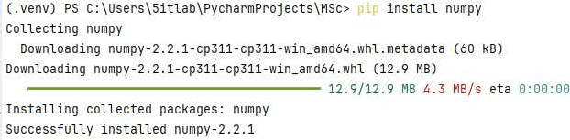

**Note:** If an error is found in installing packages from Pycharm Terminal, then open the project in the File Explorer.

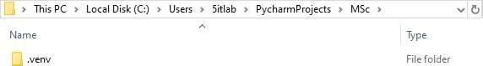

Open the **Scripts** folder and copy the path

##### M.Sc.IT Semester II

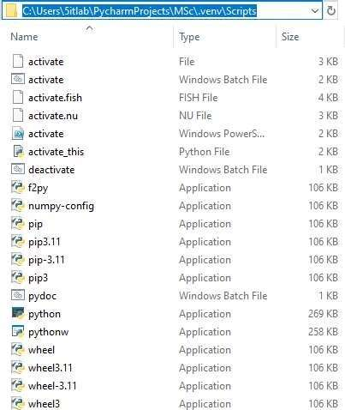

Open a command propt with administrative privileges, and change the working directory using the followingcommand:

**cd **

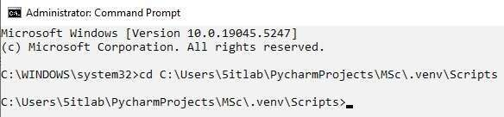

Try using the command again

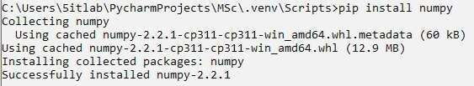



On Pycharm Terminal

##### M.Sc.IT Semester II

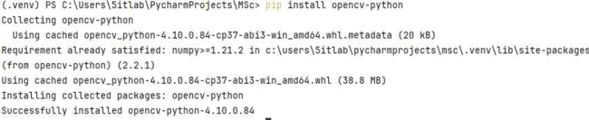

On Command Propt (Administrative Privileges)

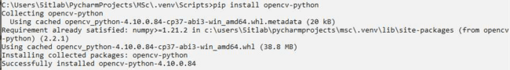

**Images Used:**

img.jpeg, moon.jpg

**Code (Translation, Rotation, Scaling and Shearing):**

import numpy as np import cv2

def translate(image, x, y): M = np.float32([

[1, 0, x],

[0, 1, y]])

translated_image = cv2.warpAffine(image, M, (image.shape[1], image.shape[0])) return translated_image

def rotate(image, angle, center=None, scale=1.0): (h, w) = image.shape[:2]

if center is None:

center = (w // 2, h // 2)

M = cv2.getRotationMatrix2D(center, angle, scale) rotated_image = cv2.warpAffine(image, M, (w, h)) return rotated_image

def scale(image, scale_x, scale_y):

scaled_image = cv2.resize(image, None, fx=scale_x, fy=scale_y) return scaled_image

def shear(image, shear_x, shear_y): M = np.float32([

[1, shear_x, 0],

[shear_y, 1, 0]])

##### M.Sc.IT Semester II

sheared_image = cv2.warpAffine(image, M, (image.shape[1], image.shape[0])) return sheared_image

image = cv2.imread('img.jpg') #Main Logic

translated_image = translate(image, 100, 100) rotated_image = rotate(image, 45) scaled_image = scale(image, 0.5, 0.5)

sheared_image = shear(image, 0.2, 0.3)

#Displayof images cv2.imshow('Original',image)

cv2.imshow('translated_image',translated_image) cv2.imshow('rotated_image',rotated_image) cv2.imshow('scaled_image',scaled_image) cv2.imshow('sheared_image',sheared_image)

#Resize Images cv2.resizeWindow('Original',250,250) cv2.resizeWindow('translated_image',250,250) cv2.resizeWindow('rotated_image',250,250) cv2.resizeWindow('scaled_image',250,250) cv2.resizeWindow('sheared_image',250,250)

cv2.waitKey(0) cv2.destroyAllWindows()

##### M.Sc.IT Semester II

**Output:**

**Original**

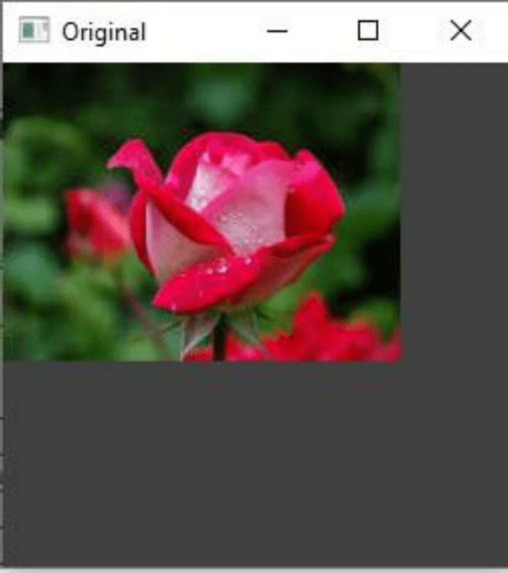

**translated_image**

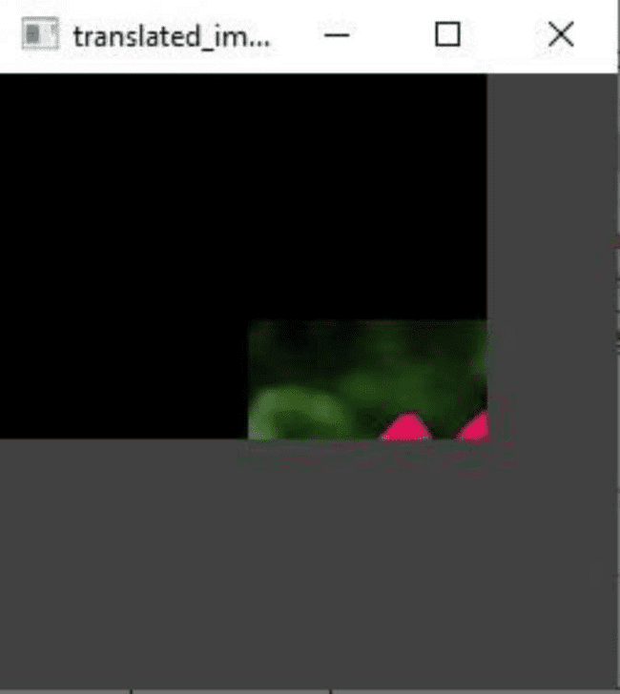

**rotated_image**

**scaled_image**



**sheared_image**

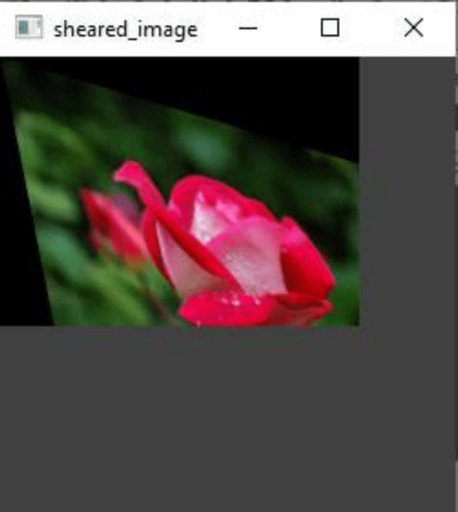



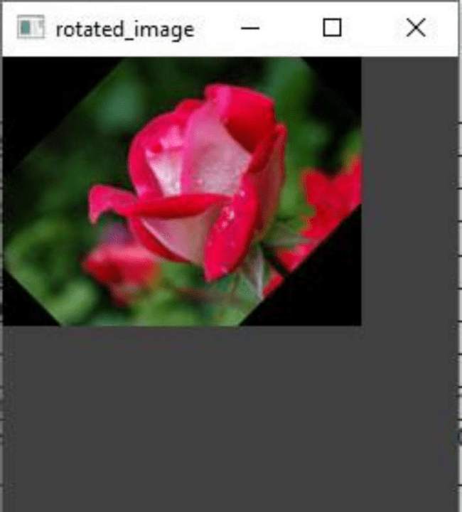

##### M.Sc.IT Semester II

**Code (Reflection):**

import cv2

# Load the image

image = cv2.imread("moon.jpg")

# Reflection w.r.t. X-axis (vertical flip) reflected_x = cv2.flip(image, 0)

# Reflection w.r.t. Y-axis (horizontal flip) reflected_y = cv2.flip(image, 1)

# Reflection w.r.t. Origin (both axes flip) reflected_origin = cv2.flip(image, -1)

# Display the results cv2.imshow("Original Image",image)

cv2.imshow("Reflection wrt X",reflected_x) cv2.imshow("Reflection wrt Y",reflected_y) cv2.imshow("Reflection wrt Origin",reflected_origin)

#Resize Images cv2.resizeWindow('Original Image',350,350)

cv2.resizeWindow('Reflection wrt X',350,350) cv2.resizeWindow('Reflection wrt Y',350,350) cv2.resizeWindow('Reflection wrt Origin',350,350)

cv2.waitKey(0) cv2.destroyAllWindows()

**Output:**



##### M.Sc.IT Semester II



**M.Sc.IT ** **Semester II**

**Part B**

**Aim: Perform Image Stitching Steps:**

**Packages Used: imutils, cv2 Command:**

**pip install imutils**

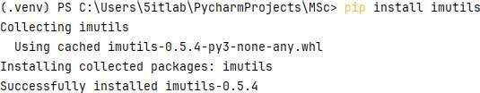

**pip install argparse**

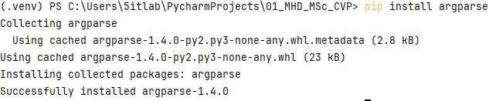

**Images Used:**

P1>>building1.jpg, building2.jpg, building3.jpg, building4.jpg, building5.jpg P2>>p21.png, p22.png, p23.png

P3>>001.jpg, 002.jpg, 003.jpg, 004.jpg, 005.jpg **Code:**

from imutils import paths import imutils

import cv2 import argparse

imagePaths = sorted(list(paths.list_images('P1'))) #'P..' is folder containing images images=[] # loop over the image paths, load each one, and add them to our

# images to stitch list

for imagePath in imagePaths:

image = cv2.imread(imagePath) images.append(image)

##### M.Sc.IT Semester II

# initialize OpenCV's image stitcher object and then perform the image # stitching print("[INFO] stitching images...")

#stitcher = cv2.Stitcher_create(cv2.Stitcher_PANORAMA)

stitcher = cv2.createStitcher() if imutils.is_cv3() else cv2.Stitcher_create() (status, stitched) = stitcher.stitch(images)

# if the status is '0', then OpenCV successfully performed image # stitching if status == 0:

# write the output stitched image to disk cv2.imwrite("P1Stitched.jpg", stitched)

# display the output stitched image to our screen cv2.imshow("Stitched", stitched) cv2.waitKey(0)

else:

print("[INFO] image stitching failed ({})".format(status))

**Output: P1Stitched.jpg**

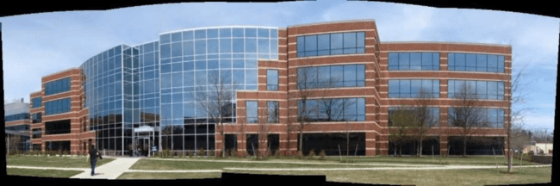

**P2Stitched.jpg**



**P3Stitched.jpg**

##### M.Sc.IT Semester II

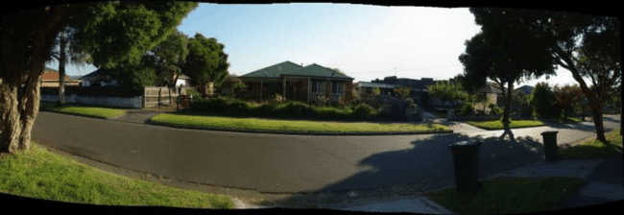

**Note:** Output image is also stored in the folder

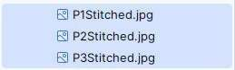

**Part C**

**Aim: Perform Camera Calibration**

**Steps:**

**Packages Used: numpy, cv2, os, glob**

**Images Used:**

p3.jpg p32.jpg p33.jpg

**Code:**

import cv2

import numpy as np import os import glob

# Define the dimensions of checkerboard CHECKERBOARD = (6, 9)

# stop the iteration when specified # accuracy, epsilon, is reached or

# specified number of iterations are completed.

criteria = (cv2.TERM_CRITERIA_EPS + cv2.TERM_CRITERIA_MAX_ITER, 30, 0.001)

# Vector for 3D points threedpoints = []

# Vector for 2D points

##### M.Sc.IT Semester II

twodpoints = []

# 3D points real world coordinates

objectp3d = np.zeros((1, CHECKERBOARD[0] * CHECKERBOARD[1], 3), np.float32) objectp3d[0, :, :2]

= np.mgrid[0:CHECKERBOARD[0], 0:CHECKERBOARD[1]].T.reshape(-1, 2)

prev_img_shape = None

# Extracting path of individual image stored # in a given directory. Since no path is

# specified, it will take current directory # jpg files alone

images = glob.glob('*.jpg')

for filename in images:

image = cv2.imread(filename)

grayColor = cv2.cvtColor(image, cv2.COLOR_BGR2GRAY)

# Find the chess board corners

# If desired number of corners are # found in the image then ret = true

ret, corners = cv2.findChessboardCorners( grayColor, CHECKERBOARD, cv2.CALIB_CB_ADAPTIVE_THRESH

+ cv2.CALIB_CB_FAST_CHECK + cv2.CALIB_CB_NORMALIZE_IMAGE)

# If desired number of corners can be detected then, # refine the pixel coordinates and display

# them on the images of checker board if ret == True:

threedpoints.append(objectp3d)

# Refining pixel coordinates # for given 2d points. corners2 = cv2.cornerSubPix(

grayColor, corners, (11, 11), (-1, -1), criteria) twodpoints.append(corners2)



corners2, ret)

# Draw and display the corners

image = cv2.drawChessboardCorners(image, CHECKERBOARD,

##### M.Sc.IT Semester II

cv2.imshow('img', image) cv2.waitKey(0) cv2.destroyAllWindows() h, w

= image.shape[:2]

# Perform camera calibration by

# passing the value of above found out 3D points (threedpoints) # and its corresponding pixel coordinates of the

# detected corners (twodpoints)

ret, matrix, distortion, r_vecs, t_vecs = cv2.calibrateCamera( threedpoints, twodpoints, grayColor.shape[::-1], None, None)

# Displaying required output print(" Camera matrix:") print(matrix)

print("\n Distortion coefficient:") print(distortion) print("\n Rotation Vectors:") print(r_vecs) print("\n Translation Vectors:") print(t_vecs)

**Output:**

**Case ** **I (p3.jpg):**

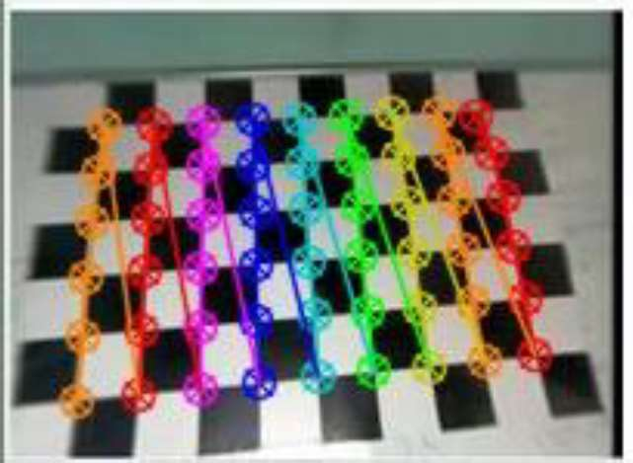

**Camera matrix:**

[[ 58.17561698 0. 102.67813943]

[ 0. 60.45272444 93.55060487]

[ 0. 0. 1. ]]

**Distortion coefficient:**

##### M.Sc.IT Semester II

[[ 0.02229387 -0.02371451 0.00047977 -0.00194139 0.00608793]]

**Rotation Vectors:**

(array([[-0.13607382], [ 0.08651059],

[ 1.49228225]]),)

**Translation Vectors:**

(array([[ 3.51290647],

[-3.70110923],

[ 3.98457147]]),)

**Case ** **II (p32.jpg):**

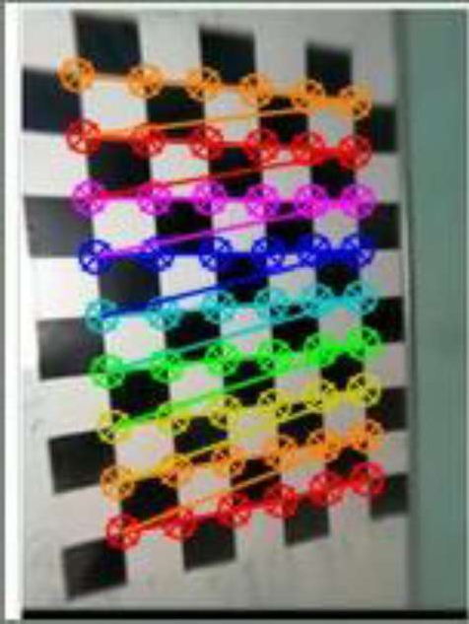

**Camera matrix:**

[[ 8.8650501 0. 75.00007197]

[ 0. 8.86817689 99.50002698]

[ 0. 0. 1. ]]

**Distortion coefficient:**

[[ 1.32152374e-04 -2.46703289e-06 -5.41268873e-05 -2.85386206e-05 1.27621105e-08]]

**Rotation Vectors:** (array([[-0.03259909], [- 0.00766796],

[ 3.07373454]]),)

**Translation Vectors:** (array([[2.9027577 ], [3.72600396],

[0.60404124]]),)

**Case ** **III (p33.jpg):**

##### M.Sc.IT Semester II

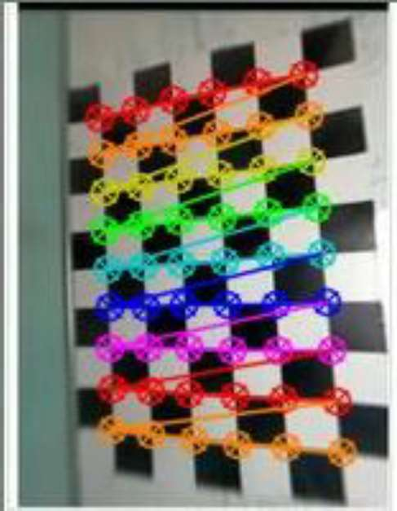

**Camera matrix:**

[[ 28.92668812 0. 57.87918422]

[ 0. 30.55971048 103.85696559]

[ 0. 0. 1. ]]

**Distortion coefficient:**

[[ 3.21879713e-03 -5.56108458e-04 1.09806782e-04 1.98033459e-04 2.63324031e-05]]

**Rotation Vectors:** (array([[-0.01773896], [ 0.07318732],

[-0.05676499]]),)

**Translation Vectors:** (array([[-1.47326778], [- 4.01274967],

[ 2.08423295]]),

**M.Sc.IT ** **Semester II**

#### Practical No. 2

**Part A.1:**

**Aim**: Perform the Face Detection

**Concept:**

Face detection is the process of identifying human faces in an image or video. It is a fundamental step in various applications like facial recognition, security systems, emotion analysis, and augmented reality.

The code implements **face detection** using the **Haar Cascade Classifier** in OpenCV

which is computationally lightweight and suitable for real-time applications. However, it has limitations, such as sensitivity to lighting conditions and difficulty detecting faces at extreme angles.

This algorithm is based on **Viola-Jones object detection**, which uses Haar-like features to identify patterns in an image. The process can be broken down into several key steps.

1. **Image Preprocessing**

The first step is to read the input image using cv2.imread() and convert it to grayscale using cv2.cvtColor(). The grayscale image simplifies computation since color information is not necessary for face detection. This step enhances processing speed because grayscale images require only a **single channel** instead of three (RGB).

1. **Loading the Pre-trained Haar Cascade Classifier**

The classifier is loaded using cv2.CascadeClassifier(), which loads the **pre-trained Haar cascade XML file** (haarcascade_frontalface_default.xml). This file contains data trained on multiple face images, enabling the classifier to recognize frontal faces effectively.

1. **Detecting Faces in the Image**

The function detectMultiScale() scans the grayscale image to detect faces. It takes several parameters:

 scaleFactor=1.01: This parameter determines how much the image size is reduced at each scale. A smaller value increases accuracy but slows down processing.

 minNeighbors=2: Specifies how many neighbors a detected region must have to be considered a face. Lower values detect more objects but increase false positives.

 minSize=(5,5): Defines the minimum face size to be detected, helping to filter out very small objects.

The function returns a list of detected faces in the form of bounding box coordinates (x, y, w, h), where (x, y) represents the top-left corner, and (w, h) represent the width and height of the detected face.

##### M.Sc.IT Semester II

1. **Drawing a Bounding Box Around Faces**

For each detected face, a green rectangle is drawn using cv2.rectangle(), which takes the starting and ending coordinates (x, y, x+w, y+h), the color (0, 255, 0) (green), and the thickness of the rectangle (4 pixels). This visualizes the detected faces in the image.

1. **Displaying the Image with Detected Faces**

The image is converted from **BGR to RGB** using cv2.cvtColor(), as OpenCV loads images in **BGR format**, whereas most display libraries (like Matplotlib) use **RGB format**. Finally, cv2.imshow() is used to display the image, and cv2.waitKey(0) ensures the window remains open until a key is pressed.

**Packages Used:**

**cv2** is the OpenCV library used for image processing tasks like loading, manipulating, and displaying images.

**img = cv2.imread('C:/Users/5itlab/Downloads/input4.jpeg')**

This line reads an image from the file path provided and stores it in the variable img.

 'C:/Users/aditi/Downloads/input4.jpeg' : The file path to the image that needs to be loaded. It could be any valid image path.

**gray_image = cv2.cvtColor(img, cv2.COLOR_BGR2GRAY)**

This converts the color image to grayscale. Face detection is often easier and faster in grayscale, as it reduces the complexity of the image (removing color information).

 img : The original image (in BGR color format).

 cv2.COLOR_BGR2GRAY : This is the color conversion code that tells OpenCV to convert the image from BGR (Blue-Green-Red) to grayscale.

**face_classifier =**

**cv2.CascadeClassifier(cv2.data.haarcascades+"haarcascade_frontalface_default.xml ")** This initializes a Haar Cascade Classifier for face detection. OpenCV comes with pre-trained models for various objects like faces, eyes, etc.

cv2.data.haarcascades : This is a predefined path to OpenCV's directory of Haar cascade files. "haarcascade_frontalface_default.xml" : This is the XML file that contains the trained data for detecting frontal faces.

**face = face_classifier.detectMultiScale(gray_image, scaleFactor=1.01, minNeighbors=2, minSize=(5, 5))**

This method detects faces in the given grayscale image.

 gray_image : The image on which face detection is applied (in grayscale).

 scaleFactor=1.01 : This compensates for faces appearing larger or smaller due to scaling in the image. It adjusts the image size at each scale.

##### M.Sc.IT Semester II

 minNeighbors=2 : This parameter defines how many neighbors each rectangle should have to retain it. Higher values result in fewer detections but more accurate ones.

 minSize=(5, 5) : Specifies the minimum size of the detected face (width, height). Faces smaller than this size are ignored.

**for (x, y, w, h) in face:**

**cv2.rectangle(img, (x, y), (x + w, y + h), (0, 255, 0), 4)**

This loop draws rectangles around each detected face in the image.

img : The image on which to draw the rectangle (this modifies the image directly). (x, y) : The top-left corner of the rectangle.

(x + w, y + h) : The bottom-right corner of the rectangle, which is calculated by adding the width

(w) and height (h) to the top-left corner.

 (0, 255, 0) : This is the color of the rectangle in BGR format (green in this case).  4 : This specifies the thickness of the rectangle's border.

**img_rgb = cv2.cvtColor(img, cv2.COLOR_BGR2RGB)**

This line converts the image from BGR color format (used by OpenCV) to RGB color format (commonly used in matplotlib for display purposes).

 img : The original image in BGR format.

 cv2.COLOR_BGR2RGB : This conversion code tells OpenCV to convert from BGR to RGB.

**cv2.imshow('i', img_rgb) cv2.waitKey(0)**

This part of the code displays the image with the detected faces and rectangles on the screen using OpenCV's imshow() function.

**Part A.2:**

**Aim: Perform Object Detection**

**Concept :**

In this practical we perform stop sign detection using  s Haar Cascade Classifier. This approach is based on pattern recognition using pre-trained features from the stop_data.xml file. The algorithm follows a systematic process to identify and highlight stop signs in an image.

1. **Image Preprocessing**

The first step involves loading the input image (stop.png) using cv2.imread(). Since OpenCV loads images in BGR format, they are converted to RGB using cv2.cvtColor(img, cv2.COLOR_BGR2RGB). Additionally, the image is converted to

##### M.Sc.IT Semester II

grayscale (cv2.COLOR_BGR2GRAY), as grayscale images reduce computational complexity while preserving important features for detection.

1. **Loading the Pre-trained Haar Cascade Classifier**

The classifier is initialized using cv2.CascadeClassifier('stop_data.xml'), which loads a pre-trained Haar cascade file for detecting stop signs. This XML file contains pre-extracted Haar-like features based on multiple positive and negative stop sign images.

1. **Detecting Stop Signs in the Image**

The function detectMultiScale() is applied to the grayscale image. It detects multiple stop signs and returns their coordinates. The parameter minSize=(20,20) ensures that very small objects (noise) are ignored, focusing only on objects that are at least 20× 20 pixels in size.

If no stop signs are detected, found remains empty, and the program does nothing. If one or more stop signs are detected, their bounding box coordinates (x,

y, width, height) are stored in found.

1. **Drawing Bounding Boxes Around Detected Stop Signs**

For each detected stop sign, a green rectangle is drawn using cv2.rectangle(). The parameters (x, y) define the top-left corner, while (x + height, y + width) define the bottom-right corner. The color (0, 255, 0) represents green, and the thickness is set to 5 pixels. This ensures that each detected stop sign is clearly highlighted.

1. **Displaying the Image with Detected Stop Signs**

The processed image is displayed using cv2.imshow('img', img_rgb). The function plt.show() is included, but it is redundant because cv2.imshow() already handles the display. The program waits for user input (cv2.waitKey(0)) before closing the window.

**Packages Used :**

**Pyplot** is a module in the Matplotlib library, which is one of the most popular data visualization libraries in Python. Pyplot provides a MATLAB-like interface for creating static, animated, and interactive plots and graphs. It is specifically designed to work with 2D plotting, and it allows you to easily generate a wide range of plots and charts, including line plots, bar charts, histograms, scatter plots, and many others.

**img = cv2.imread("stop.png")**

The cv2.imread() method loads an image from the specified file path. In this case, it loads the image stop.png into the variable img.

**img_gray = cv2.cvtColor(img, cv2.COLOR_BGR2GRAY)**

##### M.Sc.IT Semester II

The cv2.cvtColor() method is used to convert an image from one color space to another. Here, it's used to convert the original BGR image into a grayscale version, which simplifies the detection process.

 img : This is the source image (in BGR format, which is the default for images loaded via OpenCV).

 cv2.COLOR_BGR2GRAY : This is a color conversion code that tells OpenCV to convert from BGR to grayscale.

**img_rgb = cv2.cvtColor(img, cv2.COLOR_BGR2RGB)**

This method converts the BGR image to RGB format. OpenCV reads images in BGR by default, but many visualization libraries like Matplotlib expect images in RGB.

img : This is the original BGR image loaded using cv2.imread().

cv2.COLOR_BGR2RGB : The color conversion code to convert from BGR to RGB format.

**stop_data = cv2.CascadeClassifier('stop_data.xml')**

The cv2.CascadeClassifier() method loads a pre-trained classifier from an XML file. In this case, 'stop_data.xml' contains the data needed to recognize stop signs. OpenCV's Haar Cascade Classifier is commonly used for object detection in images.

 'stop_data.xml' : A file containing a pre-trained classifier in XML format. It is usually generated using machine learning techniques to detect specific objects (e.g., stop signs).

**found = stop_data.detectMultiScale(img_gray, minSize=(20, 20))**

The detectMultiScale() method detects objects (in this case, stop signs) in an image by scanning the image at multiple scales. The method uses a sliding window approach to detect objects of various sizes.

 img_gray : The input image in grayscale. Object detection typically works better with grayscale images because they remove unnecessary color information, simplifying the detection process.

 minSize=(20, 20) : This argument defines the minimum size of the object to be detected. In this case, it's set to 20x20 pixels. Objects smaller than this size will be ignored to avoid detecting noise or irrelevant small objects.

**for (x, y, width, height) in found:**

**cv2.rectangle(img_rgb, (x, y), (x + width, y + height), (0, 255, 0), 5)**

For each detected stop sign (bounding box), this code draws a green rectangle around it to highlight the detected object.

img_rgb : The image in RGB format where the rectangle will be drawn. (x, y) : The top-left corner of the bounding box.

(x + width, y + height) : The bottom-right corner of the bounding box, calculated by adding the width and height to the top-left coordinates.

##### M.Sc.IT Semester II

 (0, 255, 0) : The color of the rectangle in RGB format (green in this case).  5 : The thickness of the rectangle's border.

**Part A.3:**

**Aim: Perform Pedestrian Detection**

**Concept :**

In this practical we perform pedestrian detection in an image using the Histogram of Oriented Gradients (HOG) descriptor with a pre-trained SVM (Support Vector Machine) classifier. This method is widely used for human detection in surveillance, autonomous vehicles, and crowd analysis.

1. **Initializing the HOG Descriptor for Person Detection**

The first step involves initializing the HOG descriptor, a feature extraction technique that captures object shapes and edge orientations. The hog.setSVMDetector(cv2.HOGDescriptor_getDefaultPeopleDetector()) function loads a pre- trained SVM model specifically trained to detect humans. This combination of HOG + SVM is highly effective for pedestrian detection.

1. **Reading and Resizing the Image**

The input image (people2.jpeg) is loaded using cv2.imread(). Since larger images slow down processing, the image is resized using imutils, ensuring the width does not exceed 400 pixels (imutils.resize()). This helps optimize performance without significantly impacting detection accuracy.

1. **Detecting Pedestrians in the Image**

The function hog.detectMultiScale() is used to detect pedestrians in the image. It returns bounding box coordinates of detected persons. Several key parameters control detection accuracy:

 winStride=(4,4)  Defines the step size for the sliding window; smaller values increase accuracy but slow down processing.

 padding=(10,10)  Adds extra pixels around detected regions to improve detection in cluttered environments.

 scale=1.05  Determines how much the image size is reduced at each step; a lower value increases accuracy but increases computation time.

The function returns a list of regions, where each detected pedestrian is represented by (x, y, width, height).

1. **Drawing Bounding Boxes Around Detected Pedestrians**

For each detected pedestrian, a red bounding box is drawn using cv2.rectangle(). The parameters (x, y) define the top-left corner, while (x + w, y + h) define the bottom-right corner. The color (0, 0, 255) represents red, and the rectangle thickness is set to 2 pixels. This visually highlights the detected pedestrians in the image.

1. **Displaying the Image with Detected Pedestrians**

##### M.Sc.IT Semester II

The processed image is displayed using cv2.imshow("Image", image), and cv2.waitKey(0) ensures the window remains open until a key is pressed. Finally, cv2.destroyAllWindows() closes all OpenCV windows to free up memory.

**Packages Used :**

**imutils** is a Python library designed to provide convenience functions and utilities for image processing tasks, particularly when using OpenCV. While OpenCV itself is a powerful library for computer vision tasks, imutils is a lightweight, helper library that makes it easier to work with OpenCV by abstracting common and repetitive tasks into simple, easy-to-use functions.

**hog = cv2.HOGDescriptor() hog.setSVMDetector(cv2.HOGDescriptor_getDefaultPeopleDetector())**

This part initializes the HOG (Histogram of Oriented Gradients) person detector in OpenCV. HOG is a feature descriptor used for object detection, and here, it's specifically used for detecting people (pedestrians).

 cv2.HOGDescriptor() : Creates an instance of the HOGDescriptor class. The

HOG descriptor is responsible for extracting features from an image that can be used to detect objects (in this case, people).

 setSVMDetector() : This method sets the SVM (Support Vector Machine) detector for the HOG descriptor. It tells the HOG object which SVM to use for classifying the features as either a person or not.

 cv2.HOGDescriptor_getDefaultPeopleDetector() : This function provides a pre-trained SVM detector specifically for detecting people.

**image = cv2.imread('people2.jpeg')**

This line loads an image (people2.jpeg) into the variable image. It's the first step in processing the image for object detection.

**image = imutils.resize(image, width=min(400, image.shape[1]))**

This line resizes the image to have a width of 400 pixels or the width of the original image (whichever is smaller). It ensures that the image is appropriately scaled for faster processing during object detection.

 image : The input image to be resized.

 width=min(400, image.shape[1]) : This argument specifies the new width for resizing. The height is calculated proportionally to maintain the aspect ratio.

 image.shape[1] : Original width of the image.

**(regions, _) = hog.detectMultiScale(image, winStride=(4, 4), padding=(10, 10), scale=1.05)**

##### M.Sc.IT Semester II

The detectMultiScale() method detects objects (people) in the image by sliding a window over the image and analyzing the features using the HOG descriptor and the pre-trained SVM.

image : The input image in which people are to be detected.

winStride=(4, 4) : The step size for the sliding window (in both x and y directions). Larger values mean fewer windows and faster processing, but smaller values can improve detection accuracy.

 padding=(10, 10) : Padding added to each window during detection. This helps in preventing boundary issues when detecting objects near the edges of the image. Larger padding can allow for a more robust detection, but it may also slow down the process.

 scale=1.05 : The scaling factor that compensates for objects at different sizes (zooming in or out during detection). A value of 1.05 typically works well, though increasing the scale can speed up the detection (at the cost of precision).

 regions: A list of rectangles (x, y, w, h) where a person is detected. The coordinates (x, y) represent the top-left corner, and (w, h) represent the width and height of the bounding box.

 _: This is an unused variable for additional information returned by the method (e.g., the weights of the classifier), so it's discarded by using the underscore.

**for (x, y, w, h) in regions:**

**cv2.rectangle(image, (x, y), (x + w, y + h), (0, 0, 255), 2)**

Draws rectangles around the detected people in the image to visualize the detection result. image : The image on which the rectangle will be drawn.

(x, y) : The top-left corner of the rectangle.

(x + w, y + h) : The bottom-right corner of the rectangle (calculated from width w and height h). (0, 0, 255) : The color of the rectangle (in BGR format). (0, 0, 255) represents

red.

 2 : The thickness of the  s border.

##### M.Sc.IT Semester II

**Part A.4 -**

**Aim - Perform Face Recognition**

**Concept :**

This practical implements face recognition using the face_recognition library, which employs deep learning-based feature extraction. It detects and compares faces between two images (nana.jpg and non.jpg) to determine if they belong to the same person. This process is widely used in security systems, identity verification, and biometric authentication.

1. **Loading and Preprocessing Images**

The images are loaded using face_recognition.load_image_file(). Since OpenCV reads images in BGR format, they are converted to RGB using cv2.cvtColor(). This conversion is necessary because the face_recognition library expects images in RGB format for accurate face detection.

1. **Detecting Faces in Both Images**

Face detection is performed using face_recognition.face_locations(), which returns the bounding box coordinates (top, right, bottom, left) of the detected face. These coordinates are used to draw a purple bounding box ((255, 0, 255)) around the detected face using cv2.rectangle().

1. **Encoding Facial Features for Recognition**

Once a face is located, the function face_recognition.face_encodings() extracts unique facial features and represents them as a 128-dimensional feature vector.

 encodeElon stores the encoded face data for nana.jpg (main image).  encodeTest stores the encoded face data for non.jpg (test image).

These encodings allow the algorithm to numerically compare the two faces.

1. **Comparing Faces and Measuring Similarity**

The function face_recognition.compare_faces() checks whether the two encodings match, returning True if they do, otherwise False.

Additionally, face_recognition.face_distance() calculates the similarity score between the two faces.

 Lower values indicate higher similarity (closer to 0 means a better match).

 Higher values indicate lower similarity (greater than 0.6 usually means different faces).

The results are printed and overlaid on the test image using cv2.putText(), displaying:  results (whether the faces match or not).

 faceDis (the computed similarity score, rounded to 2 decimal places).

1. **Displaying the Images with Face Recognition Results**

Both images, now annotated with bounding boxes and text, are displayed using cv2.imshow(). The program waits for user input (cv2.waitKey(0)) before closing the windows.

##### M.Sc.IT Semester II

**import cv2**

**import face_recognition**

Imports the OpenCV and face recognition libraries for image processing and facial recognition.

 No arguments.  No return value.

**imgmain1 = face_recognition.load_image_file('nana.jpg')** Loads the image 'nana.jpg' into a NumPy array.

 'nana.jpg' : The filename of the image. Returns a NumPy array representing the image.

**imgmain = cv2.cvtColor(imgmain1, cv2.COLOR_BGR2RGB)**

Converts the loaded image from BGR to RGB format for compatibility with face_recognition.

 imgmain1 : The original image in BGR format.

 cv2.COLOR_BGR2RGB : The color conversion flag.

Returns a NumPy array of the image in RGB format.

**imgTest1 = face_recognition.load_image_file('non.jpg')** Loads the test image 'non.jpg' into a NumPy array.

 'non.jpg' : The filename of the test image. Returns a NumPy array representing the test image.

**imgTest = cv2.cvtColor(imgTest1, cv2.COLOR_BGR2RGB)** Converts the test image from BGR to RGB format.

 imgTest1 : The test image in BGR format.

 cv2.COLOR_BGR2RGB : The color conversion flag.

Returns a NumPy array of the test image in RGB format.

**faceLoc = face_recognition.face_locations(imgmain)[0]**

Detects the face location in the main image and returns its bounding box.  imgmain : The input image in RGB format.

Returns a tuple (top, right, bottom, left) representing the face's coordinates.

**encodeElon = face_recognition.face_encodings(imgmain)[0]**

Encodes the detected face into a 128-dimensional numerical representation.  imgmain : The input image containing a face.

Returns a NumPy array representing the face encoding.

##### M.Sc.IT Semester II

**cv2.rectangle(imgmain, (faceLoc[3], faceLoc[0]), (faceLoc[1], faceLoc[2]), (255, 0, 255), 2)**

Draws a rectangle around the detected face in the main image. imgmain : The image on which the rectangle will be drawn. (faceLoc[3], faceLoc[0]) : The top-left corner of the rectangle.

(faceLoc[1], faceLoc[2]) : The bottom-right corner of the rectangle. (255, 0, 255) : The color of the rectangle (purple in BGR format).

2 : The thickness of the  s border.

**faceLocTest = face_recognition.face_locations(imgTest)[0]** Detects the face location in the test image.

 imgTest : The input test image in RGB format.

Returns a tuple (top, right, bottom, left) representing the face's coordinates.

**encodeTest = face_recognition.face_encodings(imgTest)[0]**

Encodes the detected face in the test image into a 128-dimensional numerical representation.  imgTest : The test image containing a face.

Returns a NumPy array representing the face encoding.

**cv2.rectangle(imgTest,(faceLocTest[3],faceLocTest[0]),(faceLocTest[1],faceLocTest[ 2]),(255, 0, 255), 2)**

Draws a rectangle around the detected face in the test image. imgTest : The image on which the rectangle will be drawn.

(faceLocTest[3], faceLocTest[0]) : The top-left corner of the rectangle. (faceLocTest[1], faceLocTest[2]) : The bottom-right corner of the rectangle. (255, 0, 255) : The color of the rectangle (purple in BGR format).

2 : The thickness of the  s border.

**results = face_recognition.compare_faces([encodeElon], encodeTest)**

Compares the face encodings of the main and test images to determine if they match.  [encodeElon] : The encoding of the known face.

 encodeTest : The encoding of the test face.

Returns a list containing True if the faces match, otherwise False.

**faceDis = face_recognition.face_distance([encodeElon], encodeTest)**

Computes the Euclidean distance between the two face encodings. Lower values indicate greater similarity.

 [encodeElon] : The encoding of the known face.  encodeTest : The encoding of the test face.

##### M.Sc.IT Semester II

Returns a NumPy array containing the similarity score.

**print(results, faceDis)**

Prints the comparison result and face distance score to the console.  results : The Boolean result of face comparison.

 faceDis : The distance between face encodings.

No return value.

**cv2.putText(imgTest, f'{results} {round(faceDis[0],2)}', (20,20), cv2.FONT_HERSHEY_COMPLEX, 1, (0, 0, 255), 2)**

Overlays the match result and similarity score on the test image.

imgTest : The image to modify.

f'{results} {round(faceDis[0], 2)}' : The text displaying the match result and similarity score.

(20, 20) : The position of the text.

cv2.FONT_HERSHEY_COMPLEX : The font type. 1 : The font scale.

(0, 0, 255) : The color of the text (red in BGR format). 2 : The thickness of the text.

##### M.Sc.IT Semester II

**Part B :**

**Aim : Construct 3D model from images**

**Concept :**

The practical implements a depth-based image shifting effect using PIL (Pillow) and NumPy. This effect is useful in 3D rendering, parallax effects, and image transformations where pixel positions are shifted based on depth information. The algorithm works by using a base image (cube1.jpeg) and a depth image (cube2.jpeg), where pixel positions in the base image are adjusted according to depth values.

1. **Loading Images and Preparing Data** The program loads the two images:

 The base image (cube1.jpeg) is loaded and converted to RGBA format, ensuring an alpha channel (transparency support).

 The depth image (cube2.jpeg) is loaded and converted to grayscale ("L" mode), ensuring single-channel pixel values.

Both images are then converted to NumPy arrays for efficient pixel-wise operations.

1. **Computing Shift Amounts from Depth Data**

The grayscale depth values range from 0 to 255, representing different depth levels. These values are normalized by dividing by 255, then multiplied by shift_amount (default = 10). The result is an integer array (deltas) that determines how much each pixel in the base image should be shifted horizontally.

For example:

White pixels (255 in depth map) shift by 10 pixels. Black pixels (0 in depth map) remain unchanged.

Gray pixels (between 0 and 255) shift by a fraction of 10 pixels, depending on their intensity.

1. **Shifting the Image Pixels**

A new blank image (shifted_data) is created to store the transformed pixels. Thealgorithm iterates through each pixel in the depth map:

It reads the shift amount (dx) from deltas.

It moves the pixel at (x, y) to a new position (x + dx, y) in shifted_data, ensuring it stays within image boundaries.

Pixels without assigned values remain transparent (black in the final output).

1. **Converting the Shifted Data Back to an Image**

After all pixels are repositioned, the NumPy array is converted back into an image (Image.fromarray()), making it viewable. The final result is displayed using shifted_img.show().

**Packages Used :**

##### M.Sc.IT Semester II

**Pillow** is a Python Imaging Library (PIL) fork and a powerful tool for image processing in Python. It is widely used for handling and manipulating images in various ways. Using Pillow in PyCharm combines the robust image-processing capabilities of Pillow with the productivity-enhancing features of PyCharm.

**from PIL import Image # pip install Pillow import numpy as np**

Imports necessary libraries for image manipulation and numerical operations.

 Image : Used to load, process, and manipulate images.

 numpy : Used for efficient numerical computations on image arrays. **def shift_image(img, depth_img, shift_amount=10):**

Defines a function to shift pixels in an image based on depth information. img : The base image to be shifted.

depth_img : The depth map image, determining pixel shifts. shift_amount=10 : The maximum shift applied based on depth intensity.

Returns an image with shifted pixels.

**img = img.convert("RGBA")**

Ensures the base image has an alpha (transparency) channel.  img : The input image.

Returns an image in "RGBA" mode (Red, Green, Blue, Alpha).

**data = np.array(img)**

Converts the image into a NumPy array for pixel-wise manipulation.  img : The input image in RGBA format.

Returns a NumPy array representing pixel data.

**depth_img = depth_img.convert("L")**

Converts the depth image to grayscale to extract depth values.  depth_img : The depth image.

Returns an image in "L" mode (grayscale).

**depth_data = np.array(depth_img)**

Converts the depth image into a NumPy array.

 depth_img : The grayscale depth image.

Returns a NumPy array where pixel intensity represents depth.

**deltas = ((depth_data / 255.0) * float(shift_amount)).astype(int)** Computes pixel shifts based on depth intensity.

depth_data : The depth image as an array.

255.0 : Normalizes pixel intensity values between 0 and 1. shift_amount : The maximum shift applied.

Returns a NumPy array of integer shift values.

##### M.Sc.IT Semester II

**shifted_data = np.zeros_like(data)**

Creates an empty image array filled with zeros (black, fully transparent).  data : The original image array.

Returns an array of the same shape as data, initialized with zeros.

**height, width, _ = data.shape** Extracts image dimensions.

data.shape : The shape of the original image array. height : The number of rows (image height). width : The number of columns (image width).

**for y, row in enumerate(deltas): for x, dx in enumerate(row):**

Iterates over every pixel in the image, using deltas to determine shifts. y : Row index (vertical position).

x : Column index (horizontal position).

dx : Computed shift value for the pixel at (x, y).

**if x + dx<width and x + dx>= 0:**

Ensures the shifted pixel remains within the image boundaries.

x + dx<width : Ensures the new position does not exceed image width. x + dx>= 0 : Ensures the new position is not negative.

**shifted_data[y, x + dx] = data[y, x]**

Shifts the pixel from (x, y) to its new position (x + dx, y).  data[y, x] : The original pixel value.

 shifted_data[y, x + dx] : The new position of the pixel in the output image.

**shifted_image = Image.fromarray(shifted_data.astype(np.uint8))** Converts the shifted pixel data back into an image.

 shifted_data.astype(np.uint8) : Ensures pixel values are in the valid range (0-255).

Returns a PIL image object.

**return shifted_image**

Returns the final image with shifted pixels. **img = Image.open("cube1.jpeg")**

##### M.Sc.IT Semester II

Loads the main image.

 "cube1.jpeg" : The filename of the input image.

Returns a PIL image object.

**depth_img = Image.open("cube2.jpeg")** Loads the depth map image.

 "cube2.jpeg" : The filename of the depth image.

Returns a PIL image object.

**shifted_img = shift_image(img, depth_img, shift_amount=10)** Applies the shift_image function to shift pixels based on depth.

img : The base image.

depth_img : The depth map image. shift_amount=10 : Maximum shift distance.

Returns a new image with shifted pixels.

**shifted_img.show()**

Displays the final shifted image.

 shifted_img : The modified image.

No return value.

##### M.Sc.IT Semester II

**Part C :**

**Aim : Implement Object Detection and Tracking from video.**

**Concept :**

This practical implements **real-time face detection in a video file (v4.mp4)** using  s **Haar cascade classifier**. The algorithm processes each video frame, detects faces, and draws bounding boxes around detected faces. This technique is widely used in **surveillance, automated monitoring, and facial recognition systems**.

1. **Loading the Pre-Trained Face Detection Model**

The CascadeClassifier function loads the Haar cascade face detection model, a pre-trained XML file (haarcascade_frontalface_default.xml). This model is designed to recognize frontal faces based on pre-learned patterns of edges, textures, and intensity variations.

1. **Capturing Video Frames**

Instead of using a webcam, the program reads frames from a video file (v4.mp4) using cv2.VideoCapture(). The frames are processed sequentially in a loop until the video ends.

1. **Detecting Faces in Each Frame**

The function detect_bounding_box(vid) processes each frame by:

 Converting it to grayscale (cv2.cvtColor()), as Haar cascades work more efficiently with grayscale images.

 Applying face detection using detectMultiScale(), which scans the image at multiple scales and detects faces based on predefined features.

* scaleFactor=1.1: Shrinks the image by 10% per iteration to detect faces at different sizes.
* minNeighbors=5: Eliminates false positives by ensuring only strongly detected faces remain.
* minSize=(40, 40): Ignores very small detections to avoid false positives.

 Drawing a bounding box around detected faces using cv2.rectangle(), with a green (0, 255, 0) rectangle of thickness 4.

1. **Displaying the Processed Video**

Each processed frame is displayed in a window using cv2.imshow(). The loop continues reading and processing frames until the user presses 'q', which triggers cv2.waitKey(1)&0xFF == ord("q"), breaking the loop.

1. **Releasing Resources**

Once the video ends or the user exits, the system releases the video file (video_capture.release()) and closes all OpenCV windows (cv2.destroyAllWindows()) to free up memory.

**Packages Used:**

##### M.Sc.IT Semester II

**OpenCV** is the most widely used library for computer vision tasks, including image processing, object detection, and object tracking. It supports both traditional computer vision methods and deep learning- based models.

**NumPy** is a library for numerical computing in Python. It is used heavily in computer vision tasks for manipulating arrays and matrices.

**TensorFlow** or **PyTorch** are used for advanced deep learning-based object detection models.

**Pillow** is a Python Imaging Library (PIL) fork that adds image processing capabilities. **Matplotlib** is often used for visualizing data and displaying images or videos with bounding boxes, labels, or other annotations.

**face_classifier = cv2.CascadeClassifier(cv2.data.haarcascades+"haarcascade_frontalface_default.xml ")**

Loads the pre-trained Haar Cascade face detection model for detecting faces in images or videos.

 cv2.data.haarcascades + "haarcascade_frontalface_default.xml" : The path to the pre-trained face detection model.

Returns a CascadeClassifier object used for detecting faces.

**video_capture = cv2.VideoCapture("v4.mp4")** Opens the specified video file for processing.

 "v4.mp4" : The filename of the video.

Returns a VideoCapture object to read frames from the video.

**def detect_bounding_box(vid):**

Defines a function to detect faces and draw bounding boxes around them.  vid : The input frame from the video.

Returns a list of detected face bounding boxes.

**gray_image = cv2.cvtColor(vid, cv2.COLOR_BGR2GRAY)**

Converts the video frame to grayscale for more efficient face detection.  vid : The input frame in BGR format.

 cv2.COLOR_BGR2GRAY : Converts the frame to grayscale.

Returns a grayscale version of the frame.

**faces = face_classifier.detectMultiScale(gray_image, 1.1, 5, minSize=(40, 40))** Detects faces in the grayscale frame using the Haar Cascade classifier.

 gray_image : The grayscale frame.

* 1. : Scale factor (reduces image size at each scale to detect faces at different sizes).

##### M.Sc.IT Semester II

5 : The number of neighbors each candidate rectangle must have to be considered a face. minSize=(40, 40) : Minimum size of detected faces.

Returns a list of detected face bounding boxes as (x, y, w, h).

**for (x, y, w, h) in faces:**

Iterates through each detected face and extracts its bounding box coordinates.  (x, y) : The top-left corner of the face.

 (w, h) : The width and height of the face.

**cv2.rectangle(vid, (x, y), (x + w, y + h), (0, 255, 0), 4)** Draws a rectangle around the detected face.

vid : The video frame where the rectangle is drawn. (x, y) : The top-left corner of the rectangle.

(x + w, y + h) : The bottom-right corner of the rectangle.

(0, 255, 0) : The color of the rectangle (green in BGR format). 4 : The thickness of the  s border.

**return faces**

Returns the list of detected faces.

**while True:**

Starts an infinite loop to process video frames.

**result, video_frame = video_capture.read()** Reads the next frame from the video.

video_capture.read() : Captures a frame from the video file.

result : Boolean value (True if the frame is read successfully, False otherwise). video_frame : The captured frame.

**if result is False:**

Checks if the frame was not read successfully.

**break**

Exits the loop if the video ends or there is an error in reading the frame.

**detect_bounding_box(video_frame)**

Calls the face detection function to process the current frame.  video_frame : The current video frame.

Modifies the frame by drawing bounding boxes around detected faces.

**cv2.imshow("Face Detection in Video", video_frame)** Displays the processed video frame with detected faces.

##### M.Sc.IT Semester II

 "Face Detection in Video" : The name of the window.

 video_frame : The processed frame with bounding boxes.

**if cv2.waitKey(1)&0xFF == ord("q"):**

Waits for a key press and checks if the 'q' key is pressed to exit the loop.

 1 : Waits 1 millisecond before capturing the next frame.  ord("q") : Checks if the pressed key is 'q'.

**break**

Exits the loop when 'q' is pressed.

**video_capture.release()**

Releases the video capture object and frees resources.

**cv2.destroyAllWindows()**

Closes all OpenCV display windows.

##### M.Sc.IT Semester II

**Practical No. 2 Part A.1 -**

**Aim - Perform Face Detection Packaged Used - CV2, Matplotlib**

**Files Used -** input1.jpg, input2.jpg, input3.jpg **Command -**

Terminal

 pip install opencv-python (cv2)

 Pip install matplotlib (Matplotlib)

**Code** - import cv2

import matplotlib.pyplot as plt img = cv2.imread('input4.jpeg')

gray_image = cv2.cvtColor(img, cv2.COLOR_BGR2GRAY) face_classifier = cv2.CascadeClassifier(

cv2.data.haarcascades + "haarcascade_frontalface_default.xml") face = face_classifier.detectMultiScale(

gray_image, scaleFactor=1.01, minNeighbors=2, minSize=(5, 5)) for (x, y, w, h) in face:

cv2.rectangle(img, (x, y), (x + w, y + h), (0, 255, 0), 4) img_rgb = cv2.cvtColor(img, cv2.COLOR_BGR2RGB) cv2.imshow('i',img_rgb) #plt.axis('off')

cv2.waitKey(0)

**Output -**

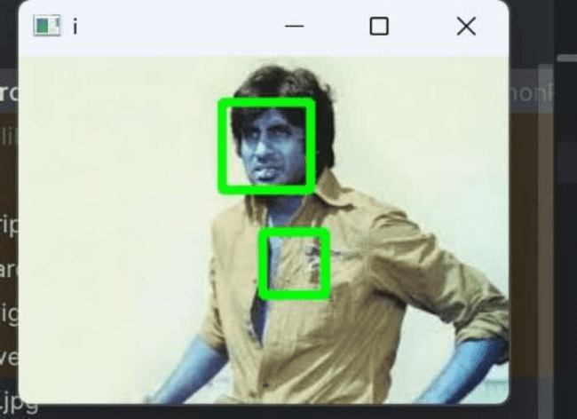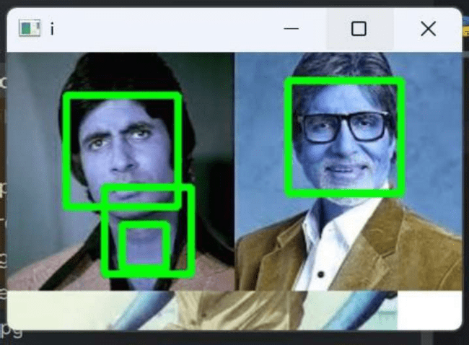

##### M.Sc.IT Semester II

**M.Sc.IT ** **Semester II**

**Part A.2 -**

**Aim - Perform Object Detection**

**Image Used -** stop.png, stop1.jpeg, stop2.jpeg **Files used -**

stop_data.xml

**Steps -**

 **Open pycharm**

 **Create Project / Open Project**

 **Upload the images on the project**

 **Upload stop_data.xml in the project ** **Start Execution**

**Code -**

import cv2

from matplotlib import pyplot as plt # Opening image

img = cv2.imread("stop.png")

# OpenCV opens images as BRG so it must be converted to RGB and grayscale version img_gray = cv2.cvtColor(img, cv2.COLOR_BGR2GRAY)

img_rgb = cv2.cvtColor(img, cv2.COLOR_BGR2RGB) # Use minSize because for not

# bothering with extra-small

# dots that would look like STOP signs

stop_data = cv2.CascadeClassifier('stop_data.xml')

found = stop_data.detectMultiScale(img_gray, minSize =(20, 20)) # Don't do anything if there's

# no sign

amount_found = len(found) if amount_found!= 0:

# There may be more than one # sign in the image

for (x, y, width, height) in found:

# We draw a green rectangle around # every recognized sign

##### M.Sc.IT Semester II

cv2.rectangle(img_rgb, (x, y),

(x + height, y + width), (0, 255, 0), 5)

# Creates the environment of # the picture and shows it cv2.imshow('img',img_rgb) plt.show() cv2.waitKey(0) **Output-**

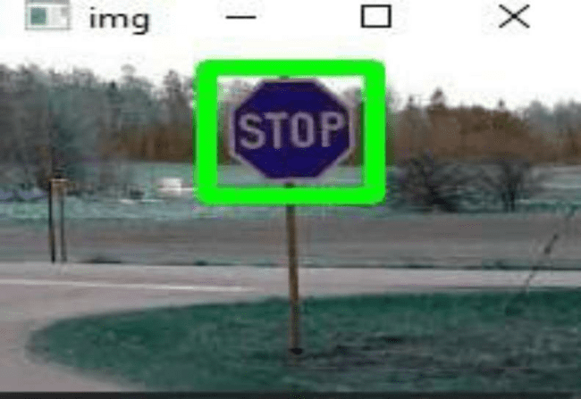

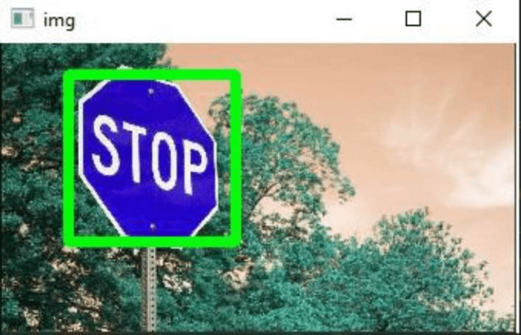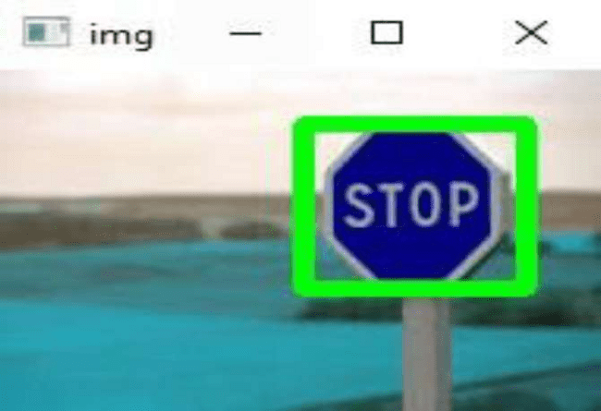

##### M.Sc.IT Semester II

**Part A.3 -**

**Aim - Perform Pedestrian detection**

**Packages Used ** **imutils Command -** Terminal

 pip install imutils

**Image Used -** input1.png, people1.jpeg, people2.jpeg **Code -**

import cv2 import imutils

# Initializing the HOG person # detector

hog = cv2.HOGDescriptor() hog.setSVMDetector(cv2.HOGDescriptor_getDefaultPeopleDetector()) # Reading the Image image = cv2.imread('people2.jpeg')

# Resizing the Image

image = imutils.resize(image,width=min(400, image.shape[1]))

# Detecting all the regions in the

# Image that has a pedestrians inside it (regions, _) = hog.detectMultiScale(image,

winStride=(4, 4),

padding=(10, 10), scale=1.05) print(regions)

# Drawing the regions in the Image for (x, y, w, h) in regions:

cv2.rectangle(image, (x, y), (x + w, y + h), (0,

0, 255), 2)

# Showing the output Image cv2.imshow("Image", image) cv2.waitKey(0) cv2.destroyAllWindows()

##### M.Sc.IT Semester II

**Output -**

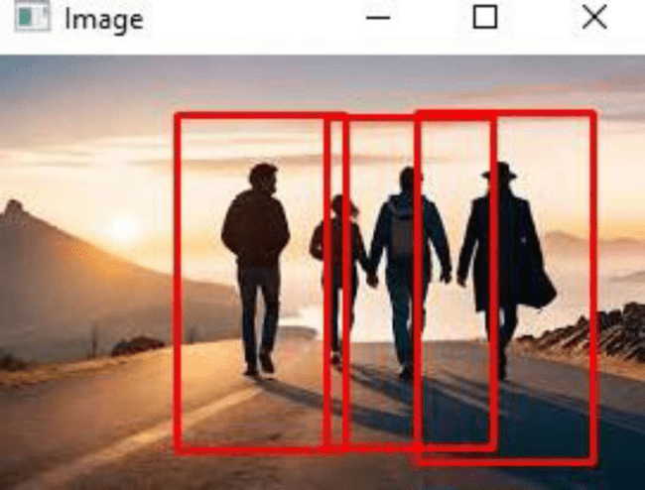

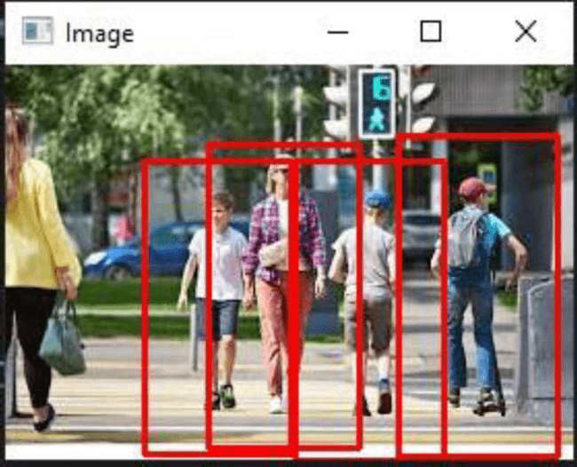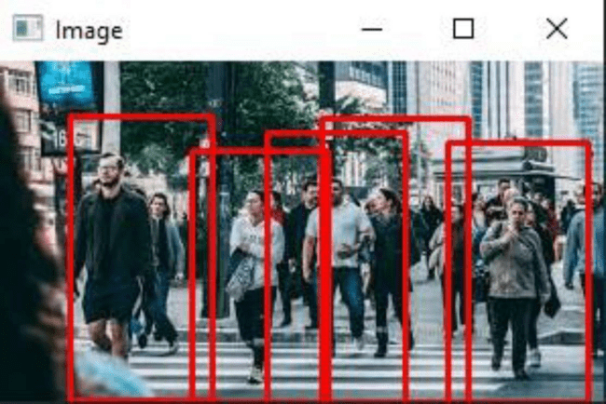

##### M.Sc.IT Semester II

**Part A.4 -**

**Aim - Perform Face Recognition**

**Packages Used -** cv2, cmake, face_recognition **Instruction**:

1. 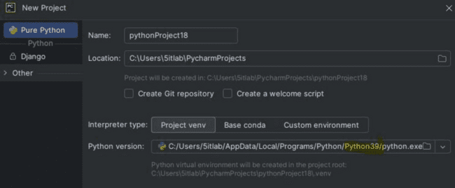Install Python 3.9>>Set Python path on python 3.9
2. Copy **dlib-19.23.0-cp39-cp39-win_amd64.whl** file in 3 locations  Pycharm Project

 C:\Users\5itlab\PycharmProjects\pythonProject17\.venv\Scripts

 C:\Users\5itlab\AppData\Local\Programs\Python\Python39\Scripts

1. Install all the packages in Pycharm Projects pip install cmake

pip install dlib-19.23.0-cp39-cp39-win_amd64.whl

pip install opencv-python ( version 3.9) pip install face_recognition

pip uninstall pillow pip install pillow pip uninstall numpy

pip install numpy==1.26.4

1. Install the packages in (PYCHARM LINK)

C:\Users\5itlab\PycharmProjects\pythonProject17\.venv\Scripts pip install cmake pip install dlib-19.23.0-cp39-cp39-win_amd64.whl pip install opencv-python ( version 3.9)

pip install face_recognition

1. Install the packages in (PROGRAM LINK)

C:\Users\5itlab\AppData\Local\Programs\Python\Python39\Scripts pip install cmake pip install dlib-19.23.0-cp39-cp39-win_amd64.whl pip install opencv-python ( version 3.9)

##### M.Sc.IT Semester II

pip install face_recognition

##### M.Sc.IT Semester II

**Files Used: nana.jpg, non.jgp, dlib-19.23.0-cp39-cp39-win_amd64.whl Code:**

import cv2

import face_recognition

imgmain1 = face_recognition.load_image_file('nana.jpg') imgmain = cv2.cvtColor(imgmain1, cv2.COLOR_BGR2RGB) imgTest1 = face_recognition.load_image_file('non.jpg') imgTest = cv2.cvtColor(imgTest1, cv2.COLOR_BGR2RGB)

faceLoc = face_recognition.face_locations(imgmain)[0] encodeElon = face_recognition.face_encodings(imgmain)[0]

cv2.rectangle(imgmain, (faceLoc[3], faceLoc[0]), (faceLoc[1], faceLoc[2]), (255, 0, 255), 2)

faceLocTest = face_recognition.face_locations(imgTest)[0] encodeTest = face_recognition.face_encodings(imgTest)[0]

cv2.rectangle(imgTest, (faceLocTest[3], faceLocTest[0]), (faceLocTest[1], faceLocTest[2]), (255, 0, 255), 2)

results = face_recognition.compare_faces([encodeElon], encodeTest) faceDis = face_recognition.face_distance([encodeElon], encodeTest) print(results, faceDis) cv2.putText(imgTest, f'{results} {round(faceDis[0], 2)}', (20, 20),

cv2.FONT_HERSHEY_COMPLEX, 1, (0, 0, 255), 2)

cv2.imshow('Main Image', imgmain) cv2.imshow('Test Image', imgTest) cv2.waitKey(0)

**Output:**

##### M.Sc.IT Semester II

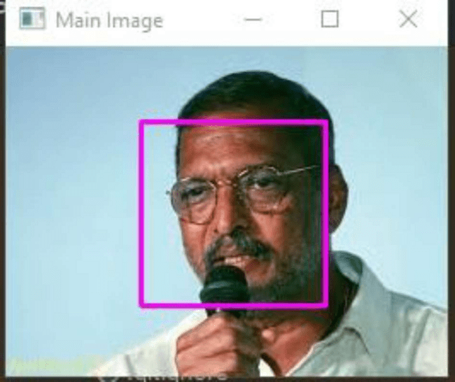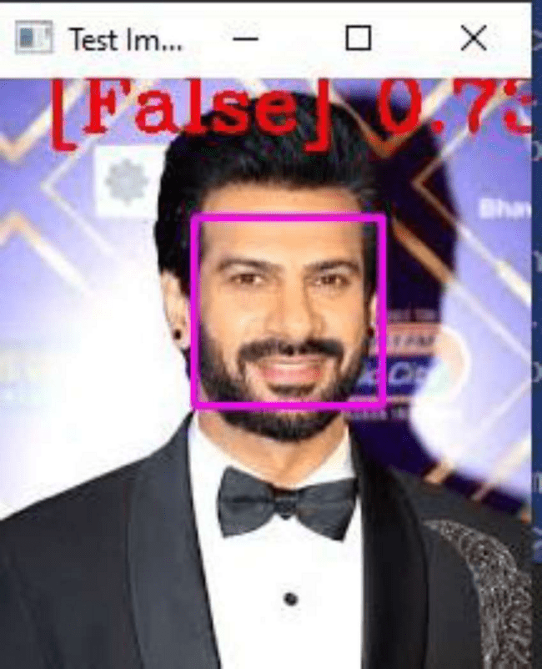

**M.Sc.IT ** **Semester II**

**Case 2:**

**Code:**

import cv2

import face_recognition

imgmain1 = face_recognition.load_image_file('jackiedada.jpg') imgmain = cv2.cvtColor(imgmain1, cv2.COLOR_BGR2RGB) imgTest1 = face_recognition.load_image_file('nanap.jpg') imgTest = cv2.cvtColor(imgTest1, cv2.COLOR_BGR2RGB) faceLoc = face_recognition.face_locations(imgmain)[0] encodeElon = face_recognition.face_encodings(imgmain)[0]

cv2.rectangle(imgmain, (faceLoc[3], faceLoc[0]), (faceLoc[1], faceLoc[2]), (255, 0, 255), 2) faceLocTest = face_recognition.face_locations(imgTest)[0] encodeTest = face_recognition.face_encodings(imgTest)[0]

cv2.rectangle(imgTest, (faceLocTest[3], faceLocTest[0]), (faceLocTest[1], faceLocTest[2]), (255, 0, 255), 2) results = face_recognition.compare_faces([encodeElon], encodeTest) faceDis = face_recognition.face_distance([encodeElon], encodeTest) print(results, faceDis) cv2.putText(imgTest, f'{results} {round(faceDis[0], 2)}', (20, 20),

cv2.FONT_HERSHEY_COMPLEX, 1, (0, 0, 255), 2)

cv2.imshow('Main Image', imgmain) cv2.imshow('Test Image', imgTest) cv2.waitKey(0)

**Output:**

##### M.Sc.IT Semester II

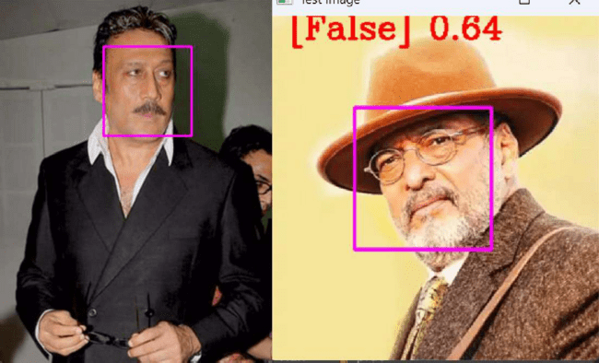

**Part B -**

**Aim - Perform Construct 3D model from images**

**Packages used - Pillow Command -**

 C:\Users\5itlab\PycharmProjects\CVP\venu\Scripts\activate (To Set the given script path in the terminal.

 Pip install pillow (Pillow)

**Image Used -** cube1.jpeg, cube2.jpeg **Code -**

from PIL import Image # pip install Pillow import numpyasnp

def shift_image(img, depth_img, shift_amount=10): # Ensure base image has alpha img = img.convert("RGBA") data = np.array(img)

# Ensure depth image is grayscale (for single value) depth_img = depth_img.convert("L")

##### M.Sc.IT Semester II

depth_data = np.array(depth_img)

deltas = ((depth_data / 255.0) * float(shift_amount)).astype(int) # This creates the transparent resulting image.

# For now, we're dealing with pixel data. shifted_data = np.zeros_like(data) height, width, _ = data.shape

for y, row in enumerate(deltas): for x, dx in enumerate(row):

if x + dx < width and x + dx >= 0: shifted_data[y, x + dx] = data[y, x]

# Convert the pixel data to an image.

shifted_image = Image.fromarray(shifted_data.astype(np.uint8)) return shifted_image img = Image.open("cube1.jpeg") depth_img =

Image.open("cube2.jpeg")

shifted_img = shift_image(img, depth_img, shift_amount=10) shifted_img.show()

##### M.Sc.IT Semester II

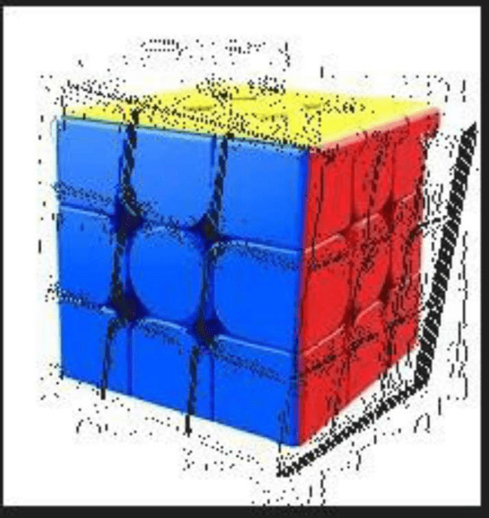**Output **

##### M.Sc.IT Semester II

**Part C**

**Aim -** Implement object detection and tracking from video **Files used -** v2.mp4, v3.mp4

**Code -**

import cv2

# Load the pre-trained face detection model face_classifier = cv2.CascadeClassifier(

cv2.data.haarcascades + "haarcascade_frontalface_default.xml"

)

# Replace webcam capture with video file capture video_capture = cv2.VideoCapture("v4.mp4")

# Function to detect faces and draw bounding boxes def detect_bounding_box(vid):

gray_image = cv2.cvtColor(vid, cv2.COLOR_BGR2GRAY) # Convert to grayscale faces = face_classifier.detectMultiScale(gray_image, 1.1, 5, minSize=(40, 40))

for (x, y, w, h) in faces:

cv2.rectangle(vid, (x, y), (x + w, y + h), (0, 255, 0), 4) # Draw rectangle return faces # Process video frames while True:

result, video_frame = video_capture.read() # Read frames from the video file if result is False: # terminate the loop if the frame is not read successfully

break

detect_bounding_box(video_frame) # Detect faces and draw bounding boxes cv2.imshow( "Face Detection in Video", video_frame

) # Display the processed frame in a window

if cv2.waitKey(1) & 0xFF == ord("q"): # Exit when 'q' is pressed break # Release video capture and close display window video_capture.release() cv2.destroyAllWindows()

##### M.Sc.IT Semester II

**Output -**

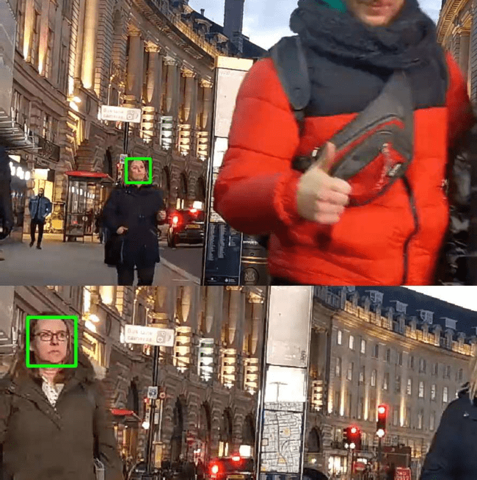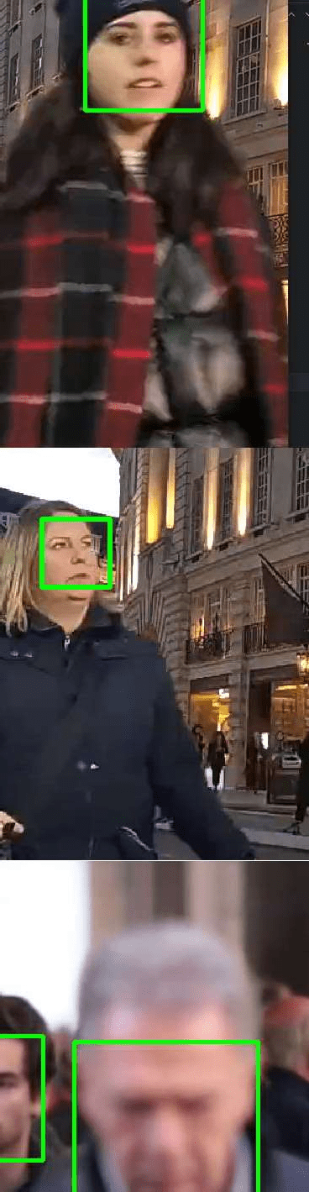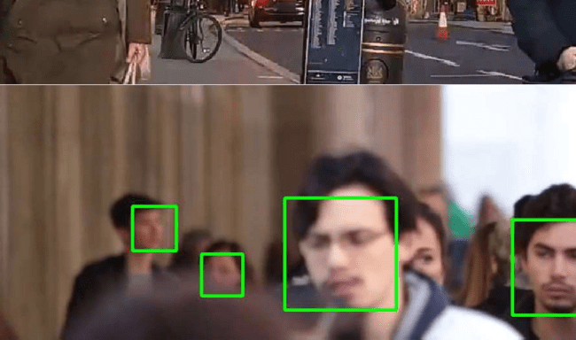

##### M.Sc.IT Semester II

**Case 2 :** Implement object detection and tracking from Camera Input.

**Files Used:** haarcascade_frontalface_default.xml - location

**(C:\Users\5itlab\PycharmProjects\pythonProject17\.venv\Lib\site-packages\cv 2\data)**

**Code:**

import cv2 face_classifier =

cv2.CascadeClassifier(cv2.data.haarcascades+"haarcascade_frontalface_defa ult.xml")

video_capture = cv2.VideoCapture(0)

def detect_bounding_box(vid):

gray_image = cv2.cvtColor(vid, cv2.COLOR_BGR2GRAY)

faces = face_classifier.detectMultiScale(gray_image, 1.1, 5, minSize=(40, 40)) for (x, y, w, h) in faces: cv2.rectangle(vid, (x, y), (x + w, y + h), (0, 255, 0), 4) return faces

while True:

result, video_frame = video_capture.read() # read frames from the video if result is False: break # terminate the loop if the frame is not read successfully faces =

detect_bounding_box( video_frame

) # apply the function we created to the video frame cv2.imshow( "My Face Detection Project", video_frame

) # display the processed frame in a window named "My Face Detection Project" if cv2.waitKey(1) & 0xFF == ord("q"):

break

video_capture.release() cv2.destroyAllWindows()

**Output:**

##### M.Sc.IT Semester II

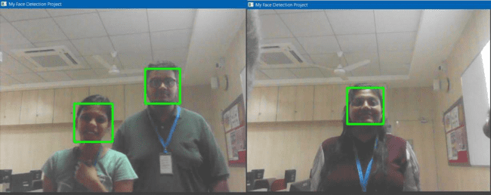

**M.Sc.IT ** **Semester II**

**Practical No. 3 Part A :**

**Aim : Perform Feature Extraction using RANSAC**

**Concept :**

1. **Linear Least Squares Regression (linearleastsquare.py)**

The **Linear Least Squares model** (LinearLeastSquareModel) is used for polynomial curve fitting. It solves the equation:

 1ATYP = (A^T A)^{-1} A^T  1ATY

where:

 AAA represents the **design matrix** containing polynomial features of input xxx.  YYY is the **output vector**.

 PPP is the **estimated model parameters** (coefficients of the polynomial).

This method **minimizes the sum of squared residuals** but is **sensitive to outliers**, which is why

**RANSAC is used as an alternative**.

1. **RANSAC Algorithm (ransac.py)**

RANSAC (**Random Sample Consensus**) is an iterative method to **estimate a model from data with outliers**. The steps are:

* 1. **Randomly select a subset (num_sample=3)** of data points.
  2. **Fit a model using the subset** (via the Least Squares method).
  3. **Evaluate the model** using all data points by counting **inliers** (points within threshold error).
  4. **Update the best model** if the new model has more inliers than the previous best.
  5. **Estimate the probability of outliers** to **adaptively determine the number of iterations**

needed.

* 1. **Repeat until the stopping condition is met** (desired probability of success). This ensures that

**outliers (noise) do not heavily impact the final model**, unlike the least squares approach.

1. **Model Fitting and Visualization (modelfitting.py)**

 Reads datasets (data_1.csv and data_2.csv).

 Computes **second-degree polynomial features** (x^2, x, 1) for curve fitting.  Uses both **Least Squares and RANSAC** to fit curves.

 **Plots and compares results**:

* **Red curve**: Least Squares model.
* **Blue curve**: RANSAC model (robust to outliers).

**Packages Used :**

**scikit-learn** is often used for robust regression tasks, including feature extraction.

##### M.Sc.IT Semester II

**OpenCV** provides robust feature matching techniques, including the use of RANSAC in methods like findHomography() and estimateFundamentalMat() for applications in image matching, homography, and stereo vision.

**PyTorch** and **TensorFlow** are used to build custom models or layers that involve robust fitting techniques (e.g., combining RANSAC with neural networks for specific applications).

**Numpy** and **SciPy** are often used in conjunction with other packages like scikit-learn and opencv for basic matrix operations, data manipulation, and statistical computations when implementing RANSAC or working with feature extraction tasks.

**ransac = RANSACRegressor()**

This initializes the RANSACRegressor object.

 min_samples : The minimum number of data points required to estimate the model (default is 2, i.e., two data points for linear regression).

 residual_threshold : The maximum distance from a point to the model to be considered an inlier (default is None, which automatically sets a value based on the scale of the data).

is_data_valid : Boolean value that determines if the data is valid (default is True). max_trials : The maximum number of iterations to run the algorithm (default is 100).

 random_state : Controls the randomization of the algorithm. This helps with reproducibility. (Default is None).

**ransac.fit(X, y)**

This fits the RANSAC model to the provided data.

X : The input data, which should be a 2D array of shape (n_samples, n_features) where n_samples is the number of data points, and n_features is the number of features (in this case, it's just one feature).

 y : The target data (labels), which is the dependent variable, in this case, the values you are trying to predict.

**RANSAC Algorithm (ransac.py)**

**class RansacModel:** defines a class for implementing the RANSAC algorithm for curve fitting.

**def**  **init** **(self, curve_fitting_model):** initializes the RANSAC model with a given curve fitting model.

 curve_fitting_model : An instance of a curve fitting model (e.g., least squares).  No return value.

##### M.Sc.IT Semester II

**def fit(self, A, Y, num_sample, threshold):** implements the RANSAC algorithm to estimate the best curve fitting model.

 A : Input matrix of features.

 Y : Output values corresponding to A.

 num_sample : Number of samples for model fitting (fixed at 3).  threshold : Error threshold to determine inliers.

 Returns the best estimated model.

**num_iterations = math.inf** sets the number of iterations to infinity initially. **iterations_done = 0** keeps track of completed iterations. **max_inlier_count = 0** stores the highest number of inliers found. **best_model = None** holds the best model found so far.

**prob_outlier = 0.5** initializes the estimated probability of an outlier. **desired_prob = 0.95** sets the desired probability of finding the best model. **total_data = np.column_stack((A, Y))** combines A and Y into a single dataset for shuffling.

**data_size = len(total_data)** gets the number of data points.

**while num_iterations>iterations_done:** runs the RANSAC loop until the required number of iterations is reached.

**np.random.shuffle(total_data)** shuffles the dataset to pick random samples. **sample_data = total_data[:num_sample, :]** selects num_sample random data points. **estimated_model = self.curve_fitting_model.fit(sample_data[:, :-1], sample_data[:,**

**-1:])** fits the curve using the selected sample data.  sample_data[:, :-1] : Extracts feature columns.  sample_data[:, -1:] : Extracts output column.

 Returns the estimated model parameters.

**y_cap = A.dot(estimated_model):** calculates predicted values using the estimated model.

**err = np.abs(Y - y_cap.T):** computes absolute errors between actual and predicted values.

**inlier_count = np.count_nonzero(err<threshold)**: counts inliers (data points with errors below threshold).

**if inlier_count>max_inlier_count:** checks if the current model is better than previous models.

 Updates max_inlier_count and best_model if more inliers are found. **prob_outlier = 1 - inlier_count / data_size**: updates the estimated probability of an outlier.

**num_iterations = math.log(1 - desired_prob) / math.log(1 - (1 - prob_outlier) ** num_sample):** updates the required number of iterations.

**iterations_done = iterations_done + 1:** increments the iteration count.

**return best_model**: returns the best estimated model after the loop completes. **Linear Least Squares Regression (linearleastsquare.py)**

##### M.Sc.IT Semester II

**class LinearLeastSquareModel:** defines a class for solving least squares problems. **def fit(self, A, Y):** fits a linear model to the given data using least squares.

 A : Feature matrix.  Y : Output values.

 Returns the estimated model parameters.

**A_transpose = A.transpose():** computes the transpose of A. ATA = A_transpose.dot(A) computes A' * A.

ATY = A_transpose.dot(Y) computes A' * Y.

model = (np.linalg.inv(ATA)).dot(ATY) solves for model parameters using (A'A)^(-1) * A'Y. return model returns the estimated parameters. **Model Fitting**

**and Visualization (modelfitting.py):**

**import numpy as np, import math, import pandas as pd, and from matplotlib import pyplot as plt**: import necessary libraries.

**from ransac import RansacModel and from linearleastsquare import LinearLeastSquareModel:** import the model classes.

**def fit_curve(data):** fits a curve to given data using least squares and RANSAC.  data : Pandas DataFrame containing x and y values.

 Returns fitted curves from least squares and RANSAC. **x_values = np.array(data['x']):** extracts x-values from the dataset. **y_values = np.array(data['y']):** extracts y-values from the dataset.

**x_sq = np.power(x_values, 2):** computes squared x-values for quadratic fitting.

**A = np.stack((x_sq, x_values, np.ones((len(x_values)), dtype=int)), axis=1)**: constructs the feature matrix [x² x 1].

**threshold = np.std(y_values) / 2**: sets an adaptive inlier threshold based on standard deviation. **linear_ls_model = LinearLeastSquareModel():** creates an instance of the least squares model. **linear_ls_model_estimate = linear_ls_model.fit(A, y_values)**: fits the least squares model. **linear_model_y = A.dot(linear_ls_model_estimate)**: computes predicted values from

the least squares model.

**ransac_model = RansacModel(linear_ls_model):** creates an instance of the RANSAC model using the least squares model.

**ransac_model_estimate = ransac_model.fit(A, y_values, 3, threshold):** fits the RANSAC model. **ransac_model_y = A.dot(ransac_model_estimate)**: computes predicted values from the RANSAC model. **return linear_model_y, ransac_model_y:** returns both fitted curves.

**if**  **name** **== '** **main** **':** ensures the script runs only when executed directly.

**df1 = pd.read_csv('data_1.csv') and df2 = pd.read_csv('data_2.csv')** load two datasets.

##### M.Sc.IT Semester II

**ls_model_y1, ransac_model_y1 = fit_curve(df1)** fits curves for dataset 1. **ls_model_y2, ransac_model_y2 = fit_curve(df2)** fits curves for dataset 2. **fig, (ax1, ax2) = plt.subplots(1, 2)** creates a figure with two subplots. **ax1.set_title('Dataset-1')** sets the title for the first subplot.

**ax1.scatter(df1['x'], df1['y'], marker='o', color=(0, 1, 0), label='data points')** plots original data points.

**ax1.plot(df1['x'], ls_model_y1, color='red', label='Least square model')** plots the least squares model. **ax1.plot(df1['x'], ransac_model_y1, color='blue', label='Ransac model')** plots the RANSAC model. **ax1.set(xlabel='x-axis', ylabel='y-axis')** labels axes.

**ax1.legend()** adds a legend.

**Same is done for another data set. plt.show()**

displays the plots.

##### M.Sc.IT Semester II

**Part B :**

**Aim : Perform Colorization**

**Concept :**

Colorization is the process of adding colors to grayscale (black-and-white) images or videos. This is done by predicting the missing chrominance (color) information while preserving the luminance (brightness details).

Traditionally, colorization was done manually by artists, but deep learning models have now automated the process with realistic results.

Most deep learning-based colorization techniques use the LAB color space instead of RGB: L (Lightness)  Represents brightness (grayscale image).

A (Green-Red channel)  Represents color from green to red.

B (Blue-Yellow channel)  Represents color from blue to yellow.

By using deep learning models, the L channel is kept as input, while the model predicts the missing A and B channels to generate a realistic color image.

**ECCV 2016 Model (Deep Colorization Model):**

The **ECCV 2016 Colorization Model** was introduced in a research paper titled    by Richard Zhang, Phillip Isola, and Alexei A. Efros at the **European Conference on Computer Vision (ECCV 2016)**.

 Uses a **deep convolutional neural network (CNN)** to learn how to predict **AB color channels** from a grayscale image.

The model is trained on **millions of images** from ImageNet, learning **natural color distributions**.

Introduces a **probabilistic color distribution approach** to handle ambiguity in colors.

 **Working:**

 The input grayscale image is **fed into a deep CNN**.  The CNN **predicts the missing AB color channels**.

 The output LAB image is converted **back to RGB** for display.

**Limitations**

 The model may **struggle with unusual color distributions**.  Sometimes, it **produces desaturated or unrealistic colors**.

**SIGGRAPH 2017 Model (Enhanced Colorization Model):**

The **SIGGRAPH 2017 Model** was introduced in the paper



  by Richard Zhang et al. at **SIGGRAPH 2017**, a premier graphics

conference.

 Uses a **deeper CNN architecture** to improve **sharpness and color accuracy**.

##### M.Sc.IT Semester II

 Introduces **semantic understanding**, meaning it learns **context** to apply the correct colors (e.g., sky is blue, leaves are green).

 Can **self-correct unrealistic color predictions**.

Uses **a classifier to refine ambiguous colors**, ensuring more **realistic and vibrant results**. **Working**

The grayscale image is passed through a **deeper CNN model**.

The model **analyzes object-level features** (e.g., detects faces, landscapes, etc.). The **AB color channels are predicted with higher accuracy**.

The output is **converted to RGB** and displayed.

**Advantages Over ECCV 2016**

 **More realistic and natural colors**

 **Better context-awareness** (understands what objects are)

 **Sharper and more detailed output**

**Packages Used :**

**Torch** is an open-source machine learning library originally developed for Lua, which has now evolved into PyTorch, a widely used Python library. PyTorch, built on Torch's foundation, is a flexible, high- performance framework used for building and training deep learning models. Torch and PyTorch are designed to handle large-scale computational tasks efficiently, particularly in the domain of deep learning and neural networks.

**argparse** handles command-line arguments (though unused in this script). **matplotlib.pyplot**

is used for displaying and saving images.

**colorizer_eccv16 = eccv16(pretrained=True).eval() colorizer_siggraph17 = siggraph17(pretrained=True).eval()** Loads two deep learning models for image colorization.

 ECCV 16 : Model from the 2016 European Conference on Computer Vision.  SIGGRAPH 17 : Model from the 2017 SIGGRAPH Conference.

**img = load_img('imgs/ansel_adams2.jpg')**

**(tens_l_orig, tens_l_rs) = preprocess_img(img, HW=(256,256))**

Loads the black-and-white image. Converts the image to Lab color space. Extracts the L-channel (grayscale information) at two resolutions:

 tens_l_orig : Original size.

 tens_l_rs : Resized to 256x256 (needed for the models).

**img_bw = postprocess_tens(tens_l_orig, torch.cat((0*tens_l_orig,0*tens_l_orig),dim=1))**

##### M.Sc.IT Semester II

**out_img_eccv16 = postprocess_tens(tens_l_orig, colorizer_eccv16(tens_l_rs).cpu()) out_img_siggraph17 = postprocess_tens(tens_l_orig,colorizer_siggraph17(tens_l_rs).cpu())**

 torch.cat((0*tens_l_orig, 0*tens_l_orig), dim=1): Creates a zero-filled a*b color channels (L stays the same).

 postprocess_tens(): Converts it back to an RGB image.

 colorizer_eccv16(tens_l_rs).cpu(): Predicts a*b color channels.

 colorizer_siggraph17(tens_l_rs).cpu(): Same process using a different model.  postprocess_tens(): Converts the outputs into RGB format.

**M.Sc.IT ** **Semester II**

#### Practical No. 3

**Part A**

**Aim**: Perform Feature extraction using RANSAC

**Steps:**

**Packages Used: numpy, math, pandas, matplotlib**

**Command:**

**pip install numpy pip install pandas pip install matplotlib**

**Files Used:**

**data_1.csv, data_2.csv**

**ransac.py**

import numpy as np import math

class RansacModel:

def init (self, curve_fitting_model): self.curve_fitting_model = curve_fitting_model

def fit(self, A, Y, num_sample, threshold):

num_iterations = math.inf iterations_done = 0 num_sample = 3

max_inlier_count = 0 best_model = None

prob_outlier = 0.5

desired_prob = 0.95

total_data = np.column_stack((A, Y)) # [A | Y] data_size = len(total_data)

# Adaptively determining the number of iterations while num_iterations > iterations_done:

# Shuffle the rows and take the first 'num_sample' rows as sample data np.random.shuffle(total_data)

##### M.Sc.IT Semester II

sample_data = total_data[:num_sample, :]

estimated_model = self.curve_fitting_model.fit(sample_data[:, :-1], sample_data[:, -1:]) # [a b c] # Count the inliers within the threshold y_cap =

A.dot(estimated_model) err = np.abs(Y - y_cap.T)

inlier_count = np.count_nonzero(err<threshold)

# check for the best model

if inlier_count > max_inlier_count: max_inlier_count = inlier_count best_model = estimated_model

prob_outlier = 1 - inlier_count / data_size print('# inliers:', inlier_count)

print('# prob_outlier:', prob_outlier)

num_iterations = math.log(1 - desired_prob) / math.log(1 - (1 - prob_outlier) ** num_sample) iterations_done = iterations_done + 1

print('# s:', iterations_done) print('# n:', num_iterations)

print('# max_inliner_count: ', max_inlier_count) return best_model

**linearleastsquare.py** import numpy as np

class LinearLeastSquareModel: def fit(self, A, Y):

A_transpose = A.transpose() ATA = A_transpose.dot(A) ATY = A_transpose.dot(Y)

model = (np.linalg.inv(ATA)).dot(ATY)

# For a linear eq. AP = Y to solve a least sqaure problem, P = (inverse(A'A))(A'Y) return model

**modelfitting.py** import numpy as np import math

##### M.Sc.IT Semester II

import pandas as pd

from matplotlib import pyplot as plt from ransac import RansacModel

from linearleastsquare import LinearLeastSquareModel # from<filename>import<classname>

def fit_curve(data):

x_values = np.array(data['x']) y_values = np.array(data['y'])

x_sq = np.power(x_values, 2) ## A = [x^2 x 1]

A = np.stack((x_sq, x_values, np.ones((len(x_values)), dtype=int)), axis=1) threshold = np.std(

y_values) / 2 # this can be tuned to sd/3 or sd/5 for various curves and better consistent results as a result of random sampling

# Instantiating the linear least square model linear_ls_model = LinearLeastSquareModel() linear_ls_model_estimate = linear_ls_model.fit(A, y_values) linear_model_y = A.dot(linear_ls_model_estimate)

# Instantiating the ransac model

ransac_model = RansacModel(linear_ls_model) ransac_model_estimate = ransac_model.fit(A, y_values, 3, threshold) ransac_model_y = A.dot(ransac_model_estimate)

return linear_model_y, ransac_model_y if

name == ' main ': # reading the values

df1 = pd.read_csv('data_1.csv') df2 = pd.read_csv('data_2.csv')

ls_model_y1, ransac_model_y1 = fit_curve(df1) ls_model_y2, ransac_model_y2 = fit_curve(df2)

fig, (ax1, ax2) = plt.subplots(1, 2) ax1.set_title('Dataset-1')

ax1.scatter(df1['x'], df1['y'], marker='o', color=(0, 1, 0), label='data points')

##### M.Sc.IT Semester II

ax1.plot(df1['x'], ls_model_y1, color='red', label='Least sqaure model') ax1.plot(df1['x'], ransac_model_y1, color='blue', label='Ransac model') ax1.set(xlabel='x-axis', ylabel='y- axis')

ax1.legend()

ax2.set_title('Dataset-2')

ax2.scatter(df2['x'], df2['y'], marker='o', color=(0, 1, 0), label='data points') ax2.plot(df2['x'], ls_model_y2, color='red', label='Least sqaure model') ax2.plot(df2['x'], ransac_model_y2, color='blue', label='Ransac model') ax2.set(xlabel='x-axis', ylabel='y-axis')

ax2.legend() plt.show()

##### M.Sc.IT Semester II

**Output:**

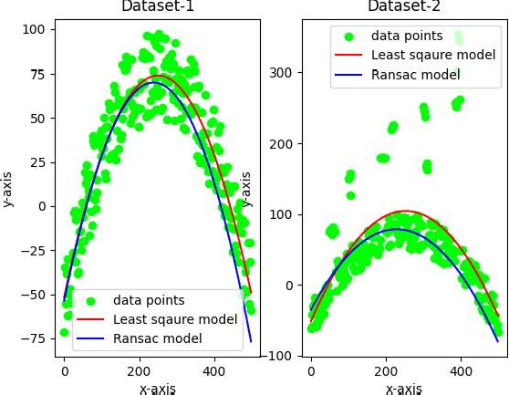

**Console:**

# inliers: 14

# prob_outlier: 0.944

# s: 1

# n: 17056.92657043659

# max_inliner_count: 14

# inliers: 13

# prob_outlier: 0.948

# s: 2

# n: 21304.062760691897

# max_inliner_count: 14

# inliers: 72

# prob_outlier: 0.712

# s: 3

# n: 123.90418270340892

# max_inliner_count: 72

# inliers: 39

# prob_outlier: 0.844

# s: 4

# n: 787.5960236371116

# max_inliner_count: 72

# inliers: 27

# prob_outlier: 0.892

# s: 5

# n: 2376.6106833968684

# max_inliner_count: 72

# inliers: 157

##### M.Sc.IT Semester II

# prob_outlier: 0.372

# s: 6

# n: 10.526691399992457

# max_inliner_count: 157

# inliers: 130

# prob_outlier: 0.48

# s: 7

# n: 19.769880355510256

# max_inliner_count: 157

# inliers: 188

# prob_outlier: 0.248

# s: 8

# n: 5.409062282538675

# max_inliner_count: 188

# inliers: 187

# prob_outlier: 0.252

# s: 1

# n: 5.525552495791251

# max_inliner_count: 187

# inliers: 55

# prob_outlier: 0.78

# s: 2

# n: 279.841710984081

# max_inliner_count: 187

# inliers: 201

# prob_outlier: 0.19599999999999995

# s: 3

# n: 4.08481384841806

# max_inliner_count: 201

# inliers: 191

# prob_outlier: 0.236

# s: 4

# n: 5.073307052973716

# max_inliner_count: 201

# inliers: 67

# prob_outlier: 0.732

# s: 5

# n: 154.12918046553153

# max_inliner_count: 201

# inliers: 184

# prob_outlier: 0.264

# s: 6

##### M.Sc.IT Semester II

# n: 5.889670195389181

# max_inliner_count: 201

##### M.Sc.IT Semester II

**Part B**

**Aim: Perform Colorization**

**Steps:**

**Packages Used: torch, argparse, ipython, scikit-image, matplotlib, colorizer (local package) Command:**

**pip install torch**

On PyCharm Terminal

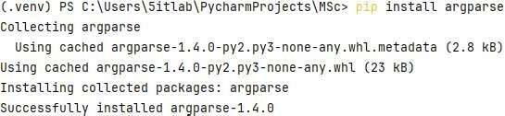**pip install argparse** On PyCharm Terminal

**pip install ipython**

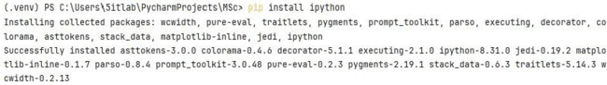On PyCharm Terminal

**pip install scikit-image** On PyCharm Terminal



**pip install matplotlib** On PyCharm Terminal

##### M.Sc.IT Semester II



Open the project folder and add the **colorizer** package in the project.

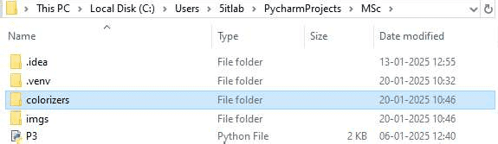

**Note:** If error is found in installing packages on both PyCharm Terminal and Command Prompt, execute the following command and then try again to install packages:

**<<Project Path>>\.venv\Scripts\activate**

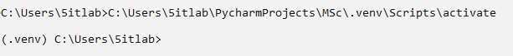

**Images Used:**

imgs>>ansel_adams.jpg, ansel_adams2.jpg, ansel_adams3.jpg, ILSVRC2012_val_00041580.JPEG, ILSVRC2012_val_00046524.JPEG, ILSVRC2012_val_00046834.JPEG

**Code:**

import argparse

import matplotlib.pyplot as plt

from colorizers import * #local package

# load colorizers

colorizer_eccv16 = eccv16(pretrained=True).eval() colorizer_siggraph17 = siggraph17(pretrained=True).eval()

# default size to process images is 256x256

# grab L channel in both original ("orig") and resized ("rs") resolutions img = load_img('imgs/ansel_adams.jpg')

(tens_l_orig, tens_l_rs) = preprocess_img(img, HW=(256,256))

# colorizer outputs 256x256 ab map

# resize and concatenate to original L channel img_bw = postprocess_tens(tens_l_orig, torch.cat((0*tens_l_orig,0*tens_l_orig),dim=1))

out_img_eccv16 = postprocess_tens(tens_l_orig, colorizer_eccv16(tens_l_rs).cpu()) out_img_siggraph17 = postprocess_tens(tens_l_orig, colorizer_siggraph17(tens_l_rs).cpu())

##### M.Sc.IT Semester II

plt.imsave('s_eccv16.png', out_img_eccv16) plt.imsave('s_siggraph17.png', out_img_siggraph17)

plt.figure(figsize=(12,8)) plt.subplot(2,2,1) plt.imshow(img) plt.title('Original') plt.axis('off')

plt.subplot(2,2,2) plt.imshow(img_bw) plt.title('Input') plt.axis('off')

plt.subplot(2,2,3) plt.imshow(out_img_eccv16) plt.title('Output (ECCV 16)') plt.axis('off')

plt.subplot(2,2,4) plt.imshow(out_img_siggraph17) plt.title('Output (SIGGRAPH 17)') plt.axis('off')

plt.show() **Output:**

**Case ** **I (ansel_adams.jpg)**

##### M.Sc.IT Semester II

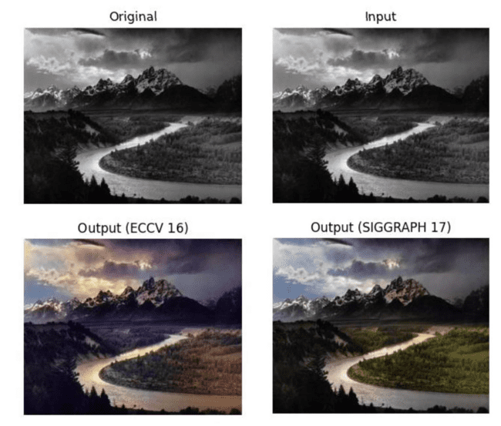

**M.Sc.IT ** **Semester II**

**Case ** **II (ansel_adams2.jpg)**

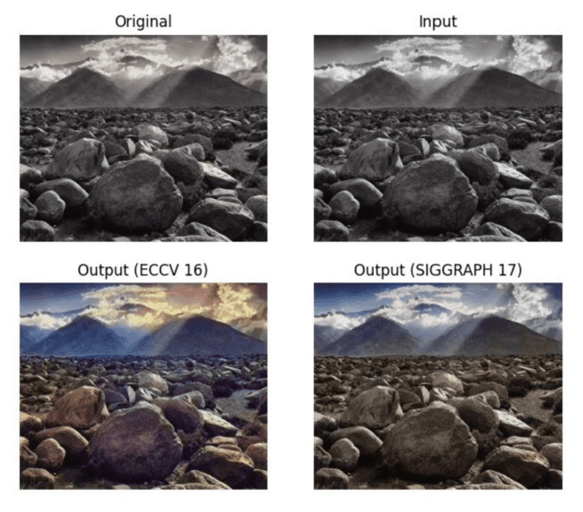

**Case ** **III (ansel_adams3.jpg)**

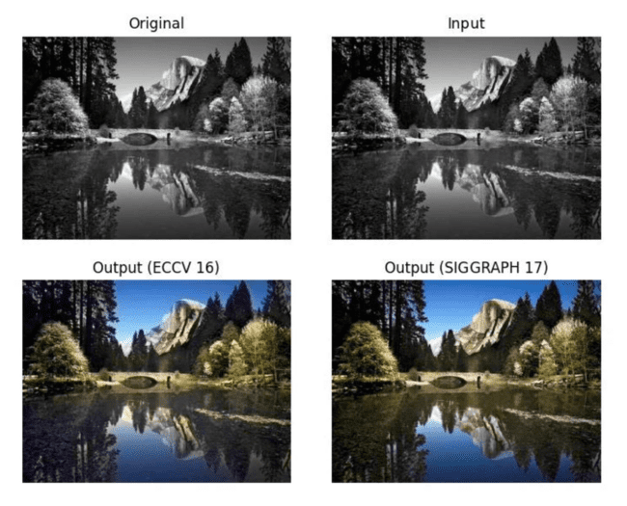

##### M.Sc.IT Semester II

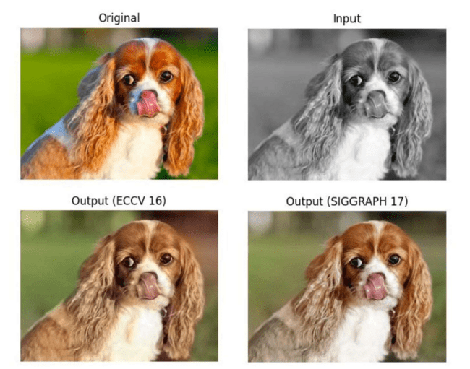**Case ** **IV (ILSVRC2012_val_00041580.JPEG)**

**Case ** **V (ILSVRC2012_val_00046524.JPEG)**

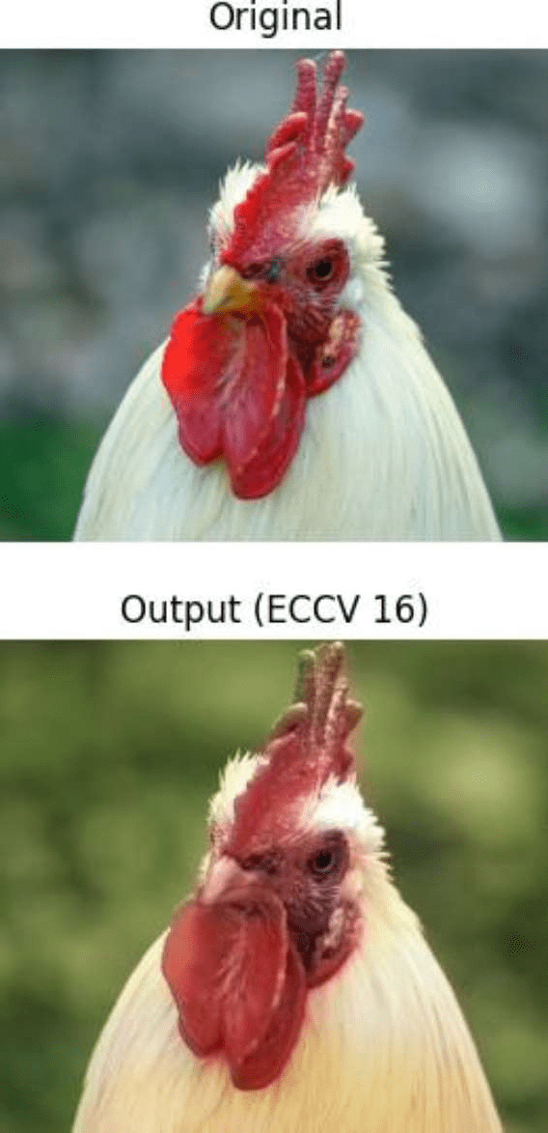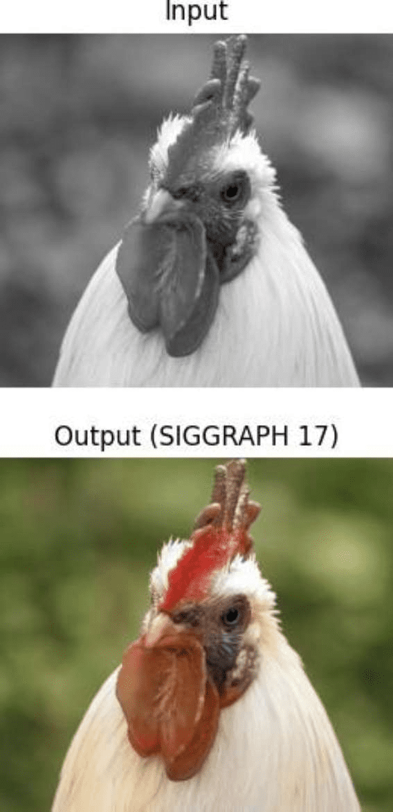

##### M.Sc.IT Semester II

**Case ** **VI (ILSVRC2012_val_00046834.JPEG)**

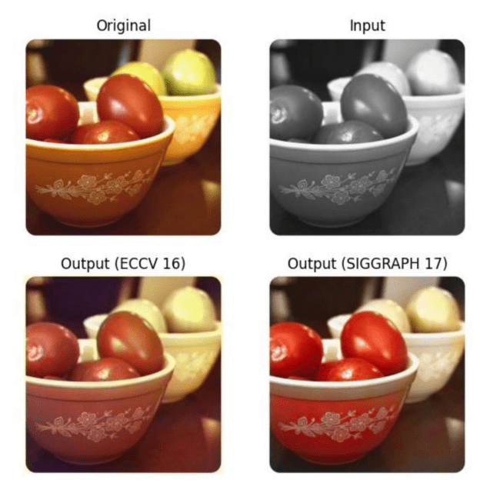

**M.Sc.IT ** **Semester II**

#### Practical No. 4

**Part A :**

**Aim:** Perform Text Detection and Recognition

**Concepts :**

Text detection is the process of **identifying the presence and location of text** in an image or video frame. It does **not** recognize the content of the text; it only detects **where text is present**.

Text recognition (also known as OCR  Optical Character Recognition) is the process of extracting and converting detected text from images into a machine-readable format.

**Packages Used :**

**pytesseract** is a Python wrapper for **Tesseract OCR**, an open-source Optical Character Recognition (OCR) engine developed by Google. It allows Python programs to extract text from images easily.

**OCR for Documents ** Convert scanned PDFs and images into searchable text.

**License Plate Recognition ** Read text from vehicle plates.

**Text Extraction from Screenshots ** Extract text from UI screenshots.

**Real-time OCR in Videos ** Use OCR on video frames for real-time applications.

**Handwriting Recognition ** Recognize handwritten text (with limitations).

**pytesseract.pytesseract.tesseract_cmd = r'C:\Program**

**Files\Tesseract-OCR\tesseract.exe'** specifies the installed location of Tesseract OCR on the system.

**img = cv2.imread("img.jpg"):** reads the input image from the file "img.jpg".  "img.jpg": The file name of the image to be processed.

 Returns an image matrix.

**gray = cv2.cvtColor(img, cv2.COLOR_BGR2GRAY):** converts the image from BGR (color) format to grayscale.

 img: Input image.

 cv2.COLOR_BGR2GRAY: Conversion code to transform the image into grayscale.  Returns a grayscale image.

**ret, thresh1 = cv2.threshold(gray, 0, 255, cv2.THRESH_OTSU | cv2.THRESH_BINARY_INV)**: applies thresholding to convert the grayscale image into a binary image.

 gray: Input grayscale image.

 0: Threshold value (ignored when using Otsu's method).  255: Maximum pixel value.

##### M.Sc.IT Semester II

 cv2.THRESH_OTSU | cv2.THRESH_BINARY_INV: Otsu's binarization with inverse thresholding.  Returns a binary thresholded image.

**rect_kernel = cv2.getStructuringElement(cv2.MORPH_RECT, (20, 20))**: creates a rectangular kernel for morphological operations.

 cv2.MORPH_RECT: Specifies a rectangular structuring element.  (20, 20): Kernel size (width, height).

 Returns a structuring element.

**dilation = cv2.dilate(thresh1, rect_kernel, iterations=1)**: applies dilation to enhance text regions.  thresh1: Input binary image.

 rect_kernel: Structuring element used for dilation.  iterations=1: Number of times dilation is applied.  Returns the dilated image.

**contours, hierarchy = cv2.findContours(dilation, cv2.RETR_EXTERNAL, cv2.CHAIN_APPROX_NONE)**: detects contours in the dilated image.

 dilation: Input binary image.

 cv2.RETR_EXTERNAL: Retrieves only the outermost contours.

 cv2.CHAIN_APPROX_NONE: Stores all contour points without approximation.  Returns a list of detected contours.

**im2 = img.copy():** creates a copy of the original image for drawing rectangles. **for cnt in contours:**

iterates through each detected contour.

**x, y, w, h = cv2.boundingRect(cnt)**: calculates the bounding box around a contour.  cnt: A detected contour.

 Returns x (top-left x-coordinate), y (top-left y-coordinate), w (width), h (height) of the bounding box.

**rect = cv2.rectangle(im2, (x, y), (x + w, y + h), (0, 255, 0), 2)**: draws a green rectangle around the detected text.

 im2: The image where the rectangle will be drawn.  (x, y): Top-left corner of the rectangle.

 (x + w, y + h): Bottom-right corner of the rectangle.  (0, 255, 0): Green color (BGR format).

 2: Thickness of the rectangle border.

**cropped = im2[y: y + h, x: x + w]**: extracts the region of interest (ROI) containing the detected text.  im2[y: y + h, x: x + w]: Crops the bounding box region.

 Returns the cropped image.

**text = pytesseract.image_to_string(cropped)**: extracts text from the cropped region using Tesseract OCR.  cropped: Input image containing text.

 Returns the extracted text as a string. **print(text)**: prints the extracted text to the console.

##### M.Sc.IT Semester II

**Part B :**

**Aim : Perform Image Matting and Composting**

**Concept :**

Image Matting is the process of extracting the foreground object from an image while accurately preserving fine details like hair, fur, or transparency. It is widely used in photo editing, film production, virtual backgrounds, and AR applications.

Image Compositing is the process of combining multiple images to create a seamless, realistic final image. After matting extracts the foreground, compositing blends it with a new background.

**Packages Used :**

**PyMatting** is a Python library for image matting that provides efficient implementations of classical and deep learning-based matting algorithms. It is useful for extracting the foreground from an image while preserving fine details like hair, fur, and transparency.

**scale = 1.0:** defines a scaling factor for resizing images.

**image = load_image("in_lemur.png", "RGB", scale, "box")**: loads the input image in RGB mode with the specified scaling.

 "in_lemur.png": File name of the input image.  "RGB": Color mode for loading the image.

 scale: Resizing factor for the image.

 "box": Interpolation method used for resizing.  Returns an RGB image.

**trimap = load_image("in_lemur_trimap.png", "GRAY", scale, "box")**: loads the trimap image in grayscale mode.

 "in_lemur_trimap.png": File name of the trimap.  "GRAY": Grayscale mode for loading the image.  scale: Resizing factor for the image.

 "box": Interpolation method used for resizing.  Returns a grayscale image.

**alpha = estimate_alpha_cf(image, trimap):** estimates the alpha matte using the input image and trimap.  image: Input RGB image.

 trimap: Grayscale trimap used to distinguish foreground, background, and unknown regions.  Returns an estimated alpha matte.

**new_background = np.zeros(image.shape):** creates a new background image filled with zeros (black).  image.shape: Dimensions of the input image.

##### M.Sc.IT Semester II

 Returns a black image with the same shape as the input. **new_background[:, :] = [0.5, 0.5, 0.5]**: fills the new background with a gray color.

 [0.5, 0.5, 0.5]: RGB values for gray (normalized between 0 and 1). **foreground, background = estimate_foreground_ml(image, alpha, return_background=True):** estimates the foreground and background based on the alpha matte.

 image: Input RGB image.

 alpha: Estimated alpha matte.

 return_background=True: Returns both the extracted foreground and background.

 Returnsthe separated foreground and background images.

**save_image("output1_alpha.png", alpha):** saves the estimated alpha matte as an image file.  "output1_alpha.png": File name for saving the alpha matte.

 alpha: Alpha matte to be saved.

**save_image("output2_foreground.png", foreground):** saves the extracted foreground image.  "output2_foreground.png": File name for saving the foreground.

 foreground: Extracted foreground image. **save_image("output3_background.png", background):** saves the extracted background image.

 "output3_background.png": File name for saving the background.  background: Extracted background image.

**cutout = stack_images(foreground, alpha)**: combines the foreground and alpha matte into a single image.  foreground: Extracted foreground image.

 alpha: Alpha matte for transparency.

 Returns an image with foreground and alpha combined. **save_image("output4_cutout.png", cutout):** saves the cutout image with transparency.

 "output4_cutout.png": File name for saving the cutout.

 cutout: Image containing the foreground with transparency.

**cutout = cv2.imread("output4_cutout.png", cv2.IMREAD_UNCHANGED):** loads the cutout image with an alpha channel.

 "output4_cutout.png": File name of the cutout image.

 cv2.IMREAD_UNCHANGED: Reads the image while preserving the alpha channel.  Returns an image with an alpha channel.

**new_background = cv2.imread("in_beach.jpg"):** loads the new background image.  "in_beach.jpg": File name of the new background image.

 Returns a background image.

**foreground = cutout[:, :, :3]**: extracts the RGB channels from the cutout image.  cutout[:, :, :3]: Extracts the first three channels (RGB).

##### M.Sc.IT Semester II

 Returns the foreground image without the alpha channel.

**am = cutout[:, :, 3] / 255.0**: extracts the alpha channel and normalizes it to a range of 0 to 1.  cutout[:, :, 3]: Extracts the alpha channel.

 / 255.0: Normalizes the alpha values.  Returns a normalized alpha matte.

**newbg_resized = cv2.resize(new_background, (foreground.shape[1], foreground.shape[0])):** resizes the new background to match the size of the foreground.

 new_background: The new background image.

 (foreground.shape[1], foreground.shape[0]): Target width and height from the foreground.  Returns a resized background image.

**composite = np.zeros_like(foreground, dtype=np.uint8)**: creates a blank composite image with the same size as the foreground.

 np.zeros_like(foreground): Creates a zero matrix with the same shape as the foreground.  dtype=np.uint8: Data type for image storage.

 Returns an empty black image.

**for c in range(3):** iterates over the three color channels (RGB).

**composite[:, :, c] = foreground[:, :, c] * am + newbg_resized[:, :, c] * (1 - am):** blends the foreground and background using the alpha matte.

 foreground[:, :, c] * am: Multiplies the foreground color by the alpha values.

 newbg_resized[:, :, c] * (1 - am): Multiplies the background color by the inverse alpha values.  Adds the two values to create a blended image.

**cv2.imwrite("CompositeImageBeach.png", composite):** saves the final composite image with the new background.

 "CompositeImageBeach.png": File name for saving the final result.  composite: The blended image with the new background.

##### M.Sc.IT Semester II

**Practical No. 4 Part A**

**Aim: Perform Text Detection and Recognition**

**Steps:**

**Packages Used: cv2, pytesseract**

**Pytesseract Installation Guide:** Download the PyTesseract Installer

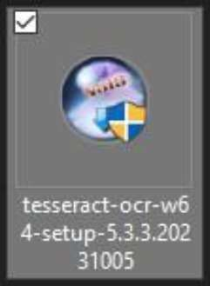

Check the Install Location&Finish the installation

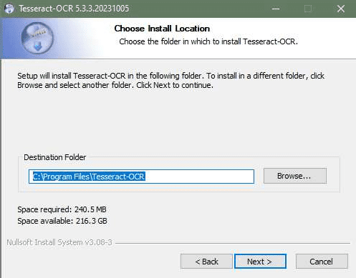

##### M.Sc.IT Semester II

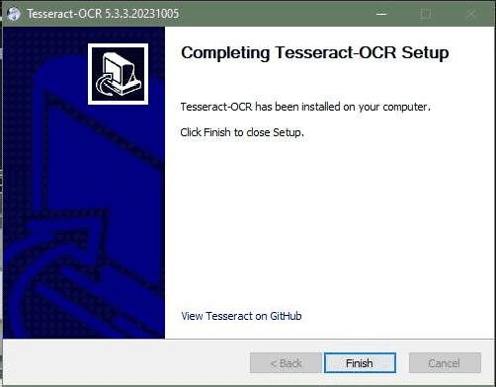

**Command:**



**Images Used:**

img.jpg sample.jpg

**Code:**

import cv2

import pytesseract

# Mention the installed location of Tesseract OCR pytesseract.pytesseract.tesseract_cmd=r'C:\Program

Files\Tesseract-OCR\tesseract.exe'

img = cv2.imread("img.jpg")

gray = cv2.cvtColor(img, cv2.COLOR_BGR2GRAY)

ret, thresh1 = cv2.threshold(gray, 0, 255, cv2.THRESH_OTSU | cv2.THRESH_BINARY_INV)

rect_kernel = cv2.getStructuringElement(cv2.MORPH_RECT,(20, 20)) dilation = cv2.dilate(thresh1, rect_kernel, iterations=1)

contours, heirarchy = cv2.findContours(dilation, cv2.RETR_EXTERNAL, cv2.CHAIN_APPROX_NONE)

im2 = img.copy()

##### M.Sc.IT Semester II

for cnt in contours:

x, y, w, h = cv2.boundingRect(cnt)

rect = cv2.rectangle(im2, (x, y), (x+w, y+h), (0,255,0), 2) cropped = im2[y: y+h, x: x+w]

text = pytesseract.image_to_string(cropped) print(text) **Output:**

**Case ** **I (img.jpg):**

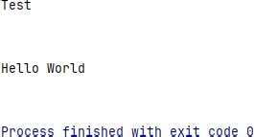

##### M.Sc.IT Semester II

**Case ** **II (sample.jpg)**

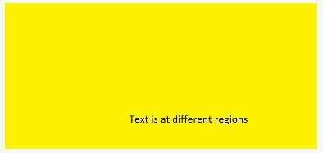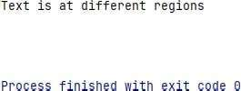

##### M.Sc.IT Semester II

**Part B**

**Aim: Perform Image Matting and Composting**

**Steps:**

**Packages Used: pymatting, numpy, cv2 Command:**



**Images Used:**

in_lemur.png in_lemur_trimap.png in_beach.png

**Code:**

from pymatting import * import numpy as np import cv2

scale = 1.0

image = load_image("in_lemur.png", "RGB", scale, "box")

trimap = load_image("in_lemur_trimap.png", "GRAY", scale, "box") # MATTING # Estimate Alpha from Image and Trimap alpha =

estimate_alpha_cf(image, trimap)

# Make gray background new_background = np.zeros(image.shape) new_background[:, :] = [0.5, 0.5, 0.5]

# Estimate foreground from image and alpha

foreground, background = estimate_foreground_ml(image, alpha, return_background=True)

# Save Alpha save_image("output1_alpha.png", alpha) # Save Foreground

save_image("output2_foreground.png", foreground) # Save Background save_image("output3_background.png", background)

##### M.Sc.IT Semester II

# Save Cutout

cutout = stack_images(foreground, alpha) save_image("output4_cutout.png", cutout)

# COMPOSTING

cutout = cv2.imread("output4_cutout.png", cv2.IMREAD_UNCHANGED) new_background = cv2.imread("in_beach.jpg")

# Split the cutout into foreground and alpha matte foreground = cutout[:, :, :3]

am = cutout[:, :, 3] / 255.0

# Resize the new background to match the size of the foreground newbg_resized = cv2.resize(new_background, (foreground.shape[1], foreground.shape[0]))

# Create composite image

composite = np.zeros_like(foreground, dtype=np.uint8)

# Composite the foreground onto the new background for c in range(3):

composite[:, :, c] = foreground[:, :, c] * am + newbg_resized[: , :, c] * (1-am) # Save the composite image cv2.imwrite("CompositeImageBeach.png", composite)

**Output:**

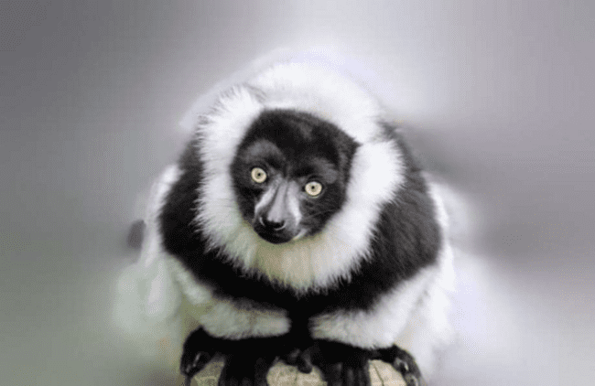**output1_alpha.png**

**output2_foreground.png**

##### M.Sc.IT Semester II

**output3_background.png**



**output4_cutout.png**

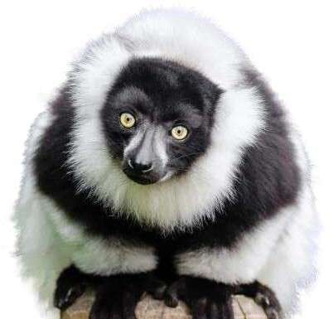

##### M.Sc.I.T. Semester II

**CompositeImageBeach.png**

